NATIONAL SERVICE SCHEME
Report on Swachhata Pakhwada
(01-Sep-2017 to 15-Sep-2017)

As per the orders of Union Government and able guidance and advice of our Director and Principal, Prof. Dr. Muddu Vinay, our NSS volunteers conducted a series of activities as part of clean drive (Swachhata Pakhwada). The intention of this drive to achieve “Swachh Bharat”, which is one of the major focuses of our Government. Presidency College is known for cleanliness; all the stakeholders of this Institution are also well aware of Clean Surroundings and always vouch for the same. During this clean drive period, the involvement from every other Presidencian is laudable.

Day1: Friday, 01-Sep-2017 (Clean Campus Day)
Our volunteers had involved in cleaning work along with house-keeping staff members within the campus. They cleaned corridors, quadrangle, and canteen area for about one hour. After sweeping the waste, they segregated the plastic waste and dumped in appropriate bins.

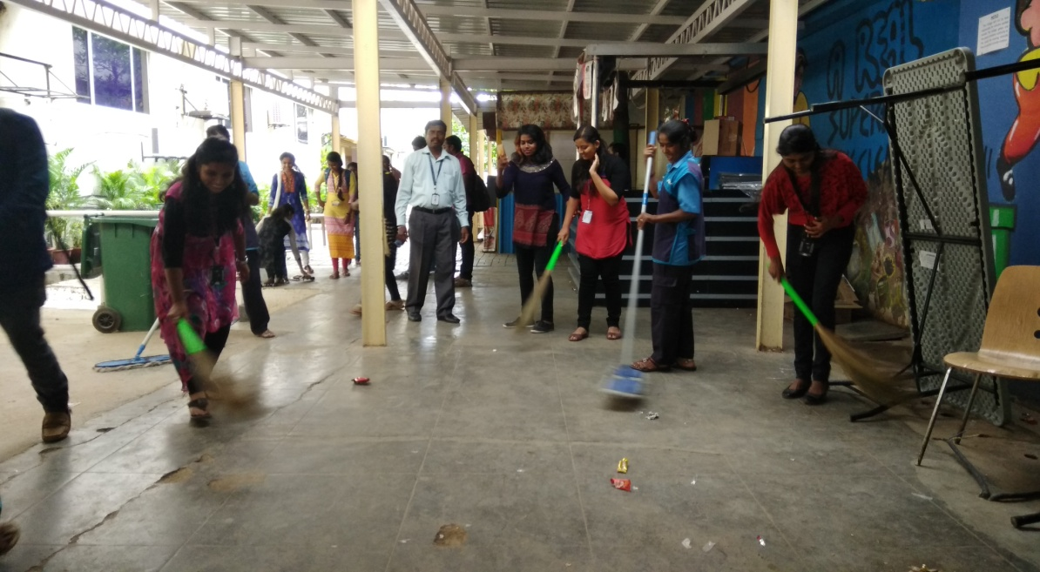
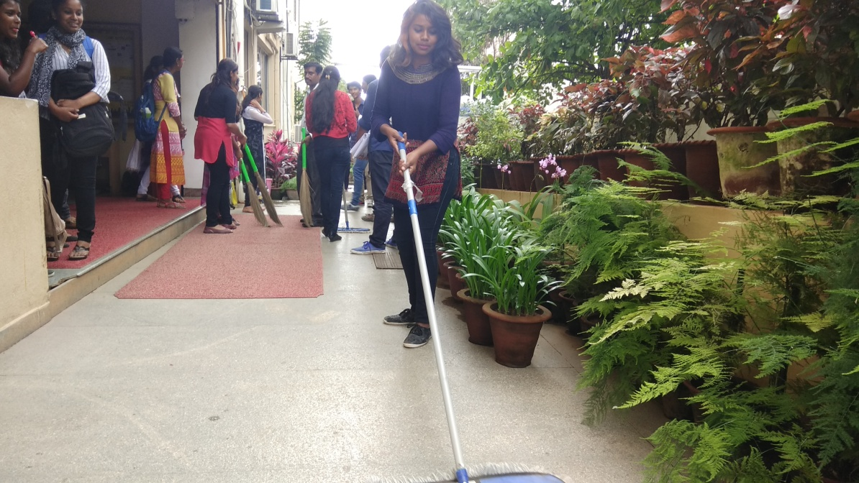
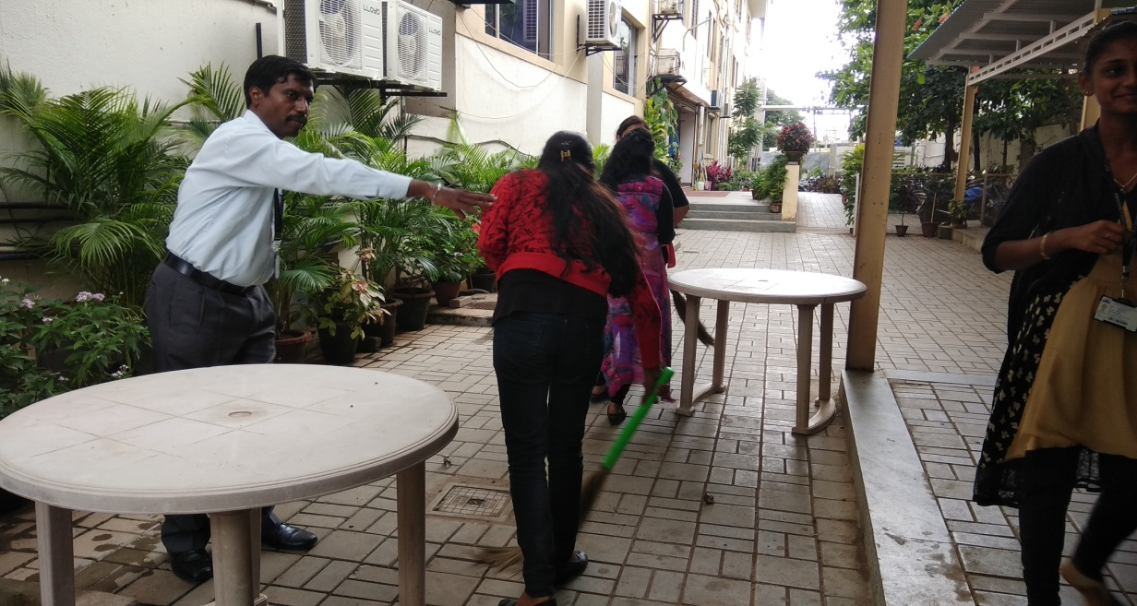
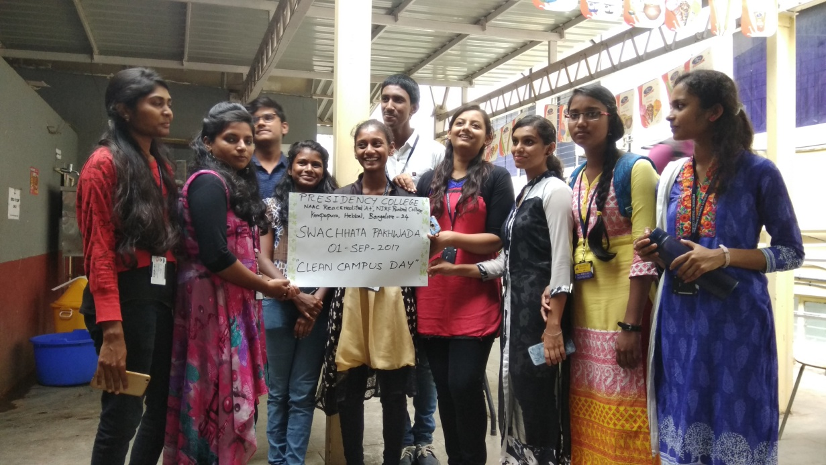

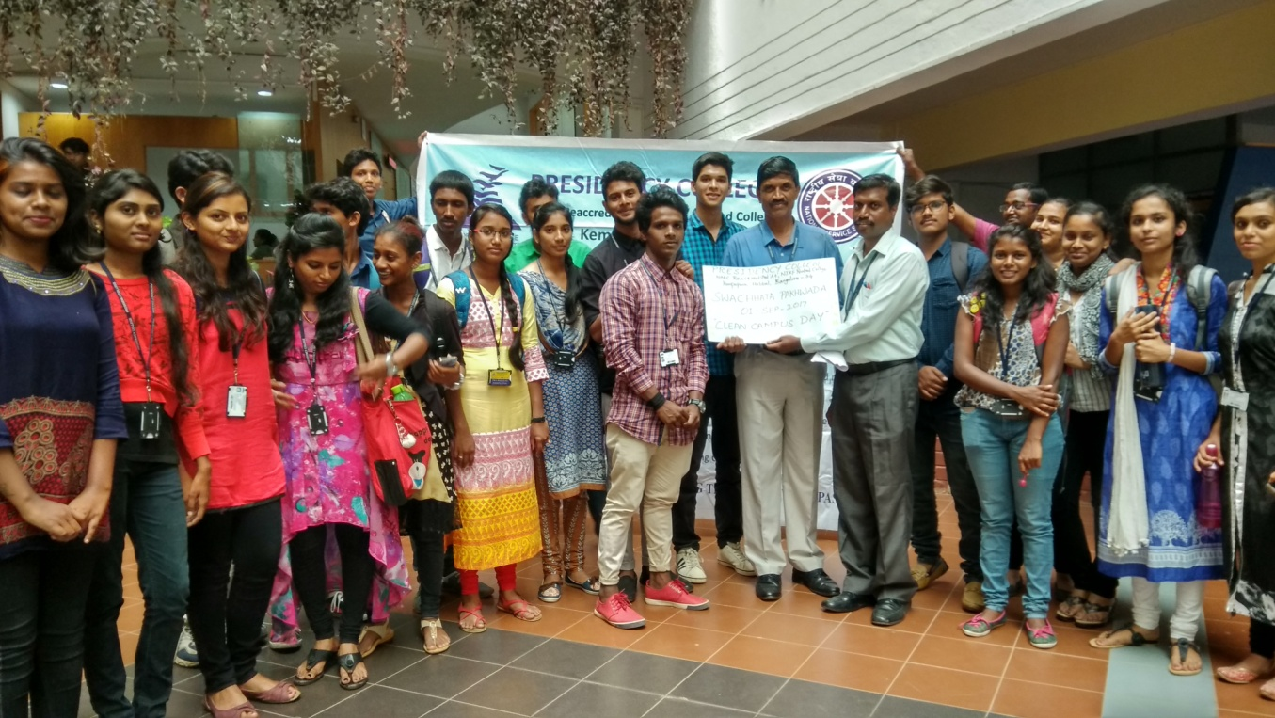
Day2: Saturday, 02-Sep-2017 (Clean Hostel Day)
All the Students of our College Hostel had participated in “Clean Hostel Day”. Students had been motivated to clean the Hostel premises and surroundings, they all involved in this particular activity with lots enthusiasm and energy. Also, they made a vow to maintain the same cleanliness always. The neighbours and onlookers applauded the students and awareness of cleanliness spread in the vicinity.
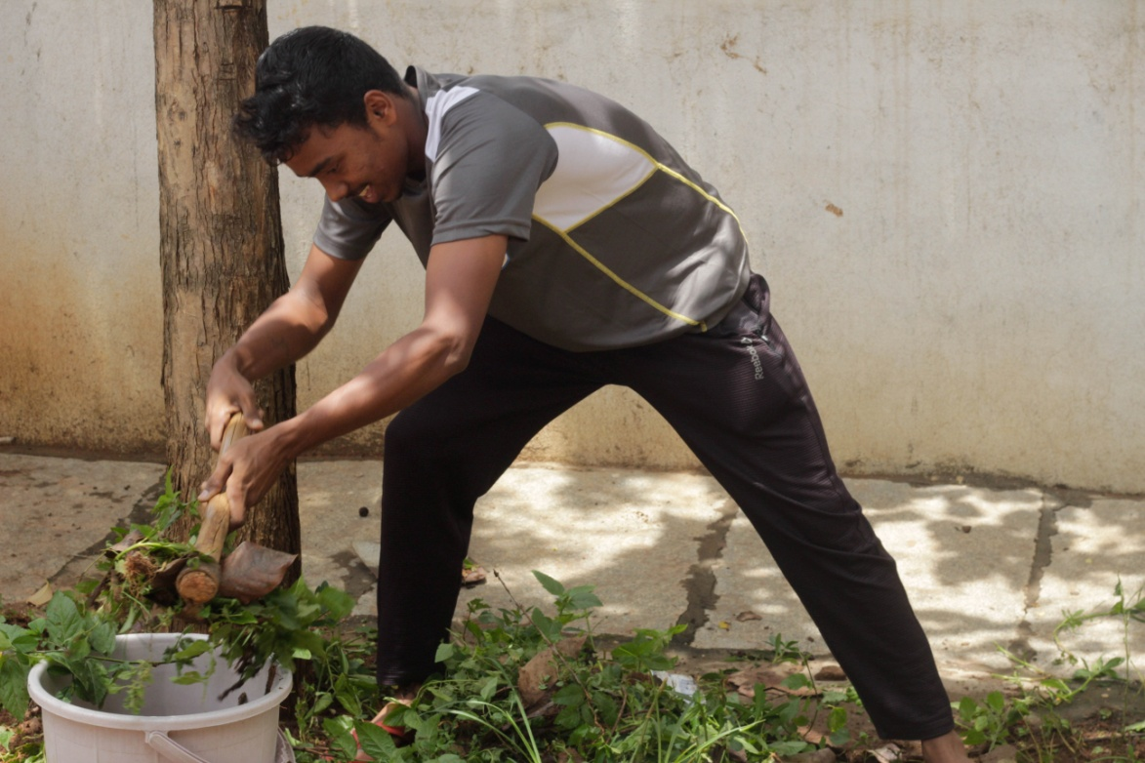

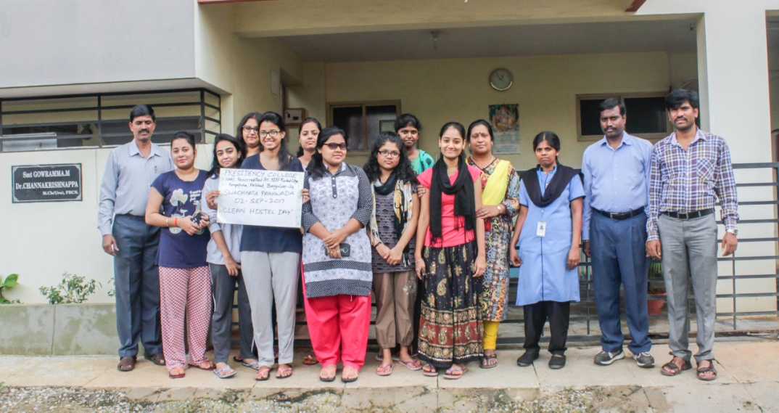
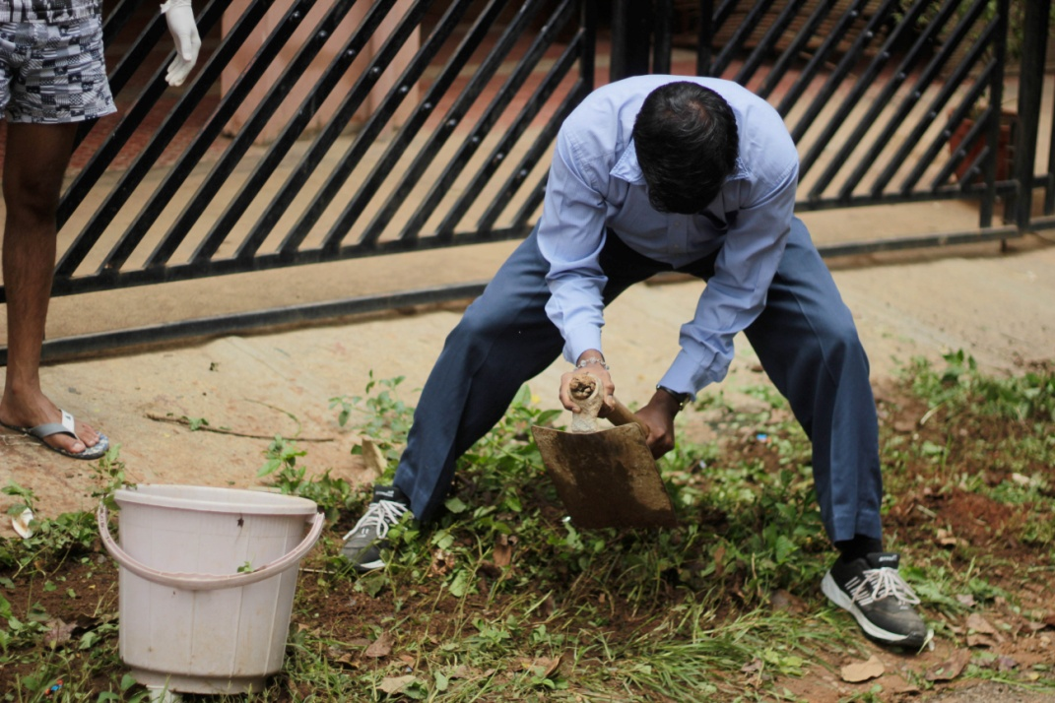
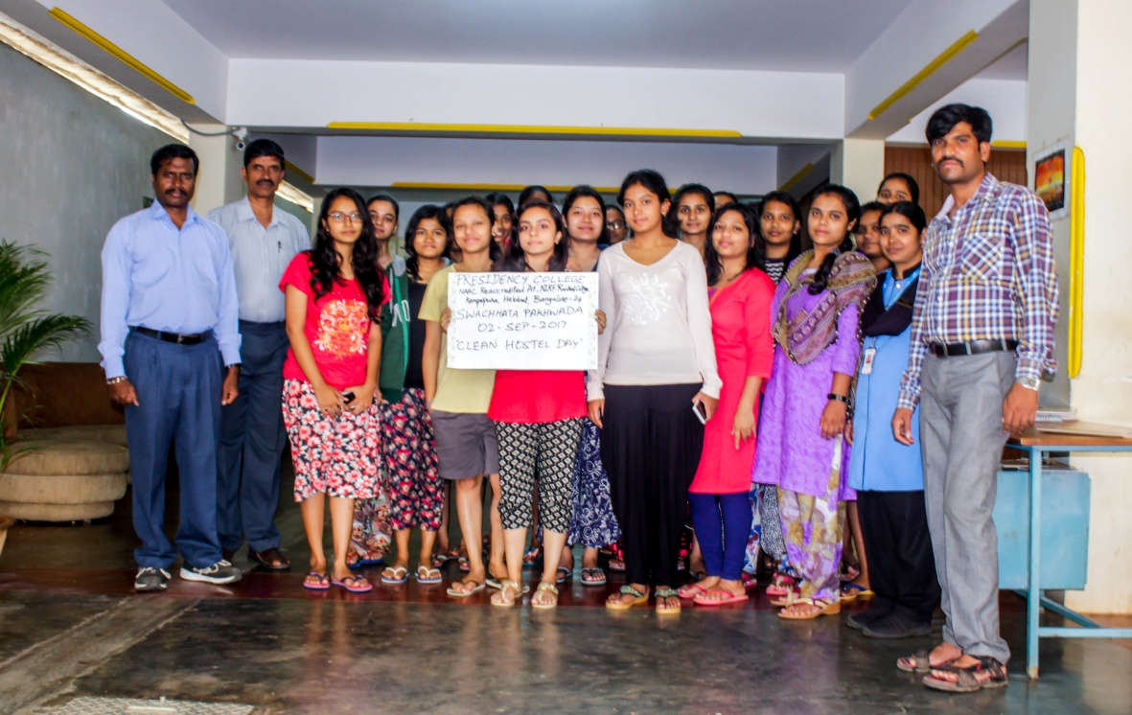
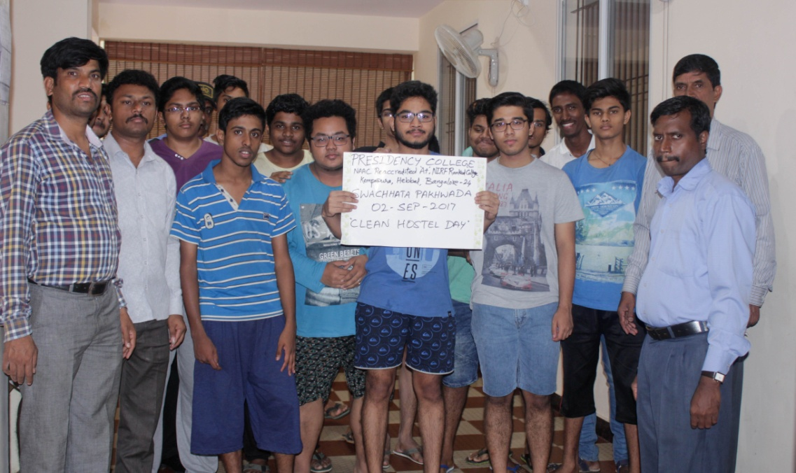
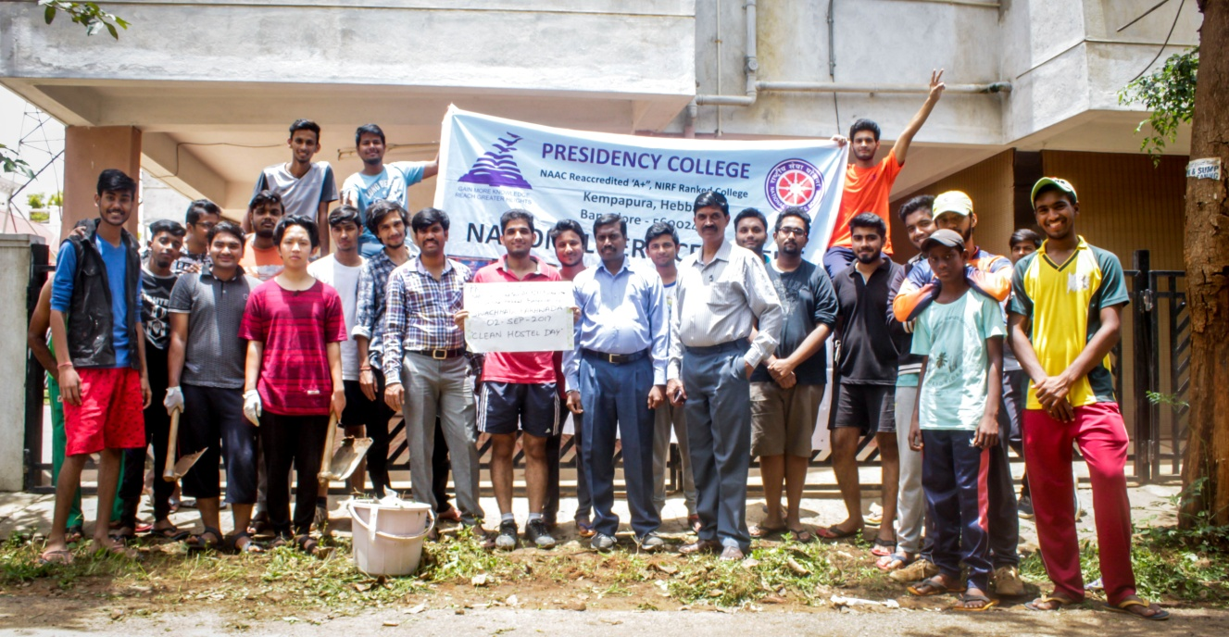

Day3: Sunday, 03-Sep-2017 (Green Campus Day)
Cleanliness without greenery makes no sense, so, to make our volunteers more sensible about environment, we celebrated “Green Campus Day”. Our volunteers are instructed to nurture greenery in the campus. They all watered the plants and trees in the College premises. Also, learnt some tips how to foster flora in the urban areas. Furthermore, they were motivated use water economically and learn mankind cannot survive without trees.
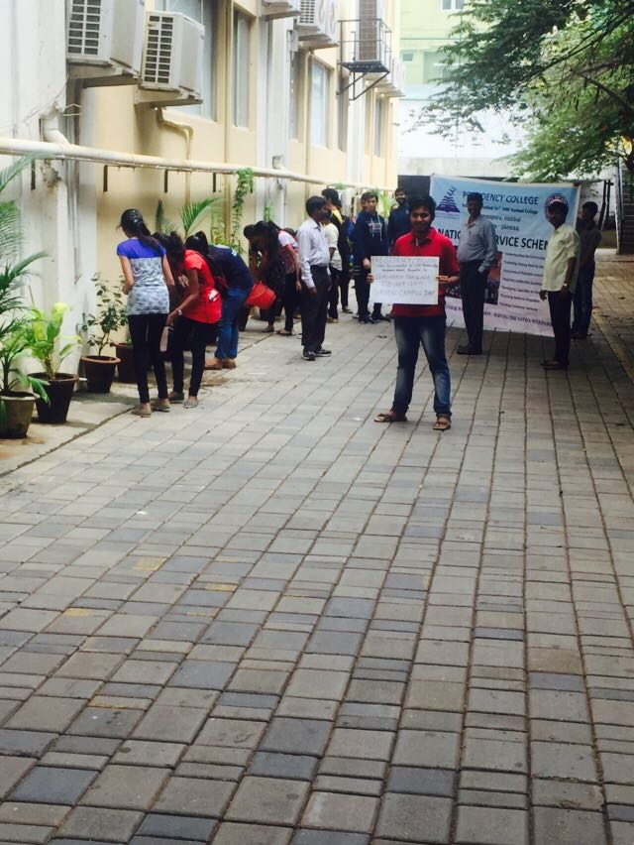
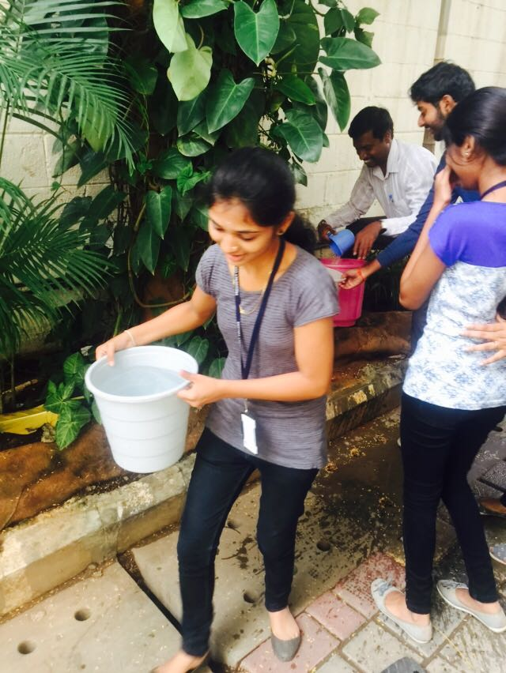
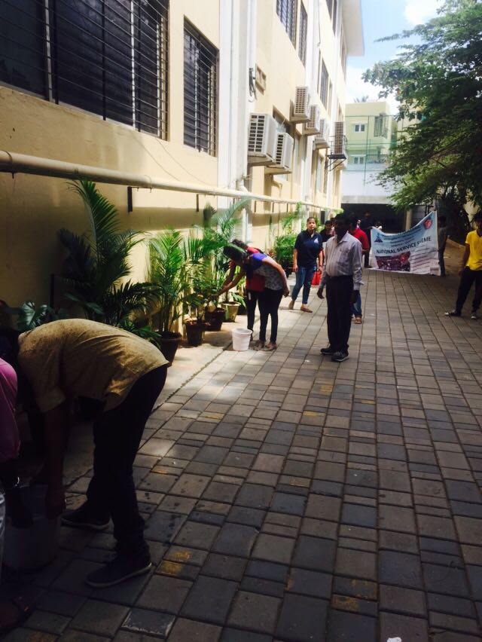
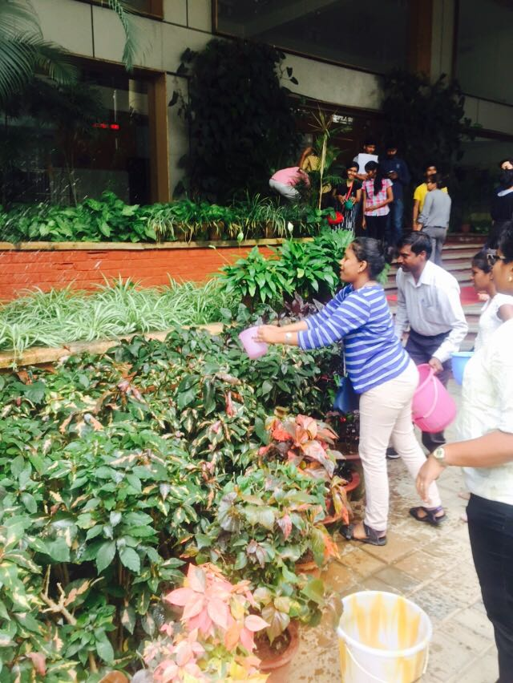
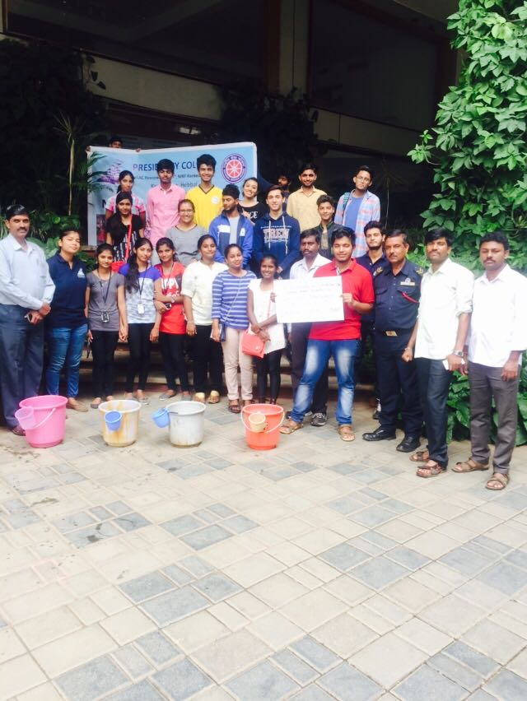
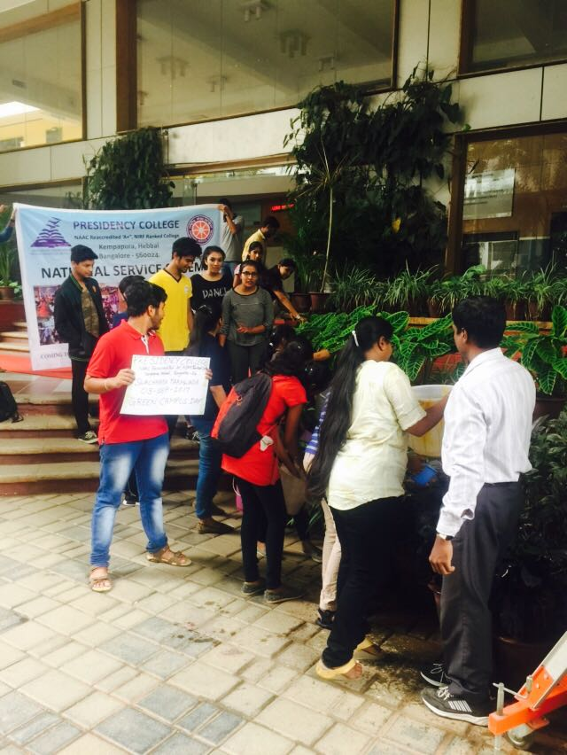
Day4: Monday, 04-Sep-2017 (Clean Mess Day)
All the Hostel Students are served lunch in the fourth floor everyday between 12:30PM and 1:30PM. Usually, during luncheon, Facility Managers and Wardens are present to oversee the session and ensure no wastage of food and dining hall is clean. On this clean mess day, Students are adviced to get served only as much as they eat so as to avoid the wastage of food. Table manners and etiquette are followed throught out the session. After having food, the used plates are stacked in crates by disposing if at all any neglible wastage in the bins kept aside. Also, water usage is as minimal as possible.
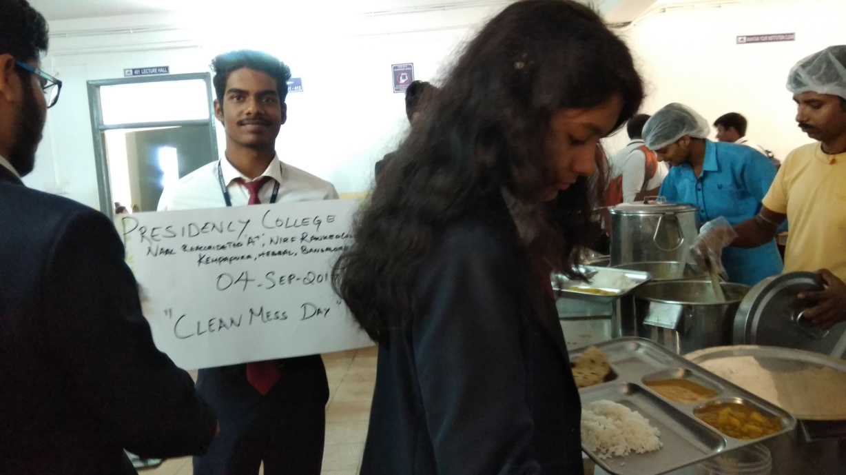
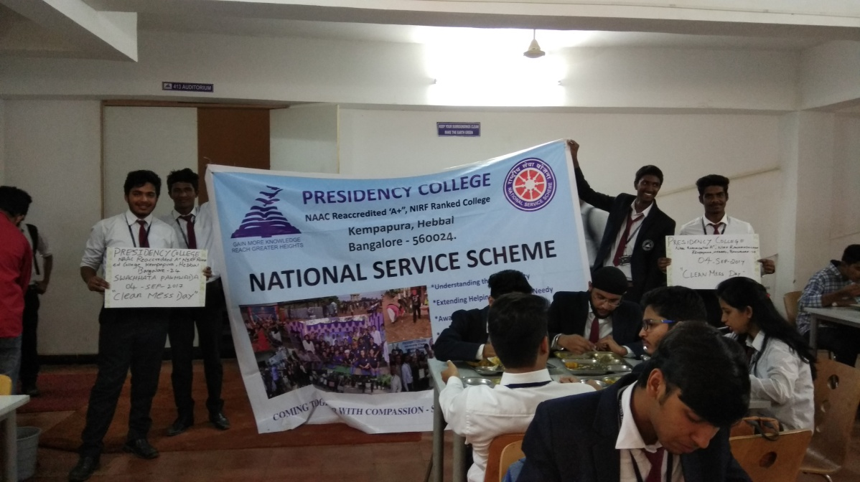
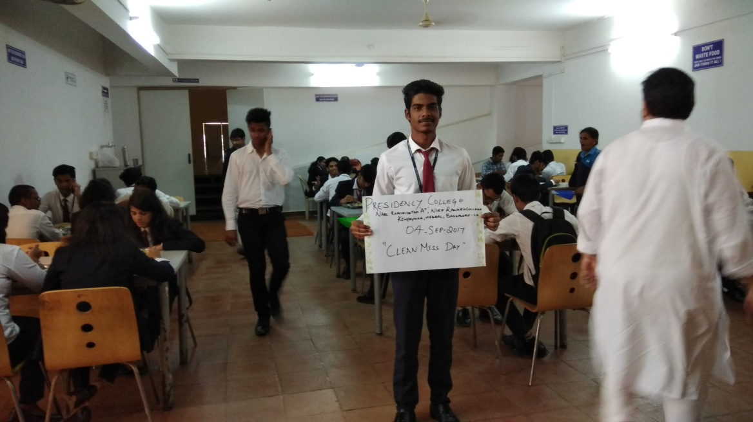
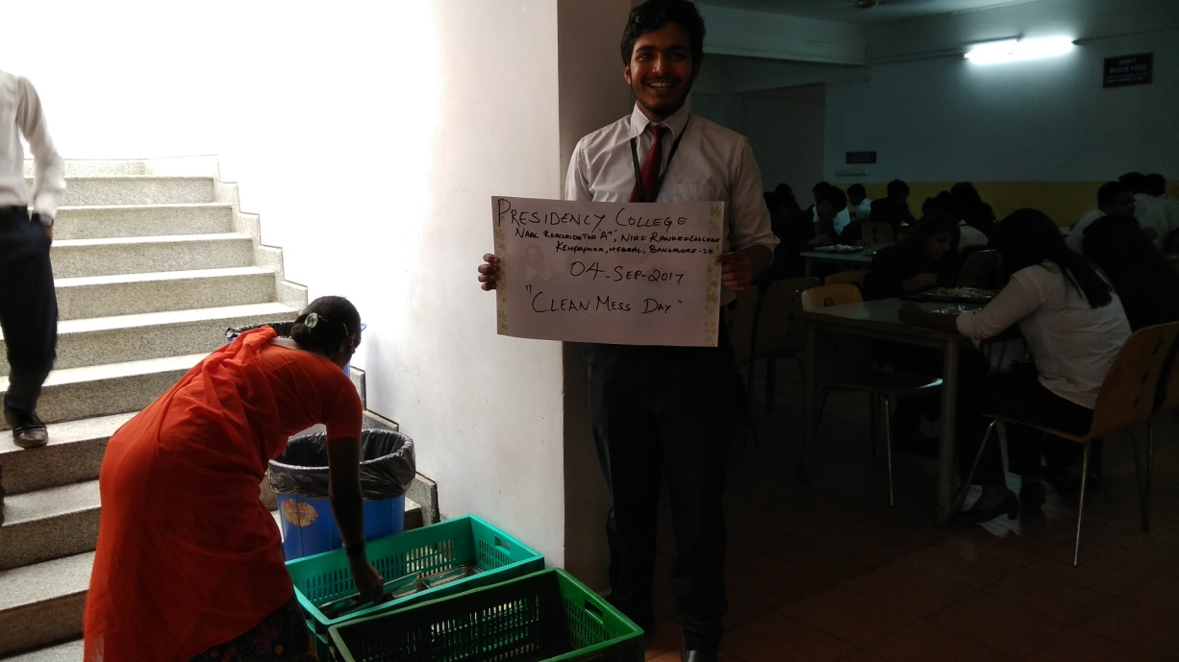
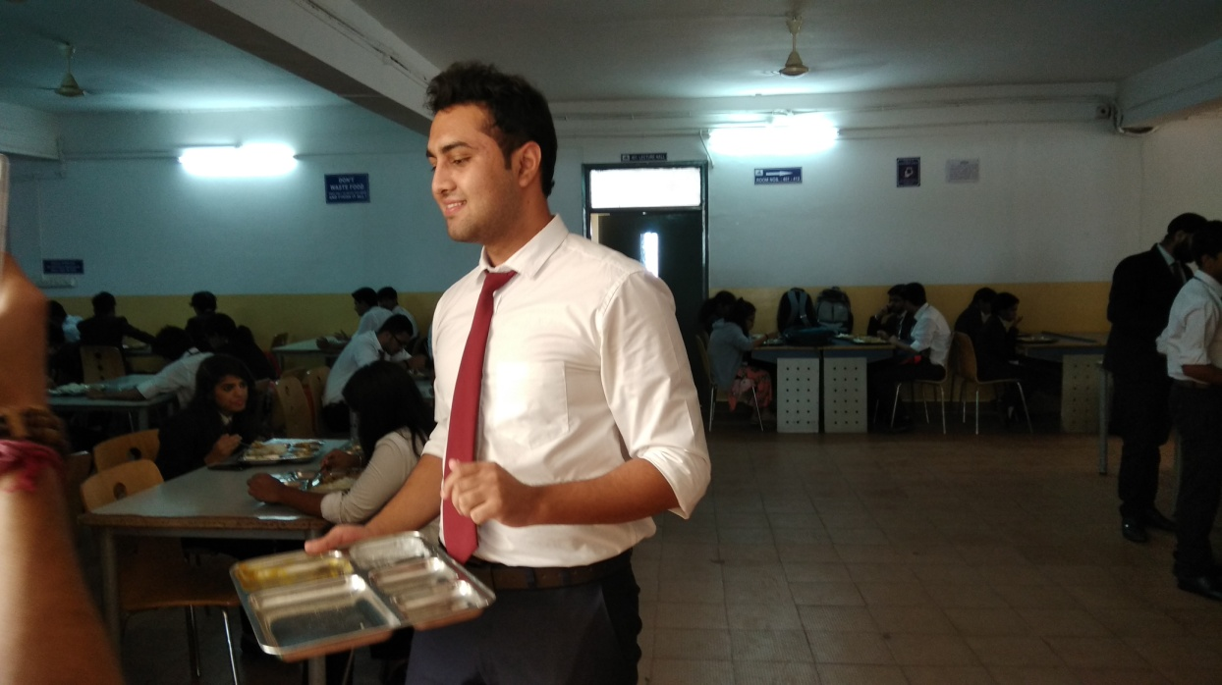
Day6: Wednesday, 06-Sep-2017 (Clean Surroundings Day)
All the Volunteers are motivated to keep the surroundings clean and tidy. To ensure this, they had participated in the cleaning activity on the roads nearby to college. Also, they raised slogans to make the passers by aware of cleanliness.
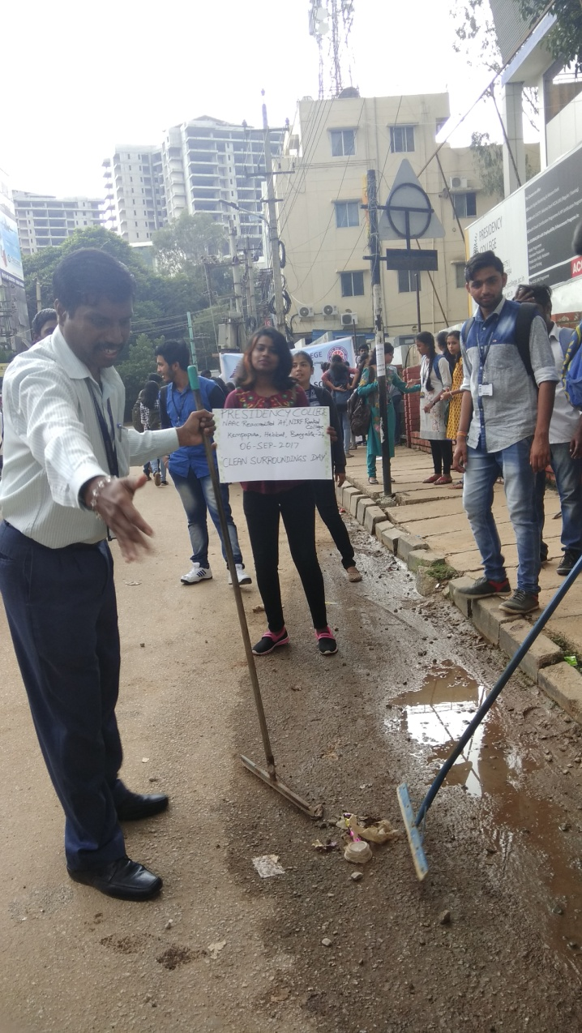

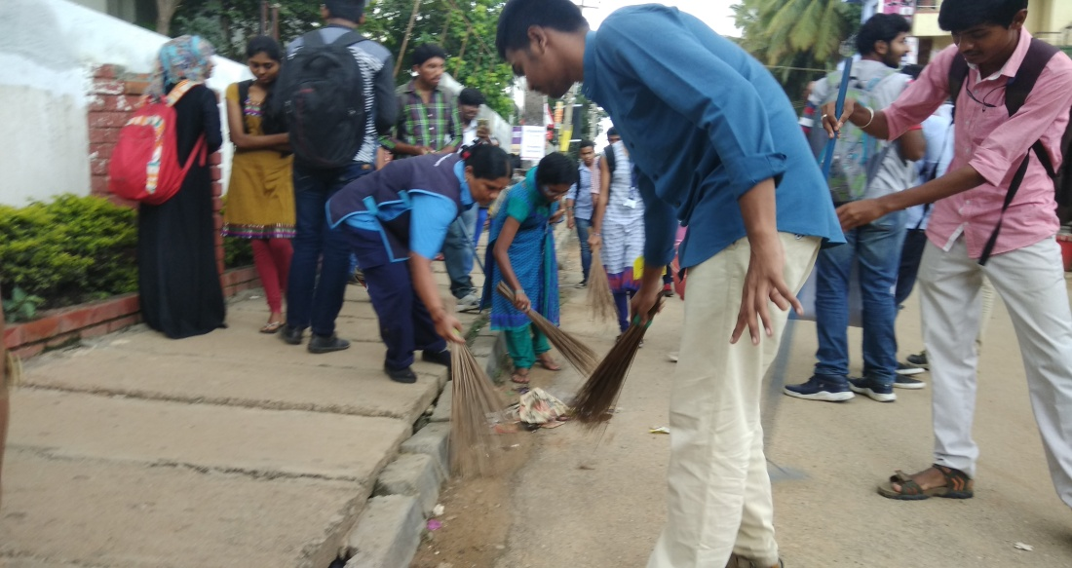
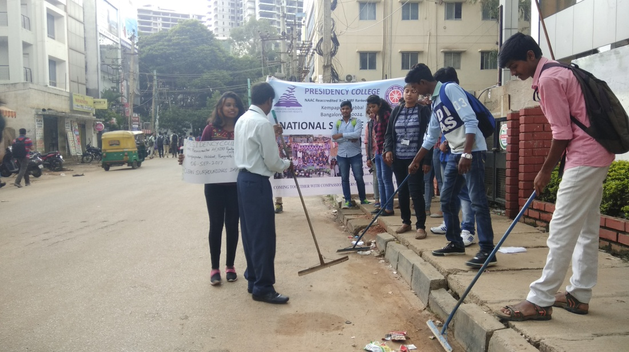
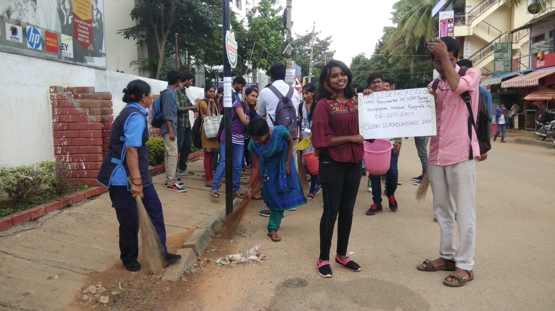
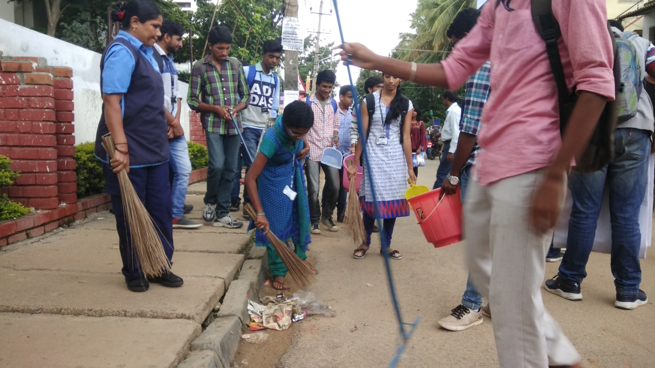
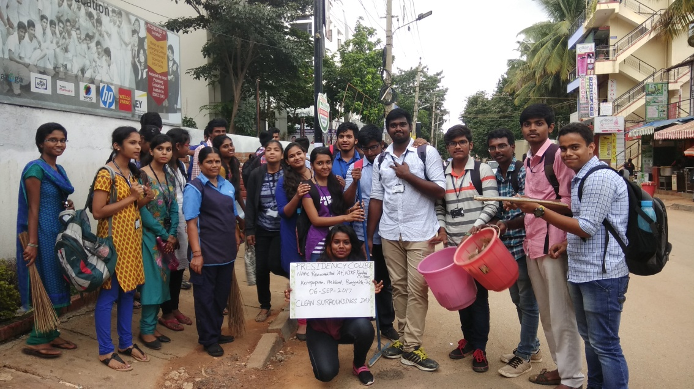
Day8: Friday, 08-Sep-2017 (Care for the Surroundings)
Our locality is a blend of clean and mounds of garbages in few pockets of slum dwellers. Our Volunteers had been advised to create awareness to the slum dwellers about garbage segregation and safe disposal. All the volunteers had visited the underprivileged class of people residing near Chiranjeevi Layout in Kempapura to spread the awareness of cleanliness in their surroundings. People had agreed to maintain the cleanliness.
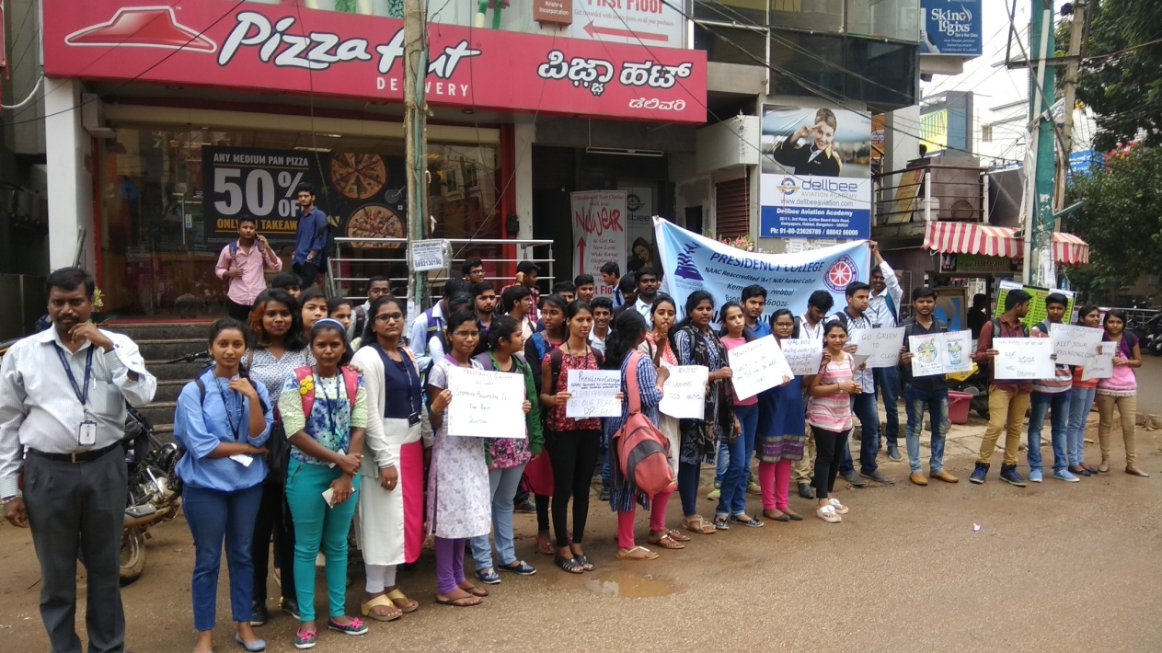

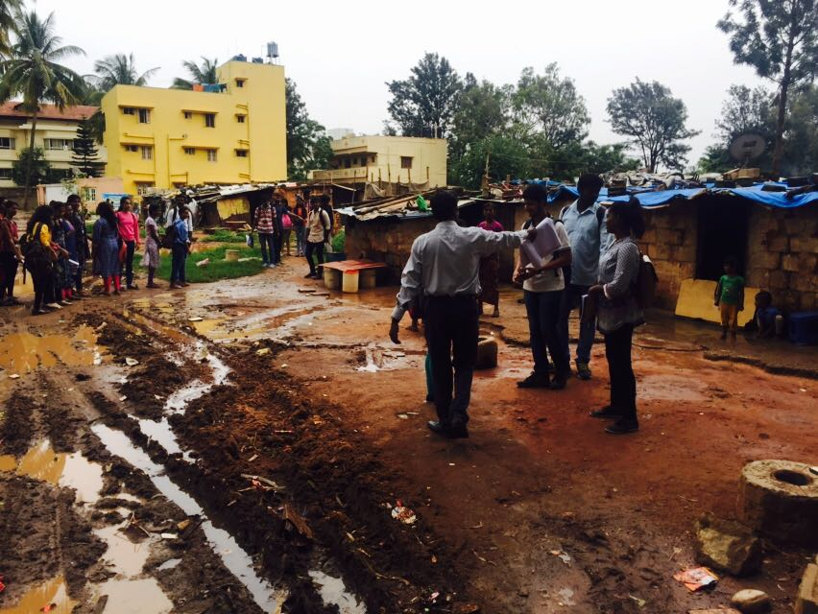
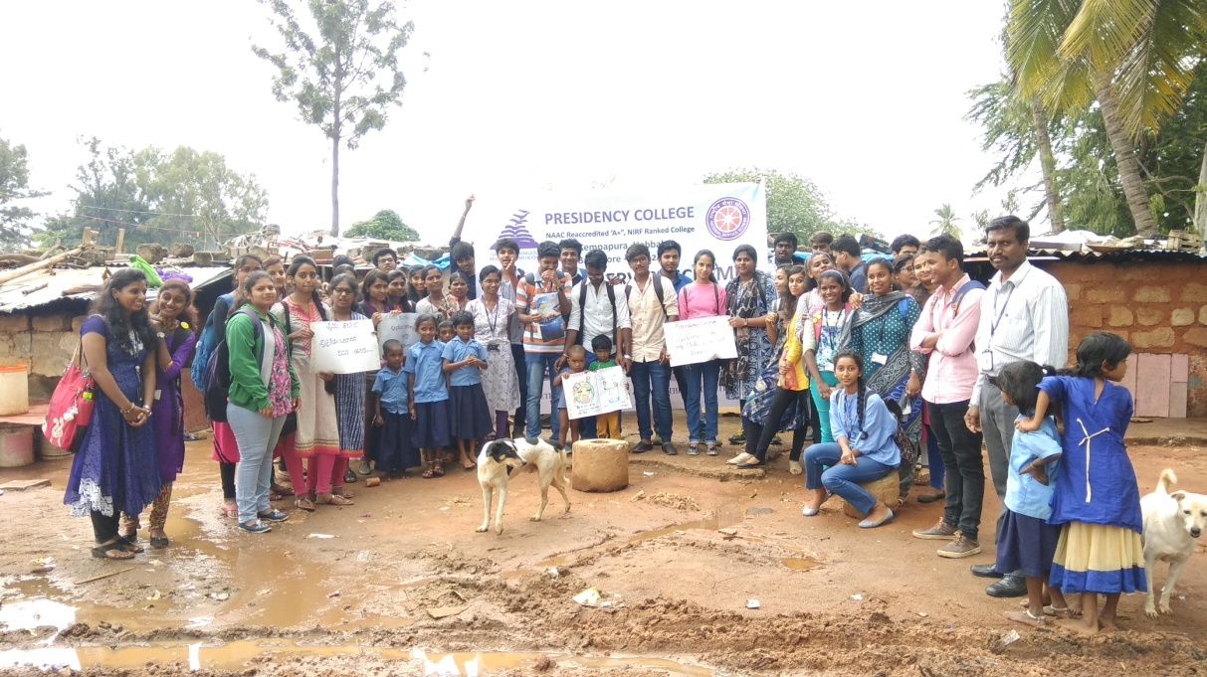
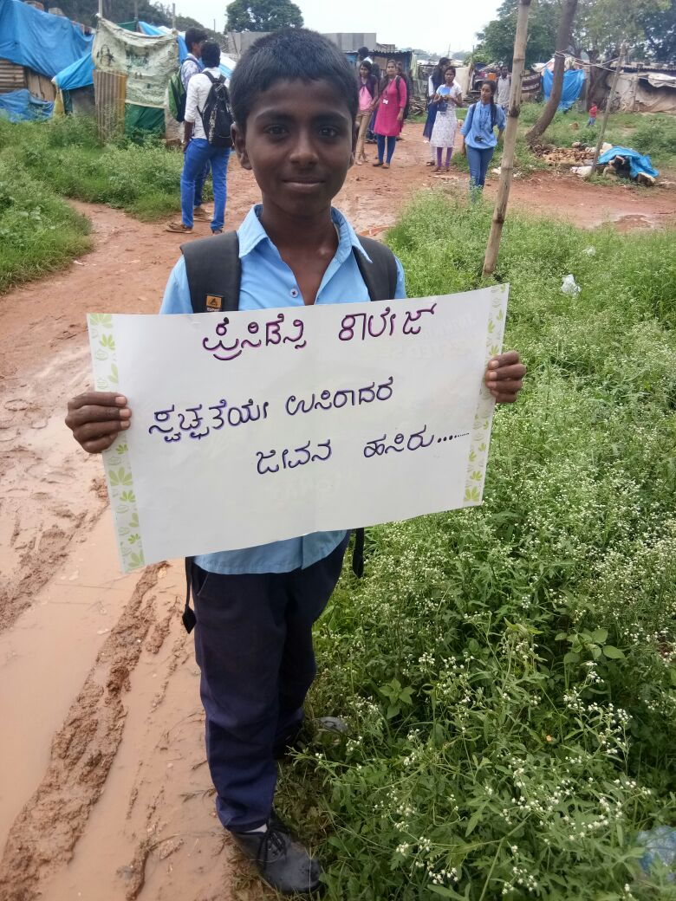
Day9: Saturday, 09-Sep-2017 (Care for the Surroundings)
Our Volunteers were instructed to study the garbage disposal system in Ganganagar market area. Several teams of volunteers were sent to various streets in the market to spread awareness of safe disposal of garbage. Most of shopkeepers and roadside vendors were aware of segregation at source and infact they are following. Few complained about the irregularities in the clearance system, otherwise the locality appeared to be clean and good.
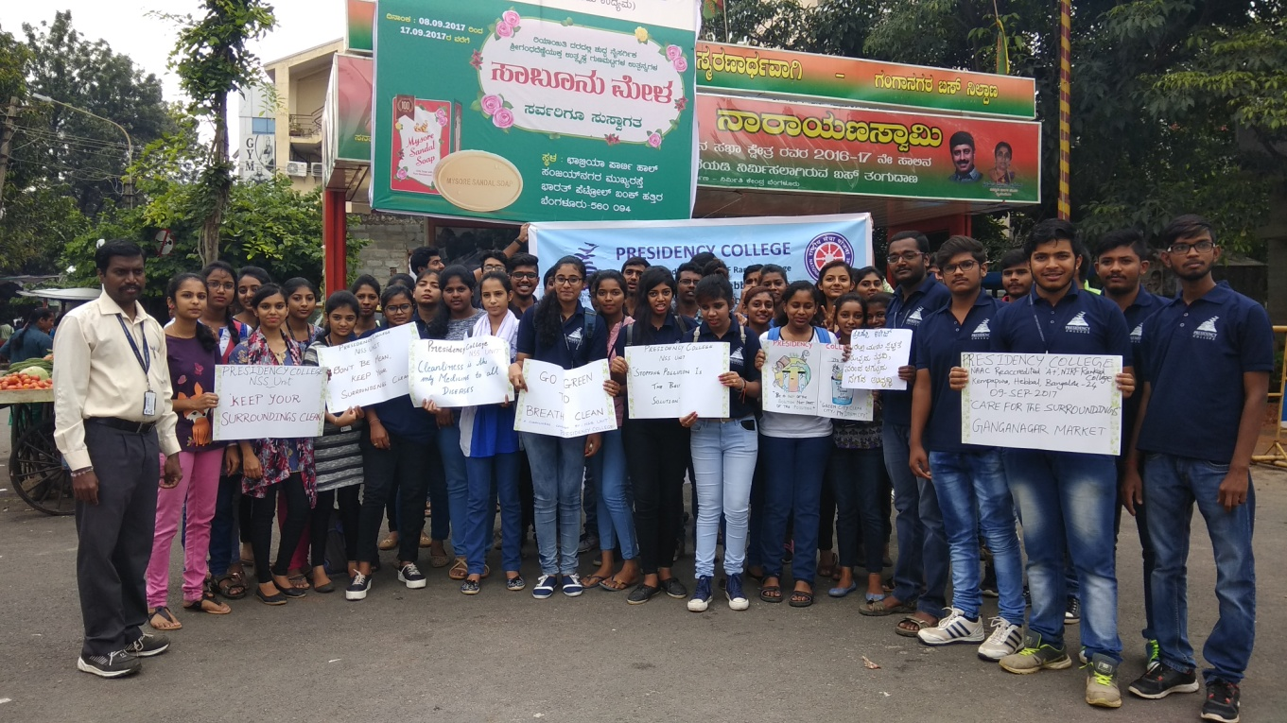

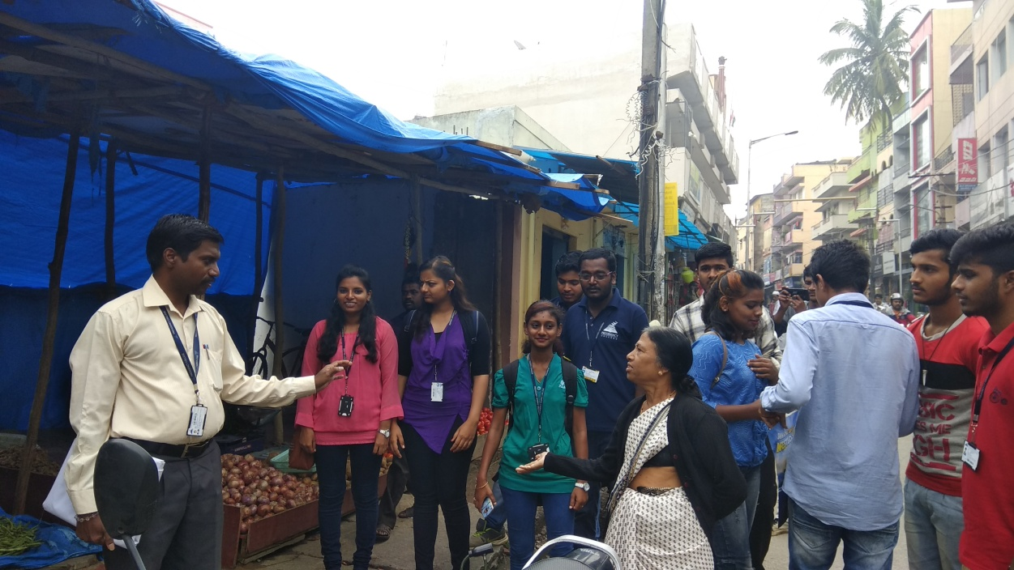
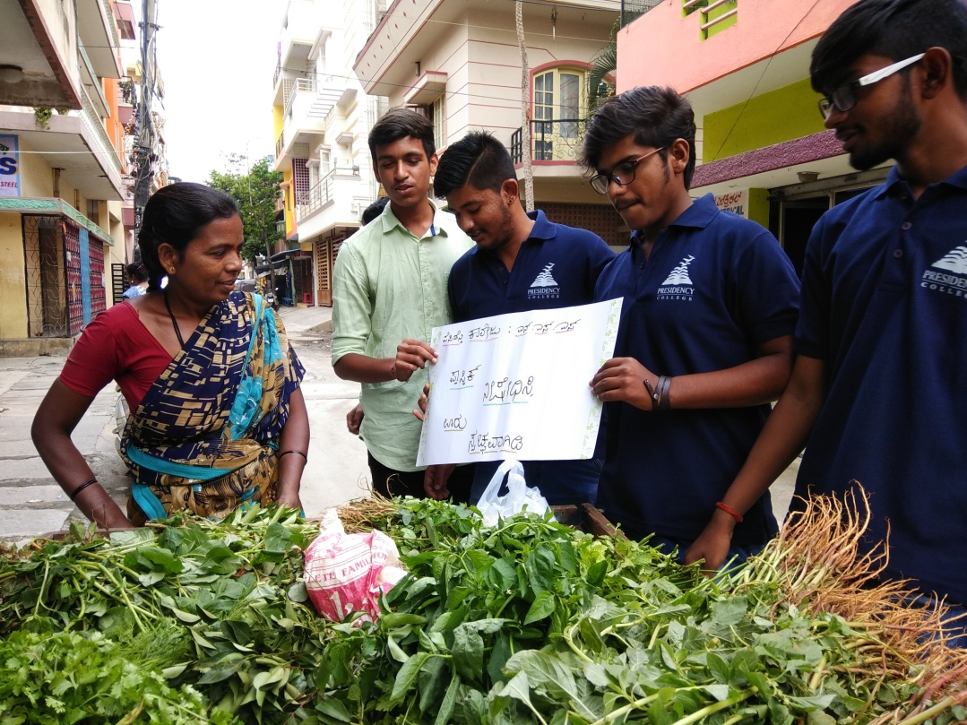
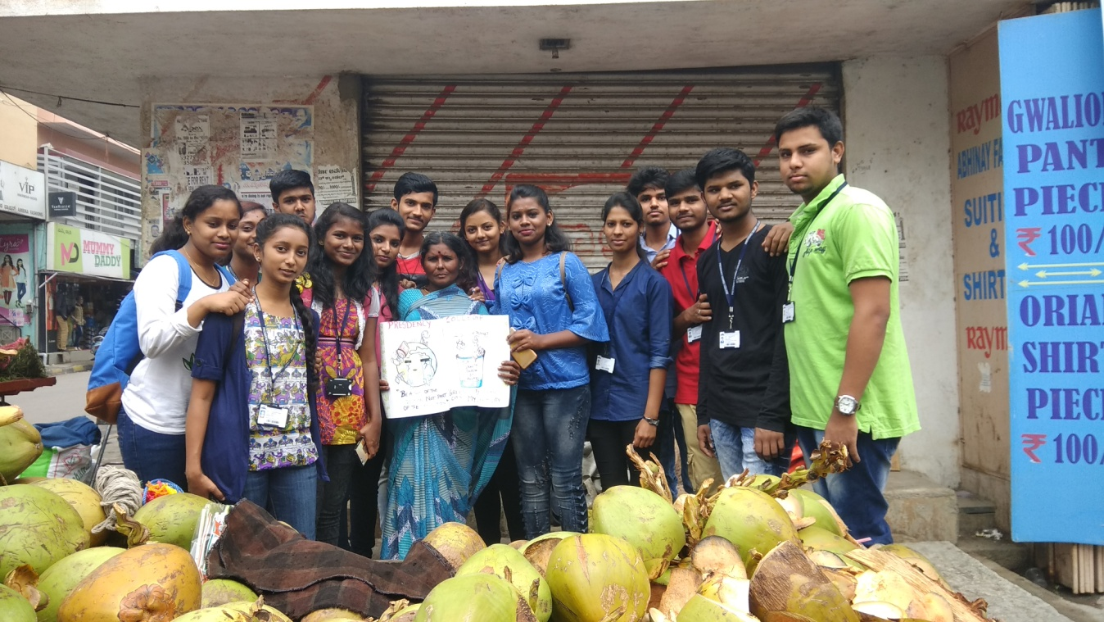
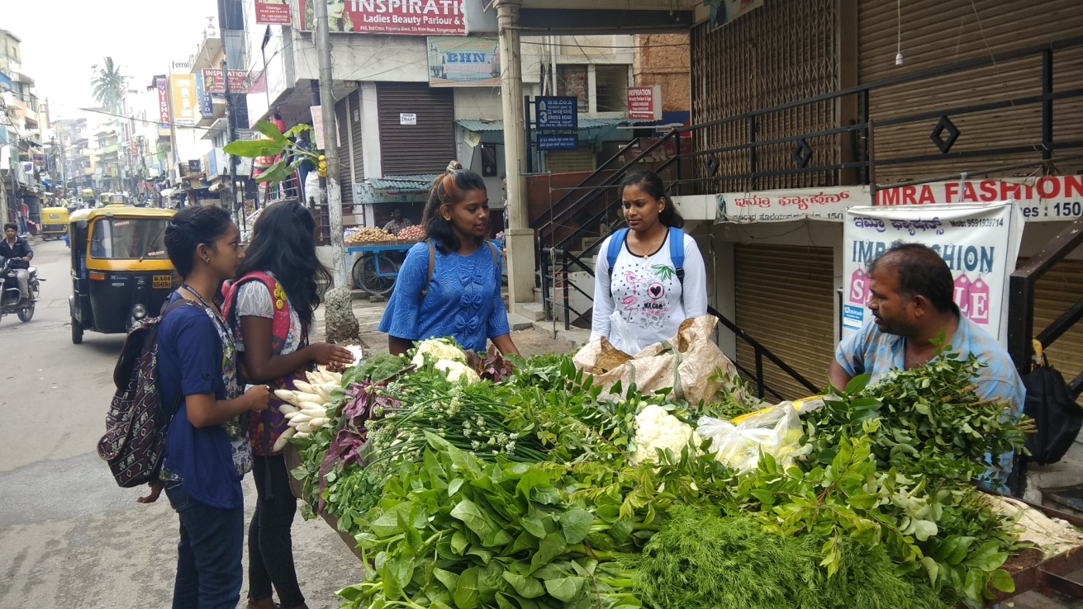
Day10: Sunday, 10-Sep-2017 (Care for the Surroundings)
One of the most hazardous waste is medical waste; to study and the waste disposal and cleanliness in the Government Hospital, a team of volunteers were sent to Minto Opthalmic Care Centre at VV Puram. Our Volunteers interacted with Hospital Authorities about the waste disposal and response was very good in terms of care for environment. Also, few volunteers had got the eye checkup done to know about the treatment methods and equipments usage. By and large the Hospital premises was well maintained.
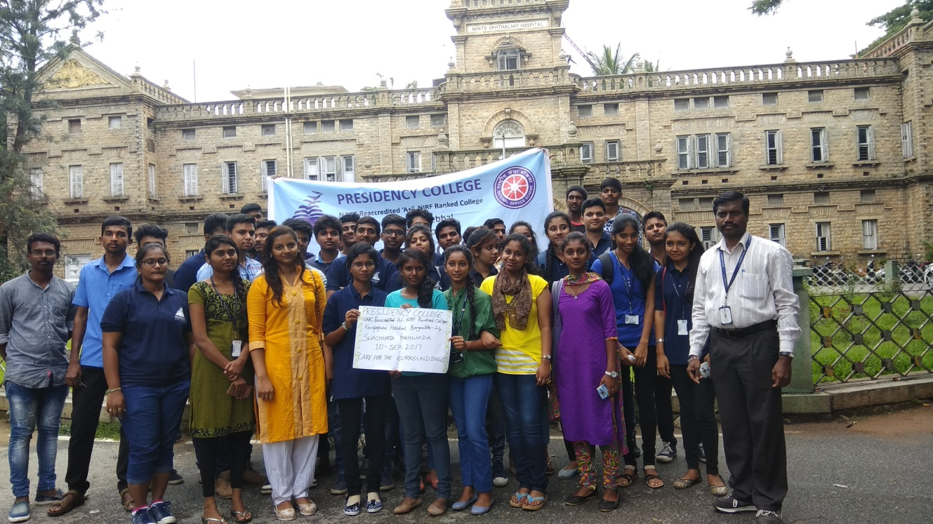

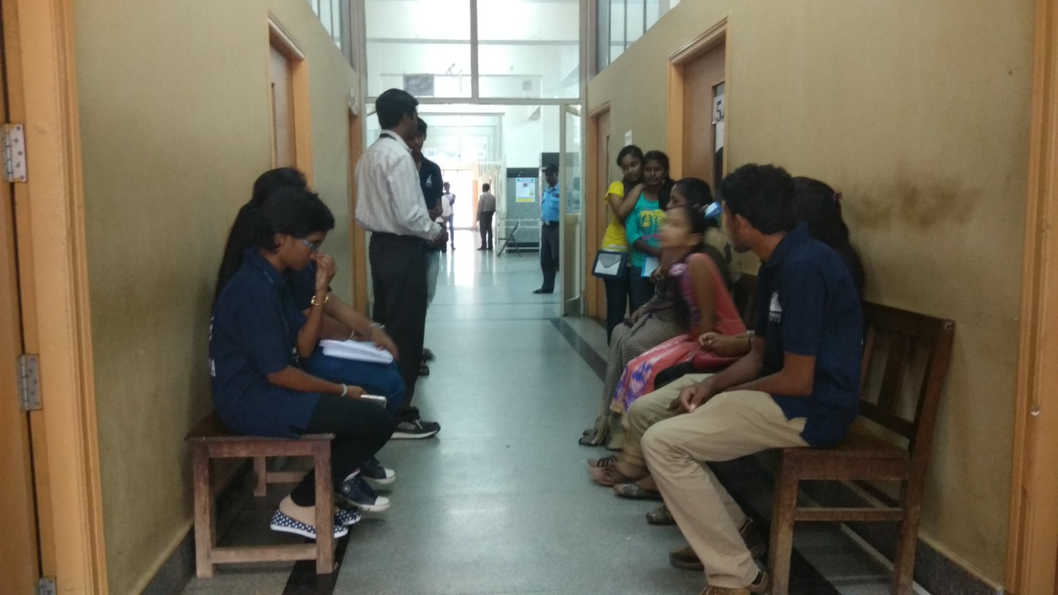
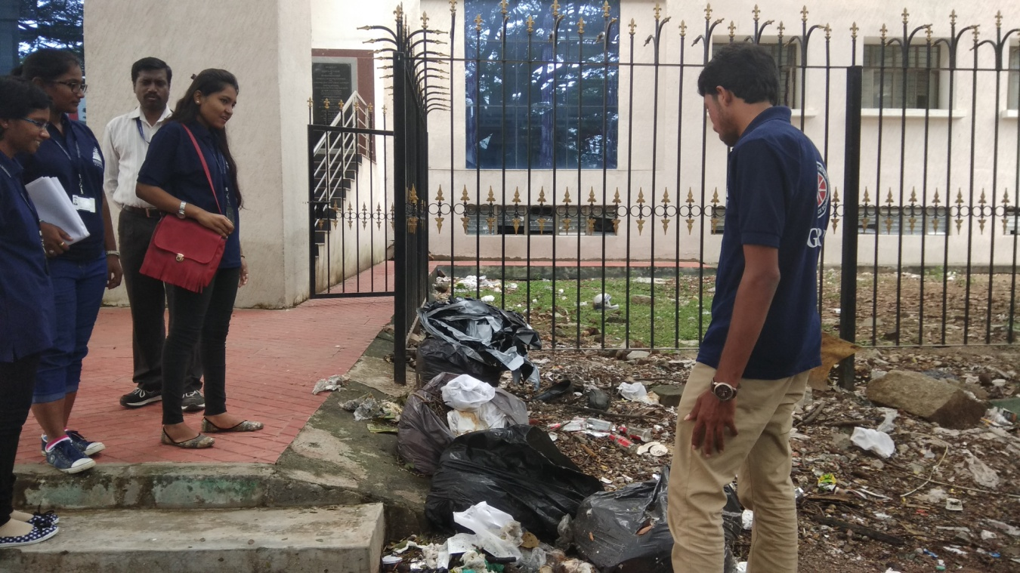
Day11: Monday, 10-Sep-2017 (Care for the Surroundings – Orphanage Visit)

A philanthropic visit as a part of Swachhata Pakhwada (Care for the surroundings), was organized by NSS Unit of our College on Monday the 11th September 2017. As per the advice of Director and Principal, Presidency College, the NSS officer identified Vidyaranya (Rainbow Home for Girl Children) in Kodihalli, HAL 2nd Stage, Bangalore for the charity work. Faculty members and volunteers whole heartedly contributed for the same. Prof. Dr. Vidya Shetty, Director for Higher Education and New Initiatives flagged off the trip to the trust. Forty Volunteers and the NSS Officer and Prof Narayanaswamy, Head, Department of Computer Applications were ferried towards Rainbow Home. Although the stay was brief, the volunteers cherished moments with children of the home. The contributions (ration items and packed food) worth Rs. 20000/- (Twenty Thousands) were handed over to the person-in-charge.

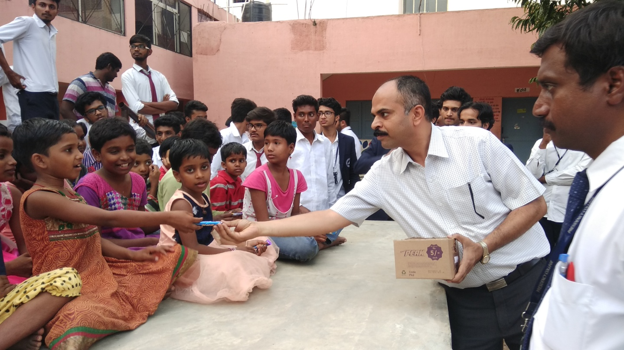
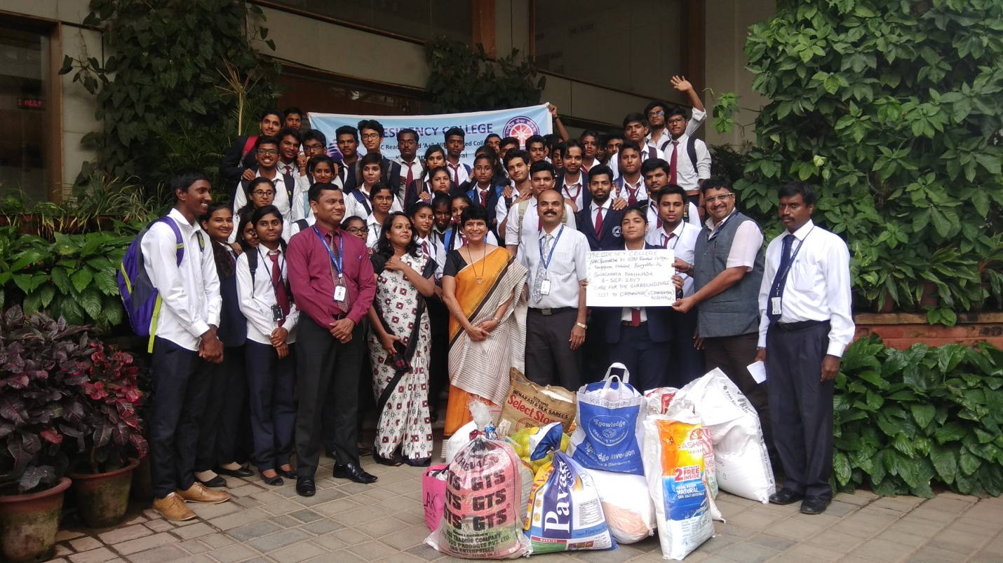
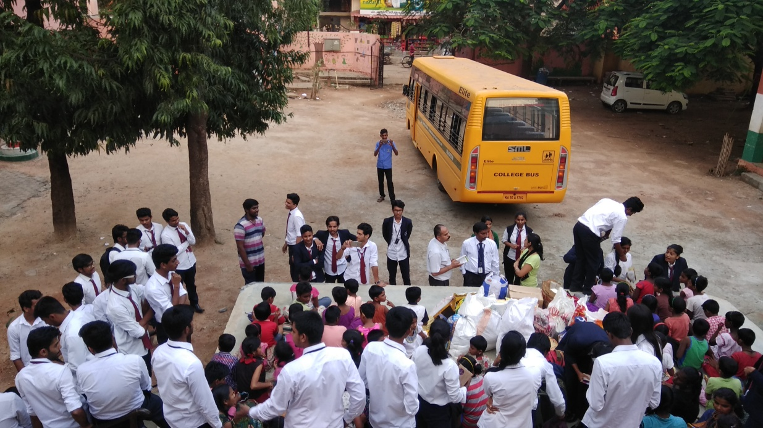

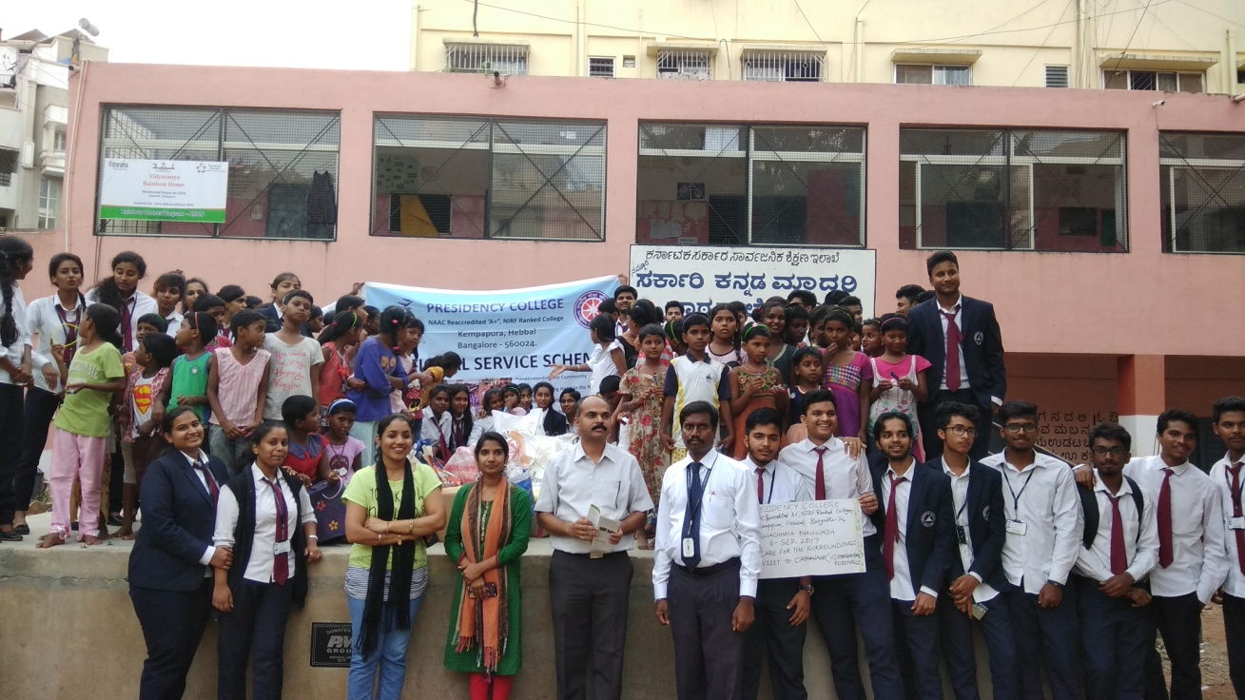
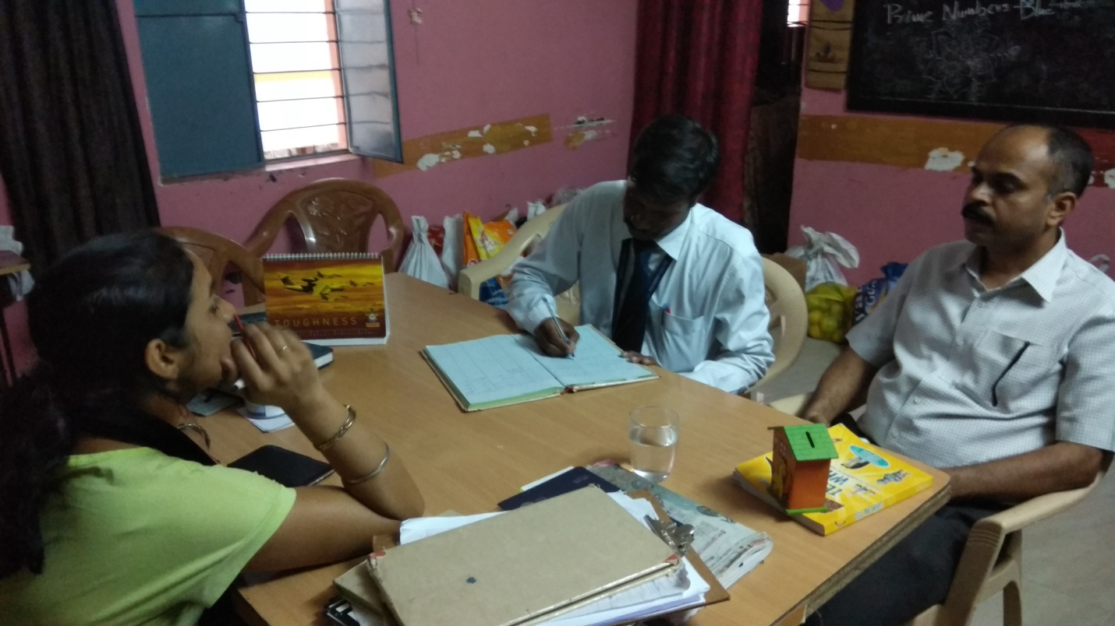

Day13: Wednesday, 13-Sep-2017 (Cleanest Hostel Room Contest)
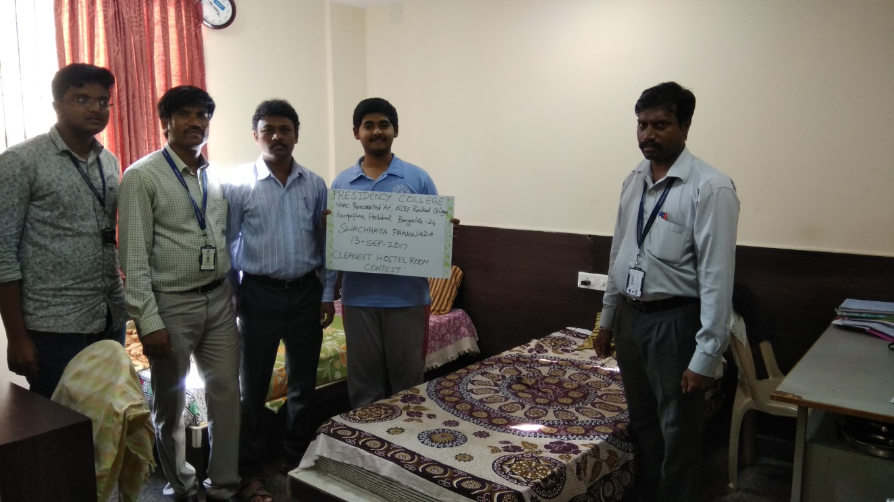
All the Students of our College Hostel had participated in “Cleanest Hostel Room Contest”. Students had been motivated to clean their rooms and surroundings. Although Housekeeping staff work in the Hostel Premises continuously to maintain the cleanliness, Students are instructed to maintain their belongings in orderly manner and facilitate the Housekeeping staff to clean the rooms. The judgment parameters such as clean, tidy, no bad odour, decorum, warmth in greeting the Guest are framed and conveyed the same. Amongst all the four Hostels, Mr. Gowtham from 1st semester BCom, had been selected as winner in this contest.

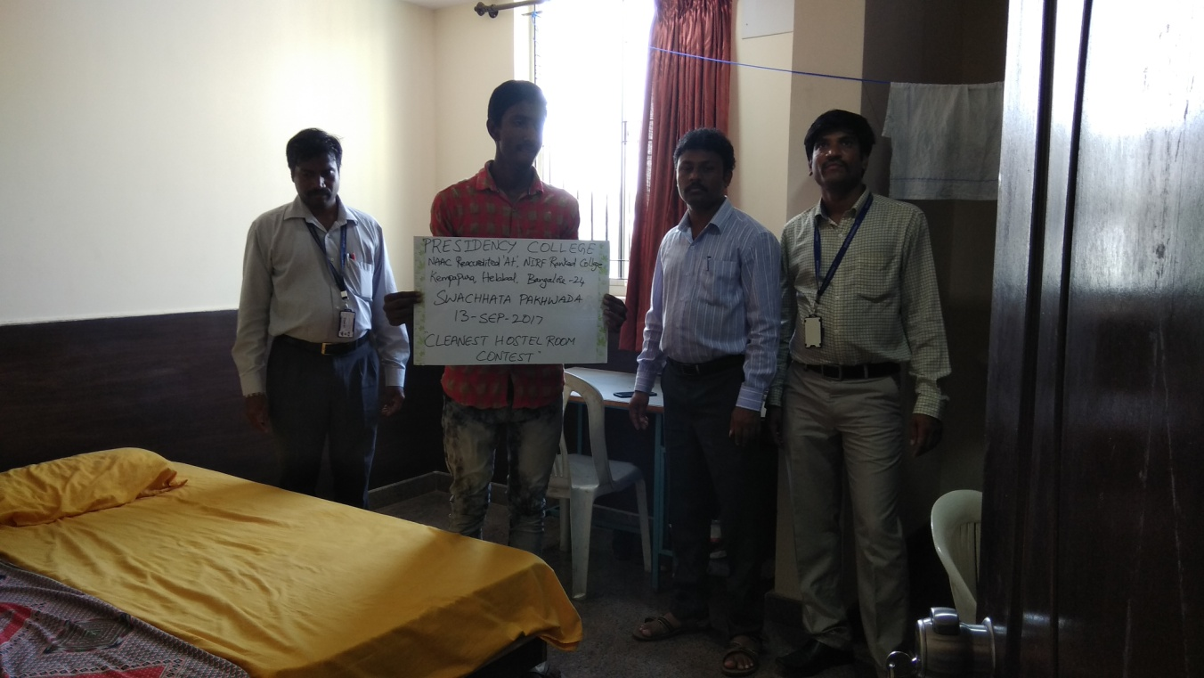
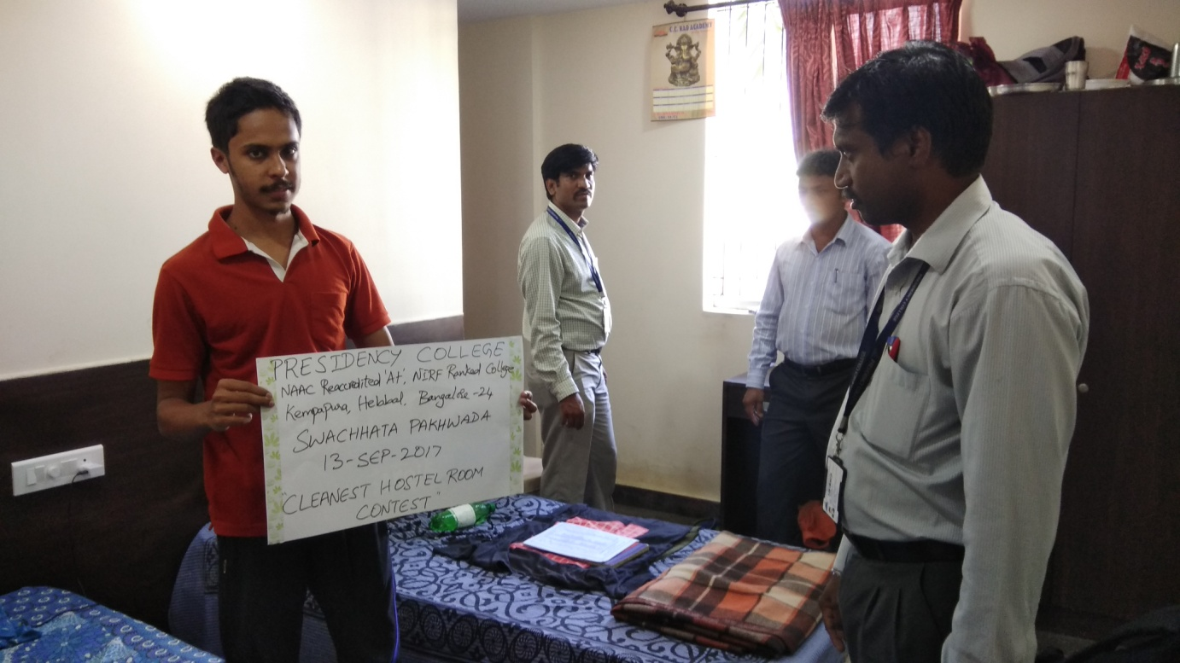
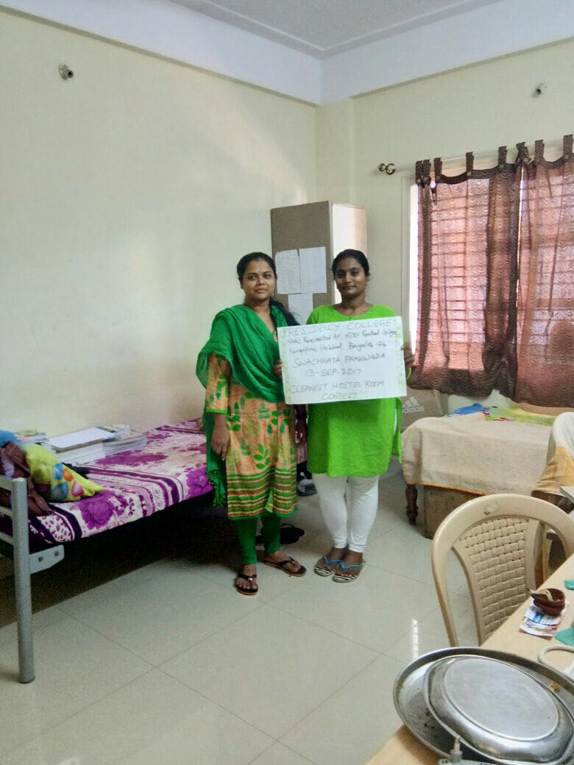
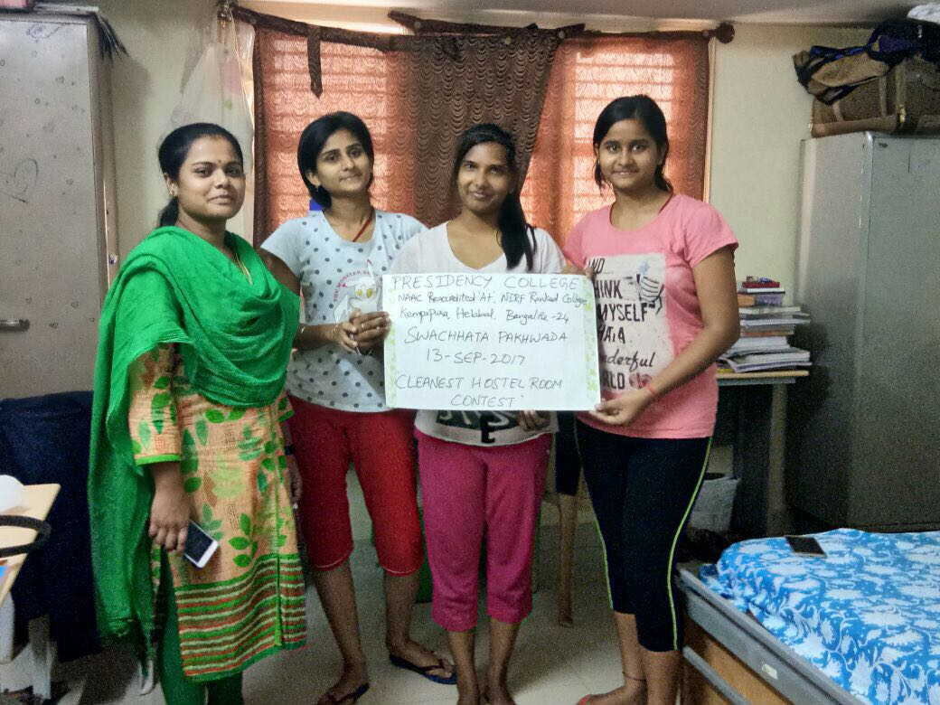
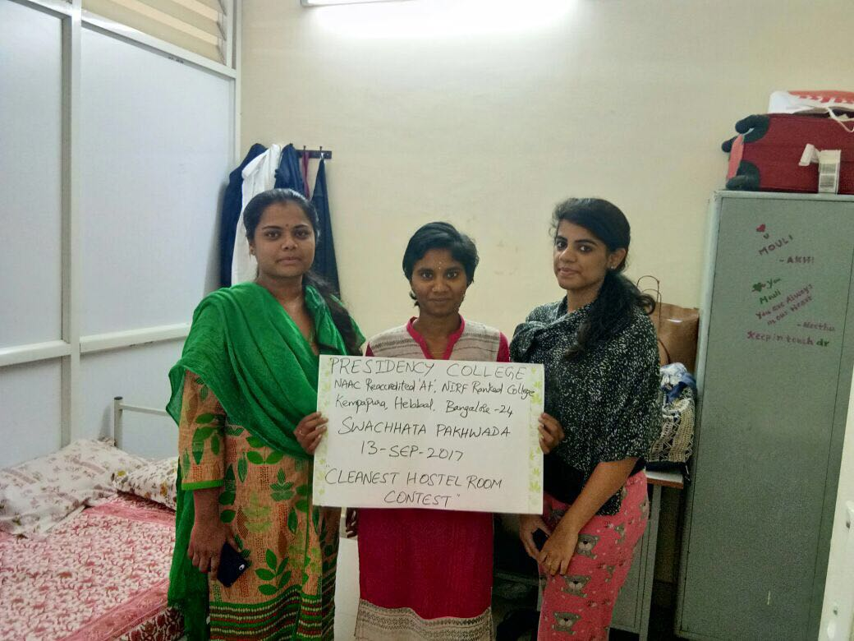
Day14: Thursday, 14-Sep-2017
(Care for the Surroundings – Blood Donation Camp)

A blood donation camp as a part of Swachhata Pakhwada (Care for the Surroundings) was organized by NSS unit in the college premises in association with Lioness Club, Sadhashivnagar and Lion’s Blood Bank from Vasanthnagar. Dr. Muddu Vinay, Director and Principal of our college, in the presence of Dr. Vidyashetty, Director, HENI, inaugurated the camp. Some of the NSS volunteers themselves had became donors; then they canvassed exhaustively to bring donors to the venue. There were 131 units of blood mobilized during the camp. Mr. Deepak, the head of team from Lion’s Blood Bank, a happy man extended his deep satisfaction to the director and principal, presented certificate as a mark of appreciation. Also, he presented a certificate to NSS officer with a sense of contentment. The donors and volunteers were also issued certificates.

