Report on Special Camp at Cheemangala
Sunday, 31-Mar-2019

The NSS unit of Presidency College conducted a special camp for eight days at Cheemangala, a village in Sidlaghatta taluk of Chikkaballapur district from 24th march 2019 to 31st march 2019. The main objective of the camp was to mould the volunteers in to disciplined and responsible citizens.
Inauguration ceremony
The camp commenced with the inauguration and lamp lighting ceremony by co-ordinator of NNS, Bengaluru central university and village authorities. The cultural event also had programmes hosted and performed by volunteers. Dr. Govinda Gowda, co-ordinator of NSS, Bengaluru central university and Mr. Narayana swamy, panchayat vice president had addressed and motivated the volunteers to give their best in their endeavours to serve the cause.

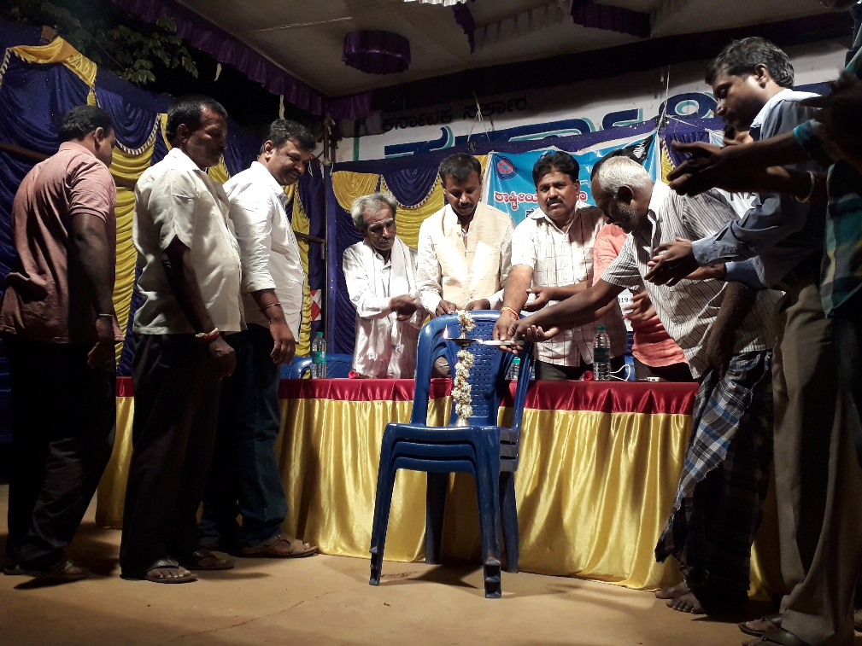
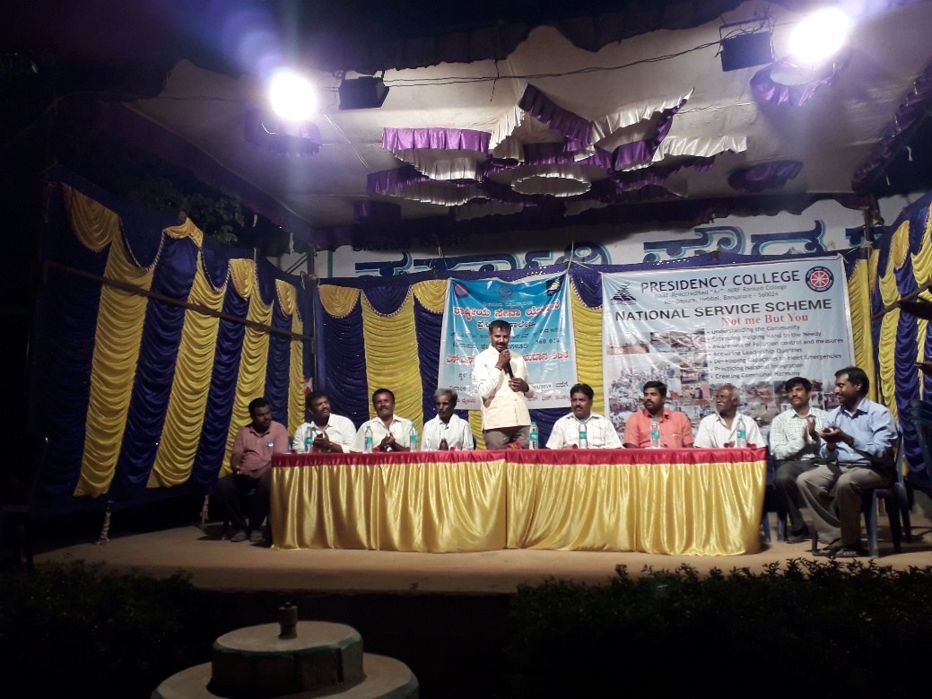
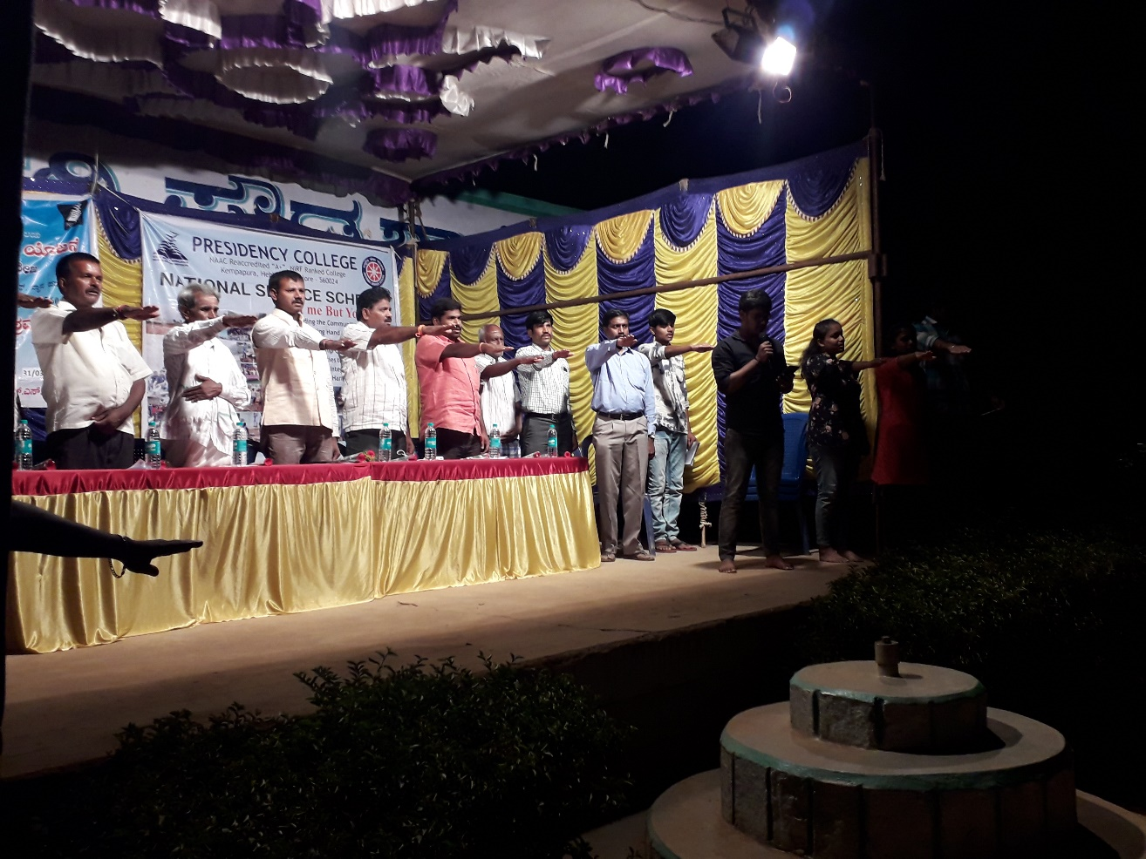

Camp Work - Shramadhan
The volunteers primarily focused on instigating a sense of cleanliness and hygiene in the minds of the residents of the village and to eradicate liquor and tobacco consumption. The volunteers did camp walk during the morning session which involved the cleaning of the roads, drainages, schools and different temple premises. In the afternoon session guest lectures, visit to prominent places and sports activities were scheduled to keep the volunteers involved and informed on various topics and also to relieve them of their tough schedule.
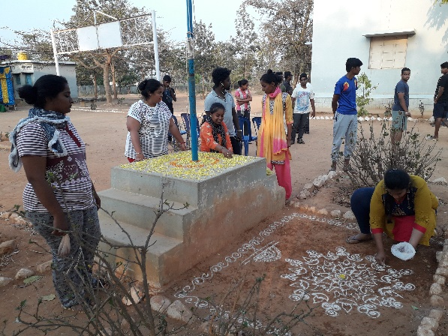
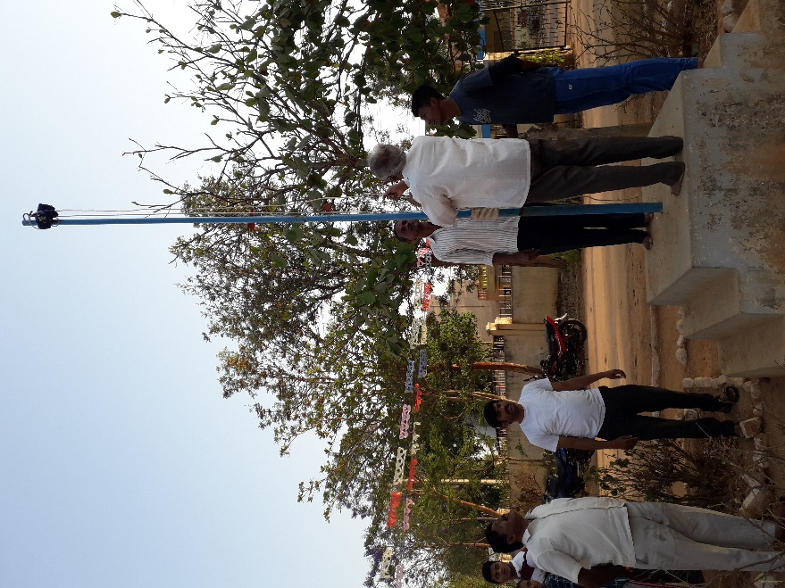
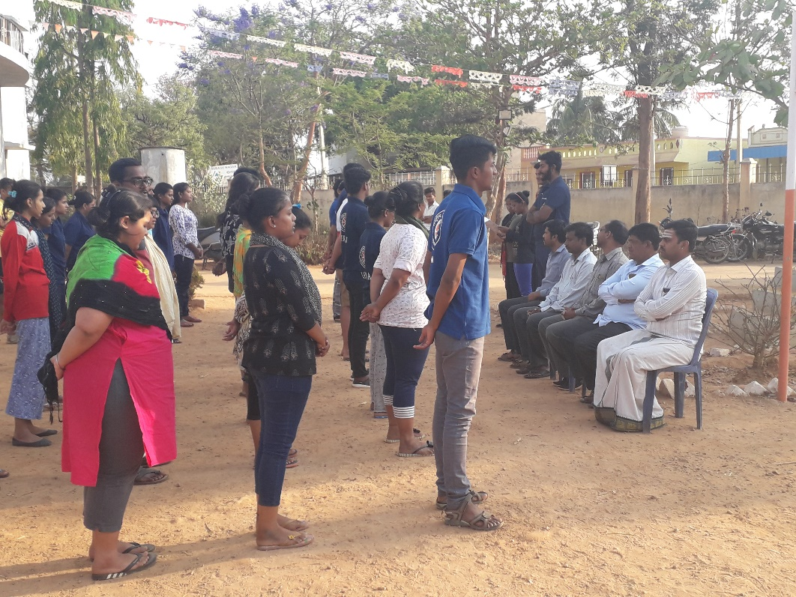
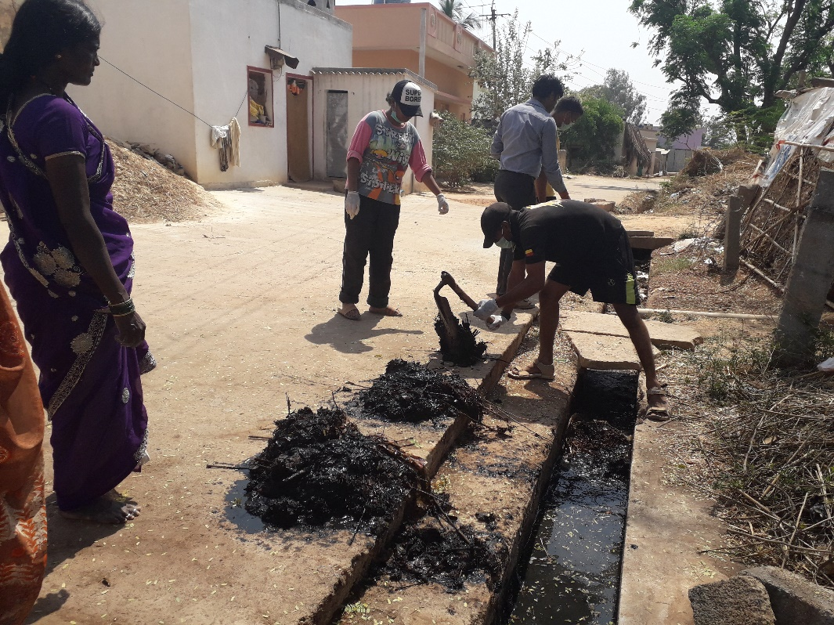
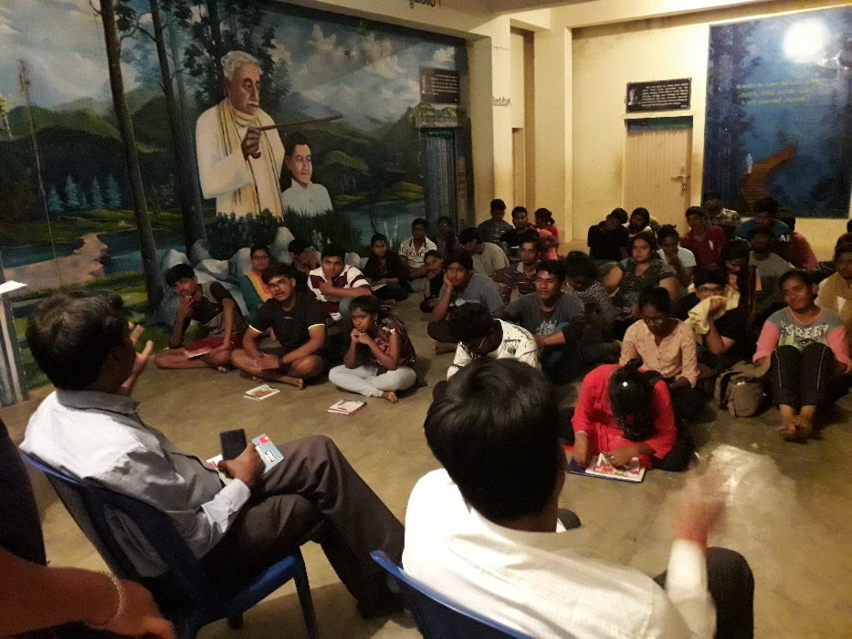
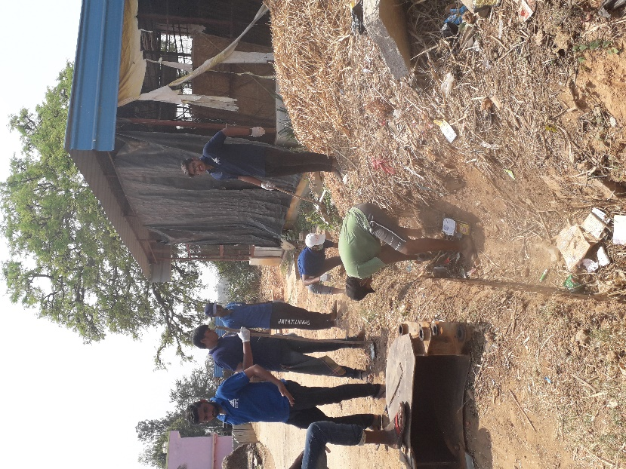
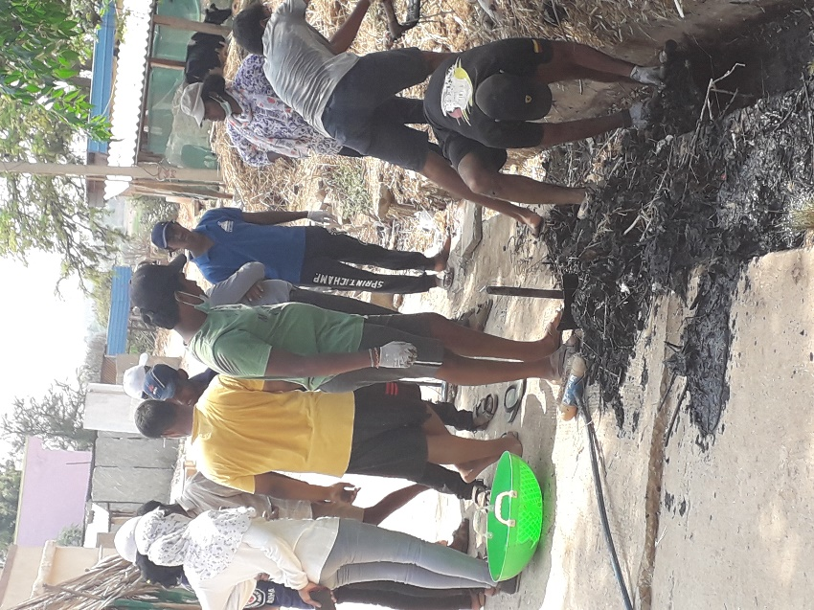

Cultural Programmes
The volunteers educated and entertained the people of the village by hosting a series of cultural programmes every day in the evening. Dramas and skits, dances and song programmes were performed.

Farmhouse visit
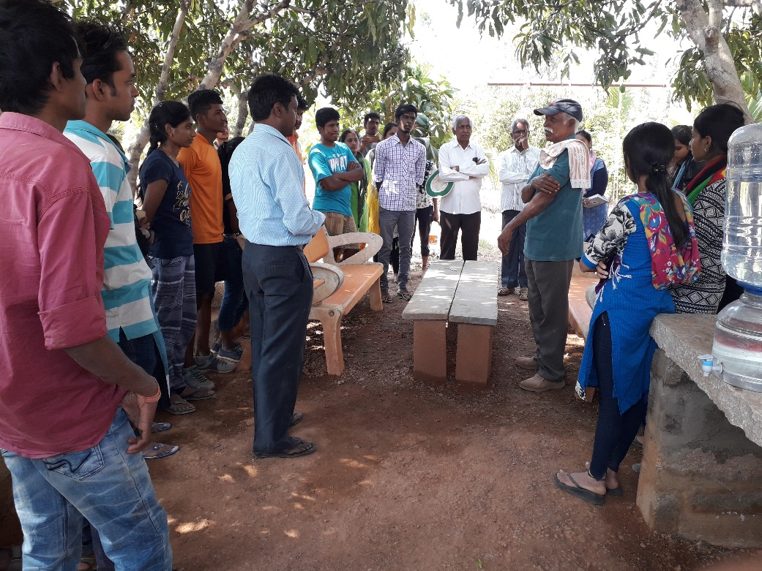
The volunteers were also taken to one of the farm houses to give them some insights on organic and natural farming and were also given practical knowledge on various techniques of agriculture. It was arranged on the third day of the camp, 26th march 2019. The farmhouse is owned by prof. Anand of Thippenahalli village. The venue was approximately 8 kms away from the camp site. The commute was taken care by a couple of volunteers.
The volunteers were exposed to various types of farming like dryland farming, mixed farming, natural and organic farming, horticulture, apiculture and use of algae in farming. The volunteers were also introduced to effective agricultural techniques like vermicomposting, drip irrigation, grafting, tissue culture and the usage of crop protection nets. The volunteers interacted enthusiastically with the professor and his counterparts and asked questions regarding the topics of discussion. They explored the farm and were given refreshments by the host.
Health camp
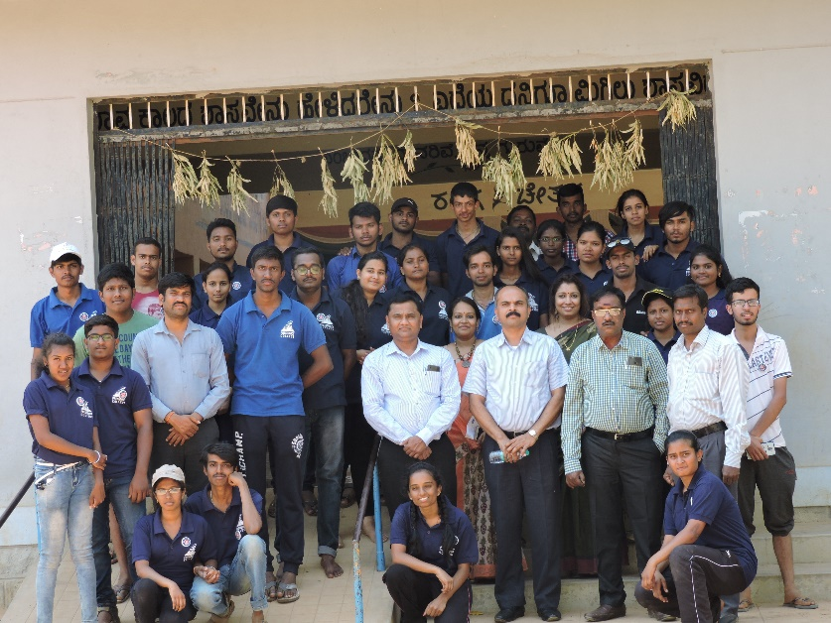
On the 5th day of the camp, 28th march 2019, a health camp was conducted for the villagers in collaboration with Aveksha hospitals. During the health camp, diabetic screening, blood pressure checkup, weight analysis and consultation by general physician was done free of cost. The residents of the village were encouraged to be an active part of the services provided.
People of all ages were seen in the vicinity taking advice from the general physician, Dr. Pankaj. The services provided were weight analysis, diabetic screening and blood pressure checkup.
The residents were thankful to be a part of the event and around 125 members had attended. They were satisfied with the services provided and the camp was also visited by the Principal Dr. Pradeep Kumar Shinde and all the heads of departments of Presidency College. The staff were delighted by the enthusiasm shown by the volunteers.
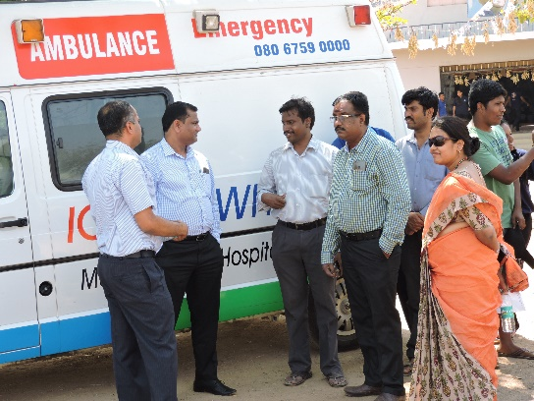
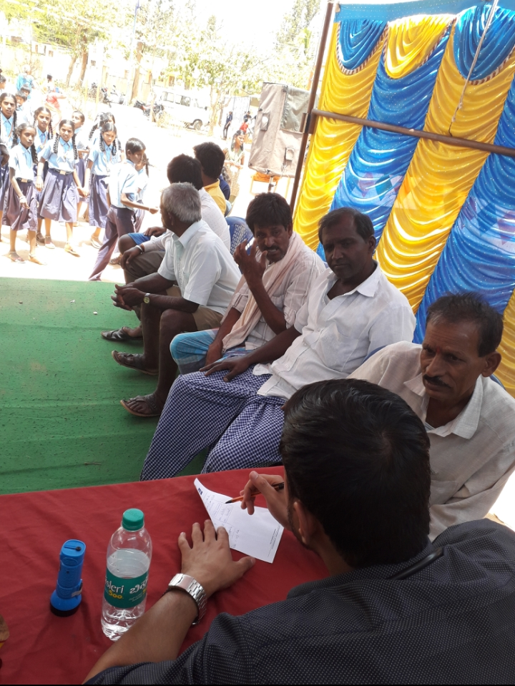

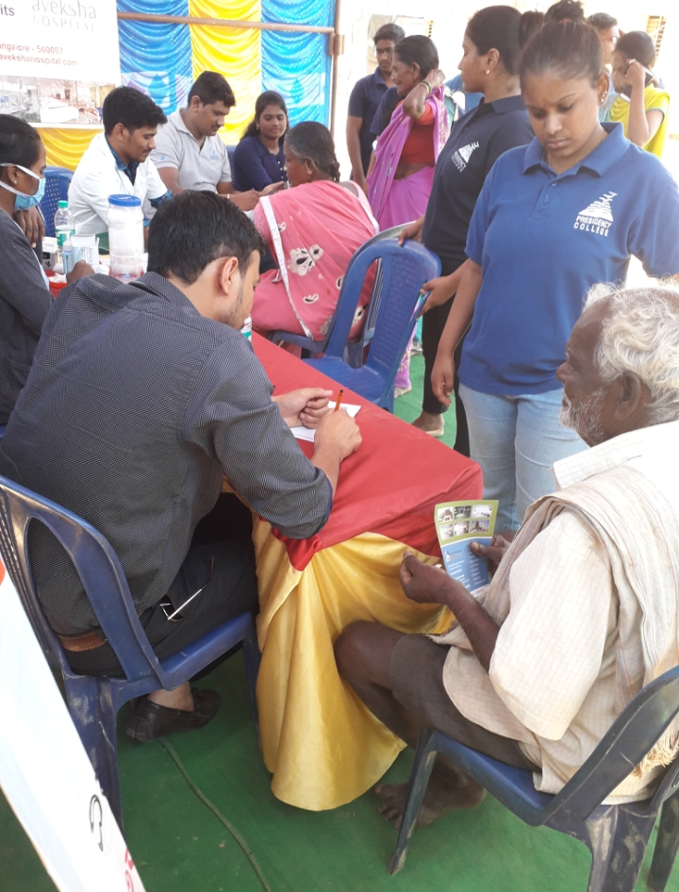

Sports day
The NSS unit conducted the sports day for the primary school students of Cheemangala Village on 30th march 2019, from 11.30 onwards and the students of the elementary school took part in various competitions like tug of war, running race, rangoli competition, biscuit race etc. The winners were awarded with prizes.
The volunteers were extremely enthusiastic throughout the camp to render their services and learnt many aspects of leadership and camaraderie.

