NATIONAL SERVICE SCHEME
A Visit to Old Age Home

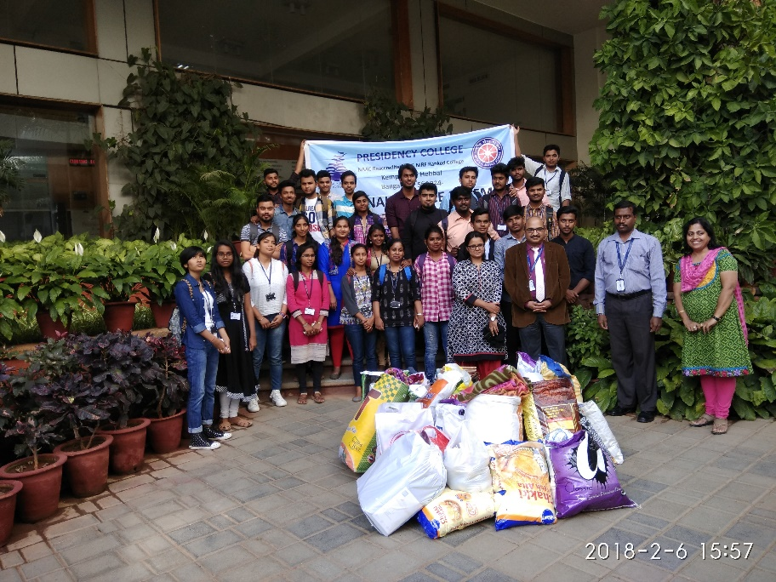
A philanthropic visit to Cheshire (Old Age Home) was organized on Tuesday, the 06th February 2018. NSS Volunteers had generated funds from fellow friends and staff members of our College to donate to the inmates of the Home. Clothes (New and Old), Blankets, Rubber Sheets, Fruits and Ration items all put together worth fifteen thousands were donated. Volunteers accompanied by the Programme Officer Mr. Pachayappan and a Faculty member Ms. Fiza were ferried to Home. Volunteers happily distributed all the things to the inmates. Also, to entertain the inmates, our Volunteers had performed few cultural such as singing, dancing and mimicry.

