Report on NSS Day Celebration and Competition for Volunteers
Wednesday, 30-Jan-2019

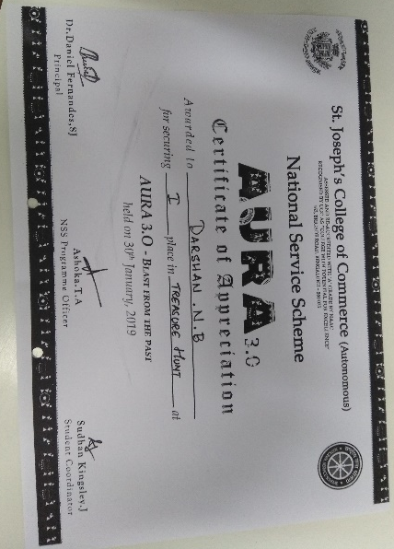
A unique style of fest called Aura was hosted by St. Joseph’s College, which involved competitors only the NSS volunteers from various colleges in the city. All the events conducted were based on social service activities. Our NSS volunteers had participated in six different activities and won first place in Treasure Hunt and second place in Rural Fashion Show. Activities of these types provides an opportunity for our Volunteers to understand problems faced by people in rural parts of India.
