International White Cane Day Contribution
Tuesday, 14-Aug-2018

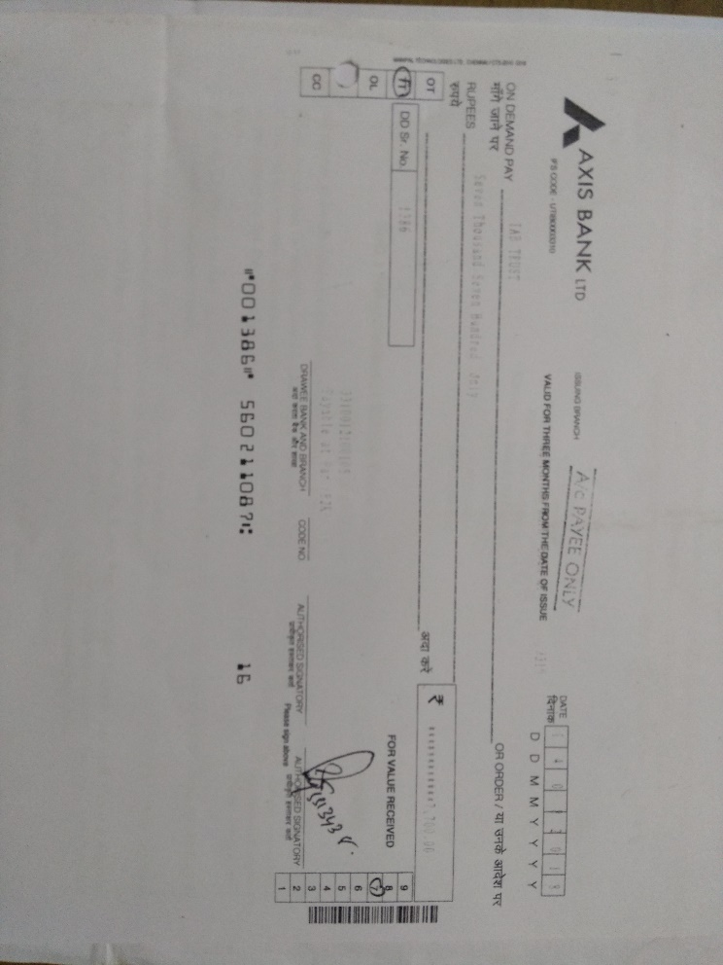
The NSS Unit of Presidency College had raised funds for contributing to education for visually challenged Children. Our Volunteers had raised seven thousand seven hundred rupees by selling 1500 flags. Details are given as below:

