Report on Computer Donation to Belaku Academy
Sunday, 7-May-2019

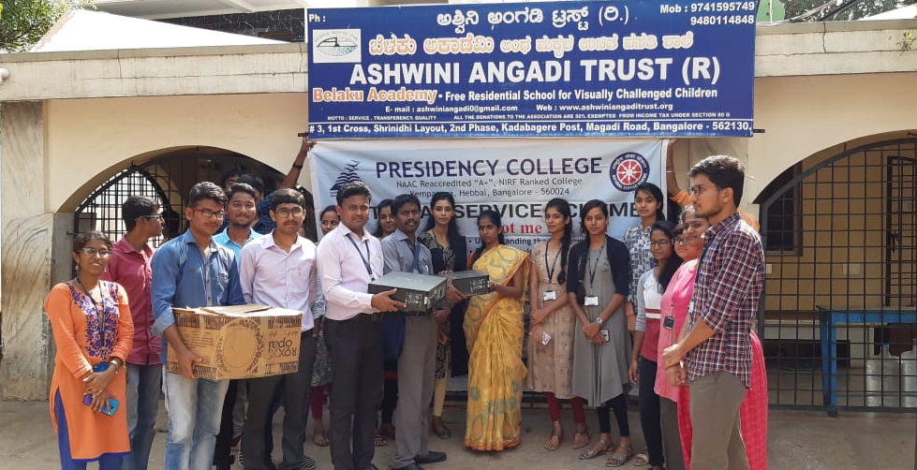
Presidency College is known for its social responsibility, as a part of it, two desktop computer systems were donated to Belaku Academy, a school for visually challenged students situated in Kadabagere Village, off Magadi Road, Bengaluru. Our Vice Chairman, Mr. Suhael Ahmed and our Principal Dr. Pradeep Kumar Shinde were kind enough to approve as soon as the request was raised. Our NSS Volunteers, accompanied by NSS officer and two staff members went to school with a sense of humanity and charity, handed over the Computer Systems to Ms. Ashwini Angadi, the founder of School. The sense of gratitude was apparently seen in the smiles of school authorities. Ms. Ashwini Angadi felt happy on receiving computers eventually her students will be benefited immensely.

