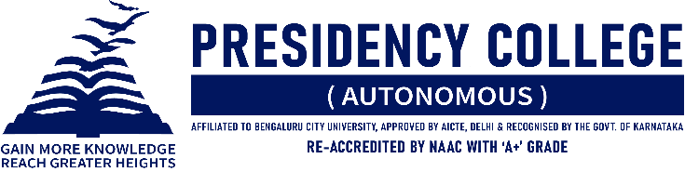

IT CLUB – TECHNOZIA – 2022
Program Name: Yuva Vignan Youth Confluence
Date: 22/07/2022
Time/ Duration: 1 Day
Total Number of Participants: 12
Name of Resource Person(s)/ Organization: Soundarya Institute of Management and Science
Venue: Soundarya Institute of Management and Science
Departments of Computer Science and Pure Science organized a Science & Technology Empowerment Program, the Yuva Vignan Youth Confluence. In order to recognize the significance of youth in the advancement of sustainable development, they organized Fest. There were events such as Ideathon, Fireband Talk, Article Writing, Poster Presentation, and Animation Video.

EVENT | PARTICIPANT | POSITION
Fireband Talk | Ritika Vashist,  Shubham Saurav | Winners
Article Writing | Ritika Vashist,  Shivraj Patare | Winners
Poster Presentation | Ritik Makhija,  Ameesha Charaniya | Runners Up
