IT Fest- 2K19
Program Name: Intercollegiate IT Fest
Date: 25/3/2019
Time/Duration: 1 day
Total Number of Participants: 12
Name of Resource Person(s)/Organization: Seshadripuram College
Venue: Seshadripuram College
The students of DCA Department took part in an Intercollegiate IT Fest held on 25-03-2019 at Seshadripuram college, Bangalore. They exhibited their talents and skills and won several prizes in the fest. They had put up their great effort and skills, the students won the overall winners trophy for the college.
EVENT | WINNER
IT Quiz | 1ST –ASHISH  -NAIF
CODEING AND DEBUGGING | 1ST –UTPAL  -ANVIKA
App Development | 1ST –ANVIKA  -NAIF
Typing | 1ST-JAIMIN
Treasure Hunt | 1st –SANGAM  -ASHISH  -ASNA  -DRUPAD
Photography | 2nd – Akash Jyoti
Culturals | 1st- Tarun

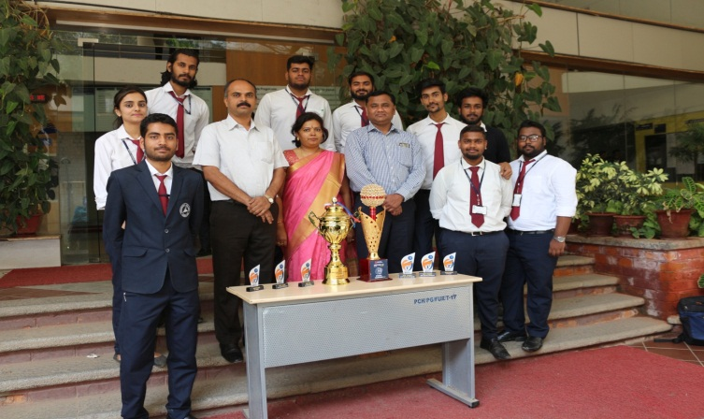
Overall championship at Seshadripuram College Bangalore

