Presidency College
Reaccredited 'A+' by NAAC
NIRF Top 100 Ranked College
Kempapura, Hebbal, Bengaluru – 560024
www.presidencycollege.ac.in

Department of computer Applications .
IT-CLUB -TECHNOZIA
IT Club TECHNOZIA of the Department Of Computer Applications had conducted a Poster design competition on 9/2/2019 for the II and IV semester BCA students to enrich their knowledge in the field of IT. It was organized to identify the hidden talent and extraordinary skills of the students.
We got overwhelming response from IV semester BCA students.The number of students who took part in the event are 7, of which six in teams of three and one student individually participated.
The judges for the event was Dr.Alli.A and Dr.Deepa . They appreciated all the participants for their active participation and their creativity. The award winning poster design done by one of the participants is enclosed in this document.
The participants details are as follows:
1.Team 1 : Mr.Md.Sadiq – 4 BCA ‘A’
Mr.Mayank Sekhar Mishra - 4 BCA ‘A’
2.Team 2 : Mr.Manish Kumar Verma - 4 BCA ‘A’
3.Team 3 : Mr.Mahesh.R - 4 BCA ‘A’
Mr.Arif Noufal.T - 4 BCA ‘A’
4.Team 4: Mr.M.Sasithar – 2 BCA ‘A’
Mr.Vijay.S – 2 BCA ‘A’

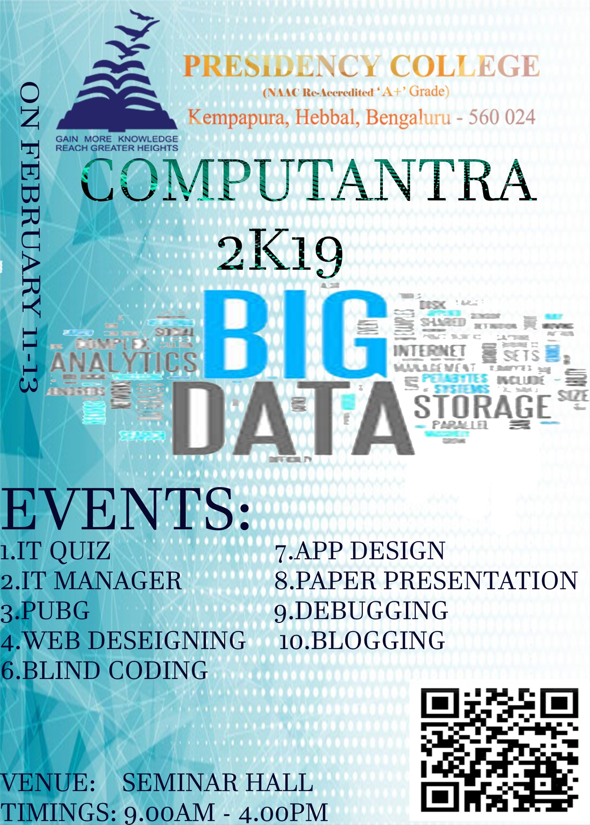

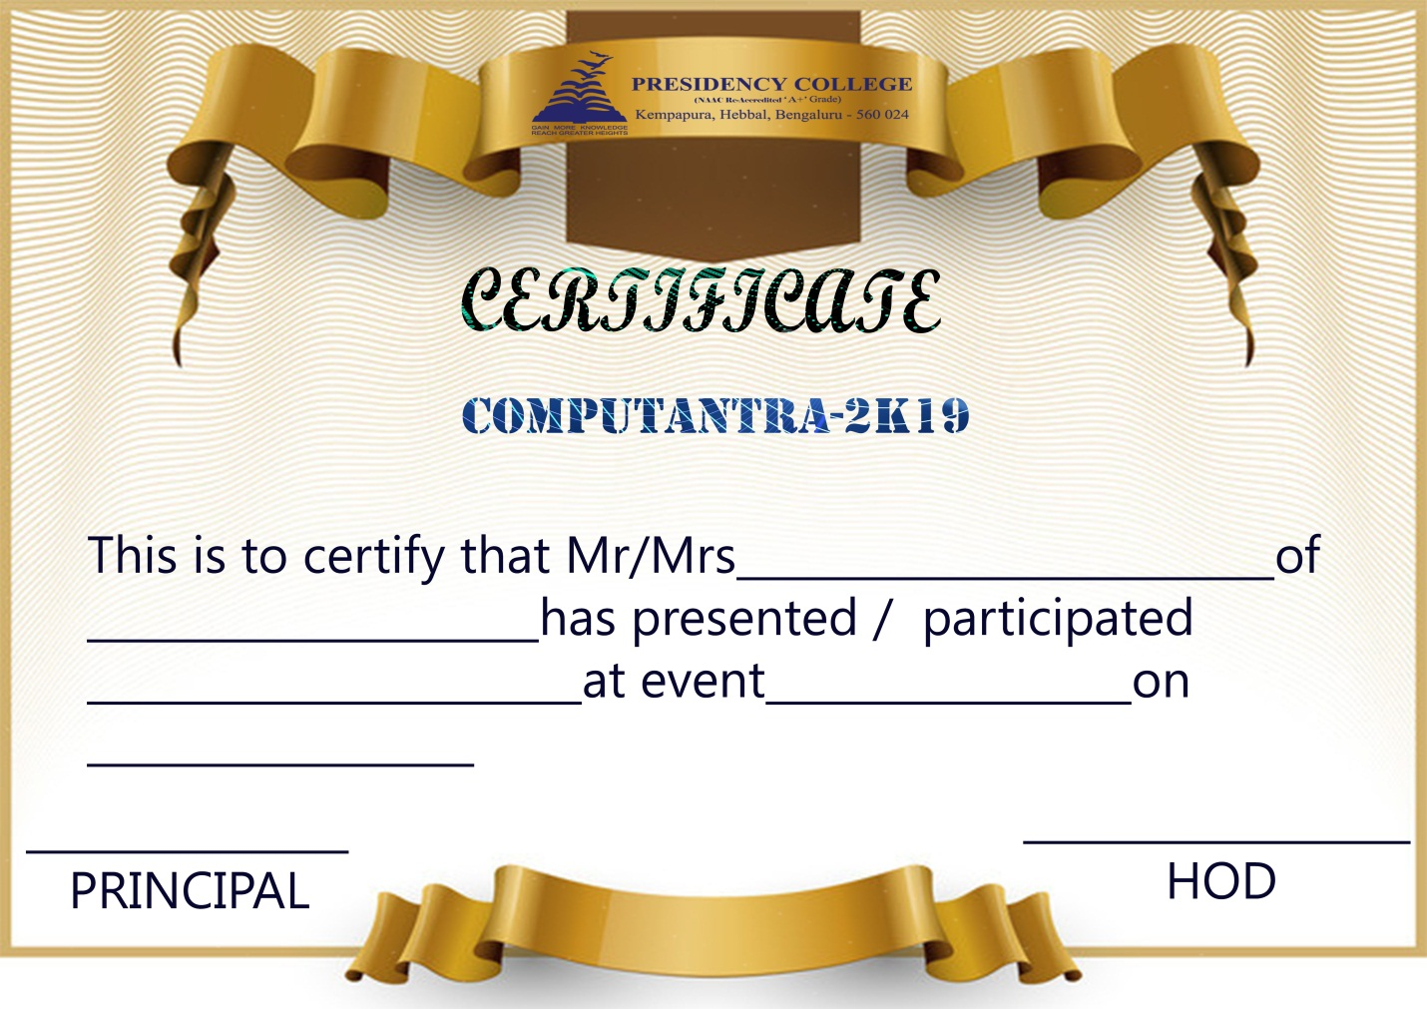

The winners details are as follows:
Mr.Mahesh and Arif- IV BCA ‘A’
Mr.Sasithar and Vijay-II BCA ‘C’

