IT Fest- 2K19
Program Name: Intercollegiate IT Fest
Date: 28/3/2019 and 29/3/2019
Time/Duration: 2 days
Total Number of Participants: 15
Name of Resource Person(s)/Organization: MSRIT College
Venue: MSRIT College
The students of DCA Department took part in an Intercollegiate IT Fest held on 28-03-2019 and 29-3-2019 at MSRIT, Bangalore. They exhibited their talents and skills and won several prizes in the fest. They had put up their great effort and skills, the students won the overall winners trophy for the college.
EVENT | WINNER
IT Manager | 1ST –Tushar
CODEING AND DEBUGGING | 2nd –UTPAL  -ANVIKA
IT Quiz | 2nd –ASHISH  -NAIF
App Development | 1st –SANGAM  --Siddharth  -Shyam

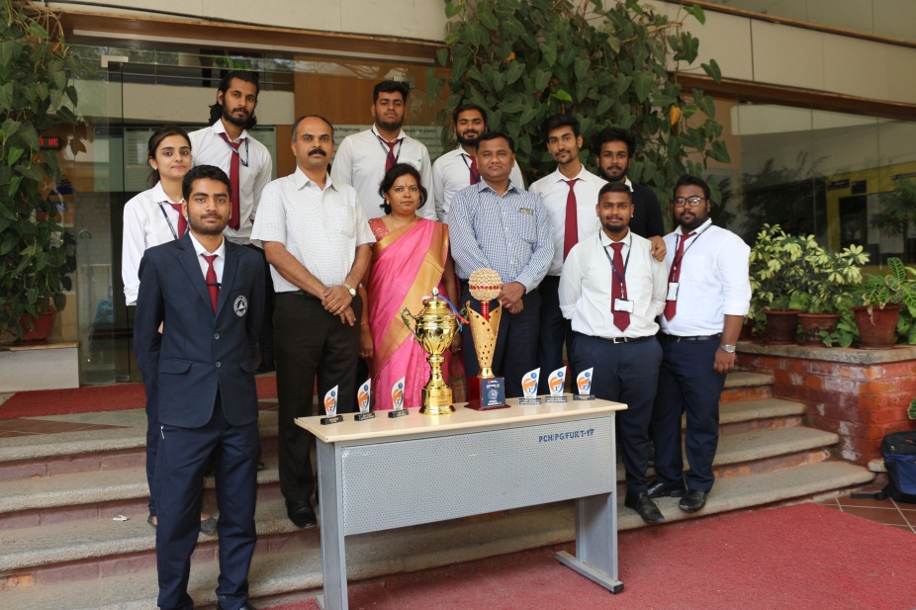
Overall championship at MSRIT Bangalore

