PRESIDENCY COLLEGE
Kempapura, Hebbal, Bangalore – 560024
Reaccredited ‘A+’ by NAAC
NIRF Ranked College
IT Fest-Computantra-2017,Edition-VI
The Department of Computer Applications had organized an intercollegiate IT fest on August 22nd and 23rd in the college premises. The theme for the fest was “CIPHERTECH” which is a perfect blend of innovation and cybersecurity. We had received an overwhelming response from various colleges in Bangalore. The Chief Guest for the inauguration ceremony was Dr.M.Hanumanthappa – Chairman of MCA programme Bangalore University, Guest of Honor was Mr.Venugopala-Sai Kalyan Builders.
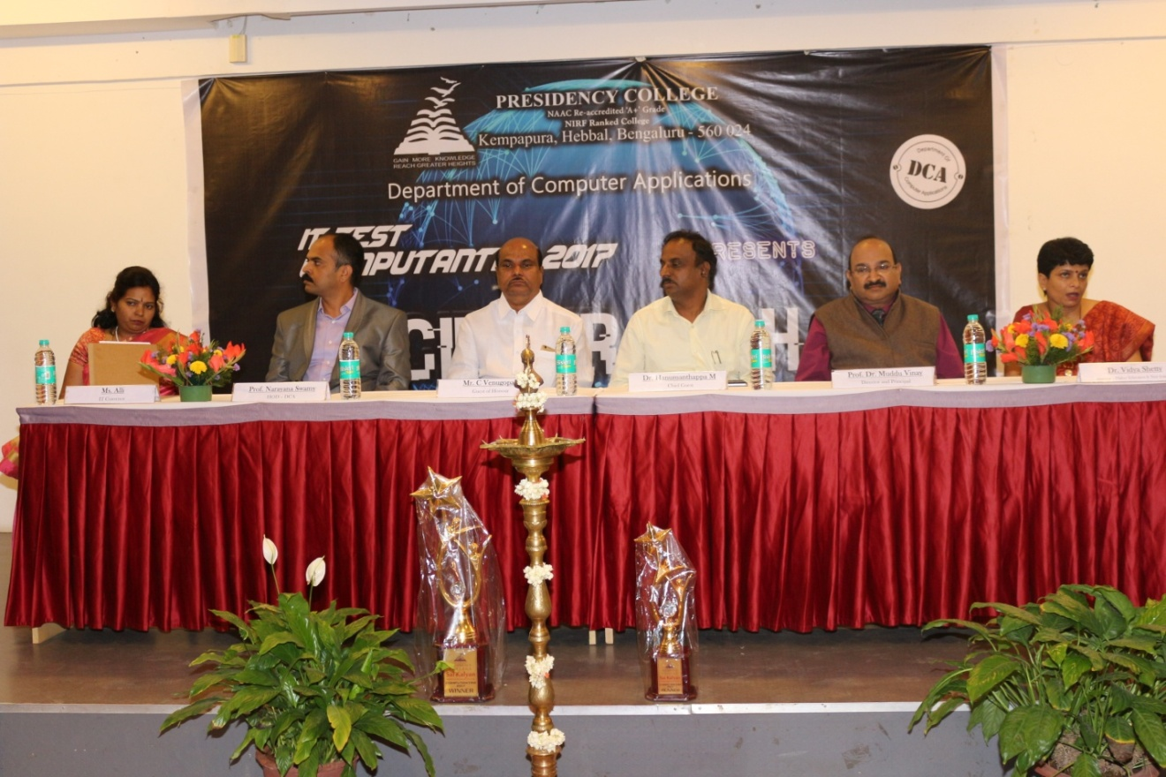
Inaugration –Chief guest Dr.M.Hanumanthappa,
The events that were held on the first day were Gaming, Coding and Debugging, Photography, Movie making, That’s my App, Cybersecurity-Exploit it , Web Designing, JAM’D and IT-quiz.The preliminary rounds of IT-Manager were conducted on the same day.
The events that were held on the second day were the finals of Web-designing , IT-Manager, Cybersecurity-Exploit-it, Gaming, Photography and Movie making. The total number of participants were 301 from 20 different colleges who actively took part in various events to prove their skills and knowledge they had acquired other than academics.
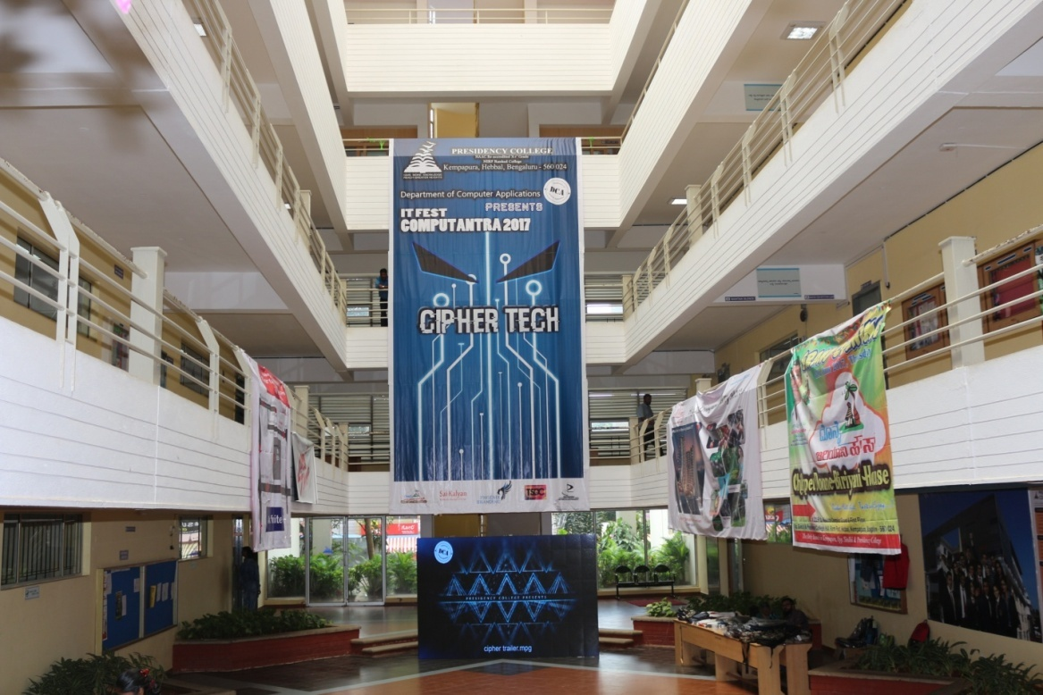
The facts and figures behind this sixth edition of Computantra, 2017 is tabulated below.
Total No. of colleges participated | 20
No. of students participated in gaming events | 156
No. of students participated in IT events | 155
Total No. of students who attended IT FEST | 301
EVENT DETAILS:
S.NO | Event Name | Number of teams | Number of participants
 | JAM’D | 7 | 14
 | Web Designing | 15 | 30
 | Cybersecurity | 15 | 30
 | That’s my App | 7 | 14
 | Coding and Debugging | 20 | 40
 | IT-Quiz | 12 | 24
 | IT-Manager | 7 | 7
 | Photography and Movie Making | 31 | 31
 | Counter Strike | 19 | 96
 | Mini Militia | 15 | 60

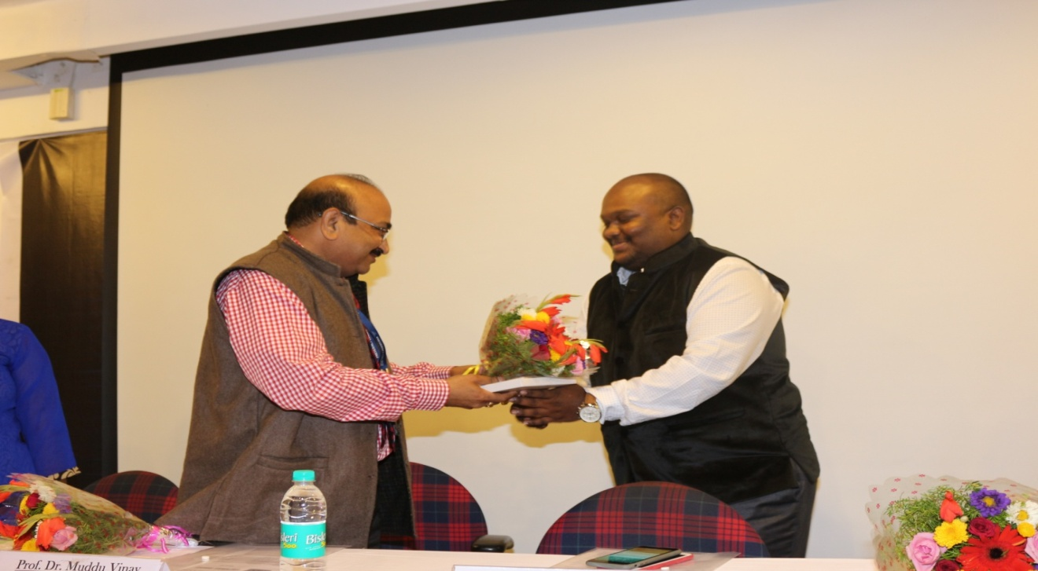
The Chief guest for the Valedictory was Director /Principal Professor Dr. Muddu Vinay , Guests of Honor was Mr Sangarsh and Mrs Vidyabharthi Harish.
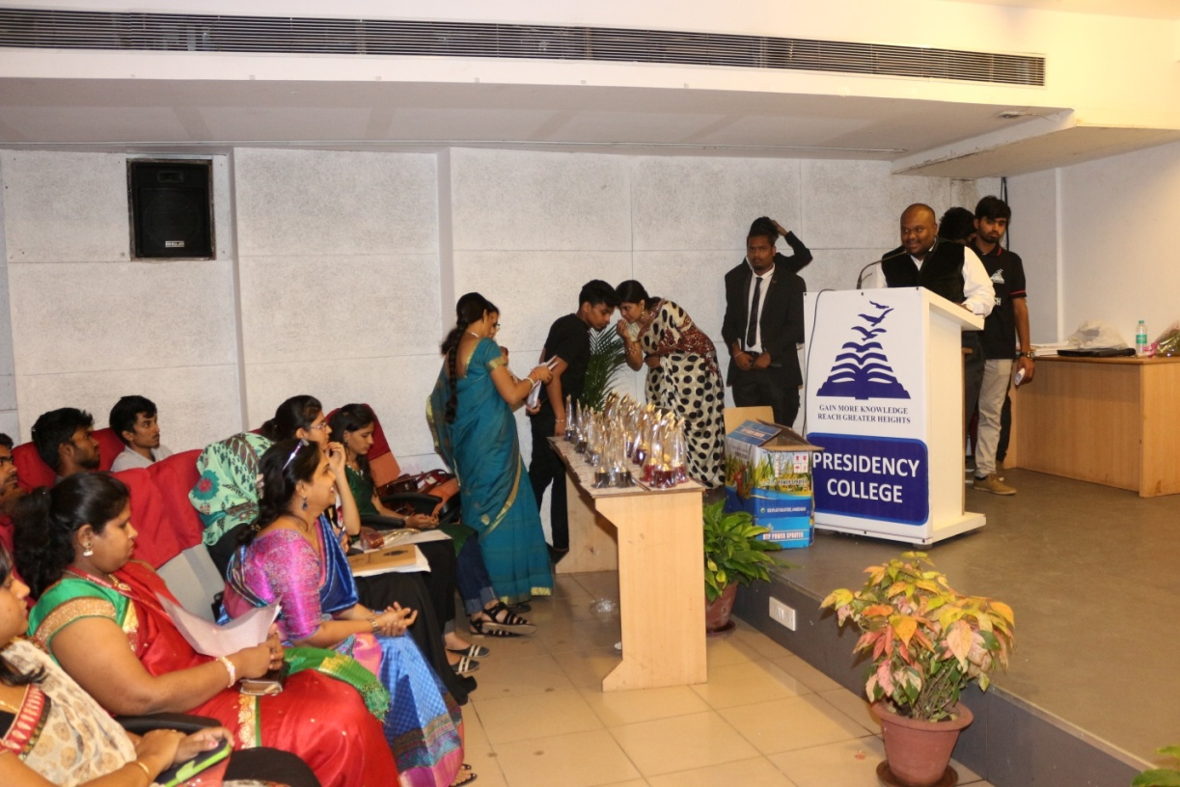
The Overall Winners trophy was bagged by Kristu Jayanti College whose participants exhibited exceptional IT Skills and expertise, followed by Mount Carmel College College who took the Overall Runners up trophy.
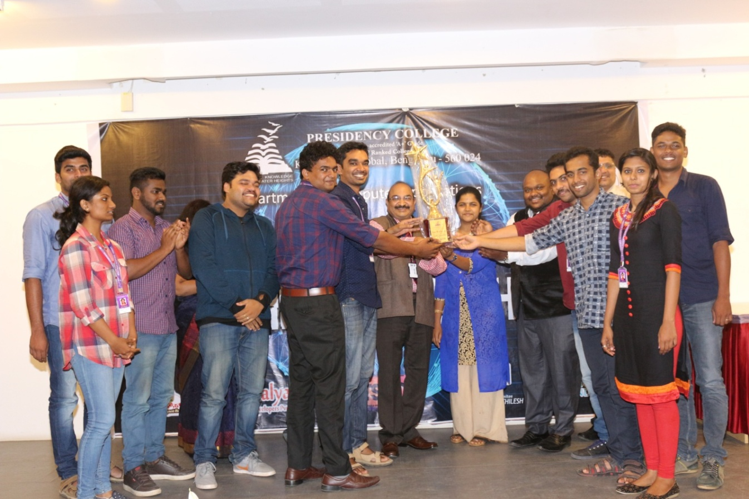
The list of Colleges who took part in our IT-fest Computantra-2017.
S.NO | College Name
 | AIMS
 | AIMS IHE
 | BALDWINS COLLEGE
 | BAPU DEGREE COLLEGE
 | KLE COLLEGE
 | KRISTU JAYANTI COLLEGE
 | MOUNT CARMEL COLLEGE-BCA
 | OXFORD COLLEGE OF SCIENCE HSR LAYOUT
 | RAMAIAH INSTITUTE OF MANAGEMENT STUDIES
 | SURANA COLLEGE PG CENTRE
 | REVA UNIVERSITY
 | CHRIST UNIVERSITY
 | SHESHADERIPURAM MAIN
 | SHESHADERIPURAM KENGERI
 | SINDHI COLLEGE
 | SJES COLLEGE
 | PES UNIVERSITY
 | IFIM COLLEGE
 | MES DEGREE COLLEGE
 | ACHARYA INSTITUTE OF GRADUATE STUDIES

COMPUTANTRA 2K17 TEAM
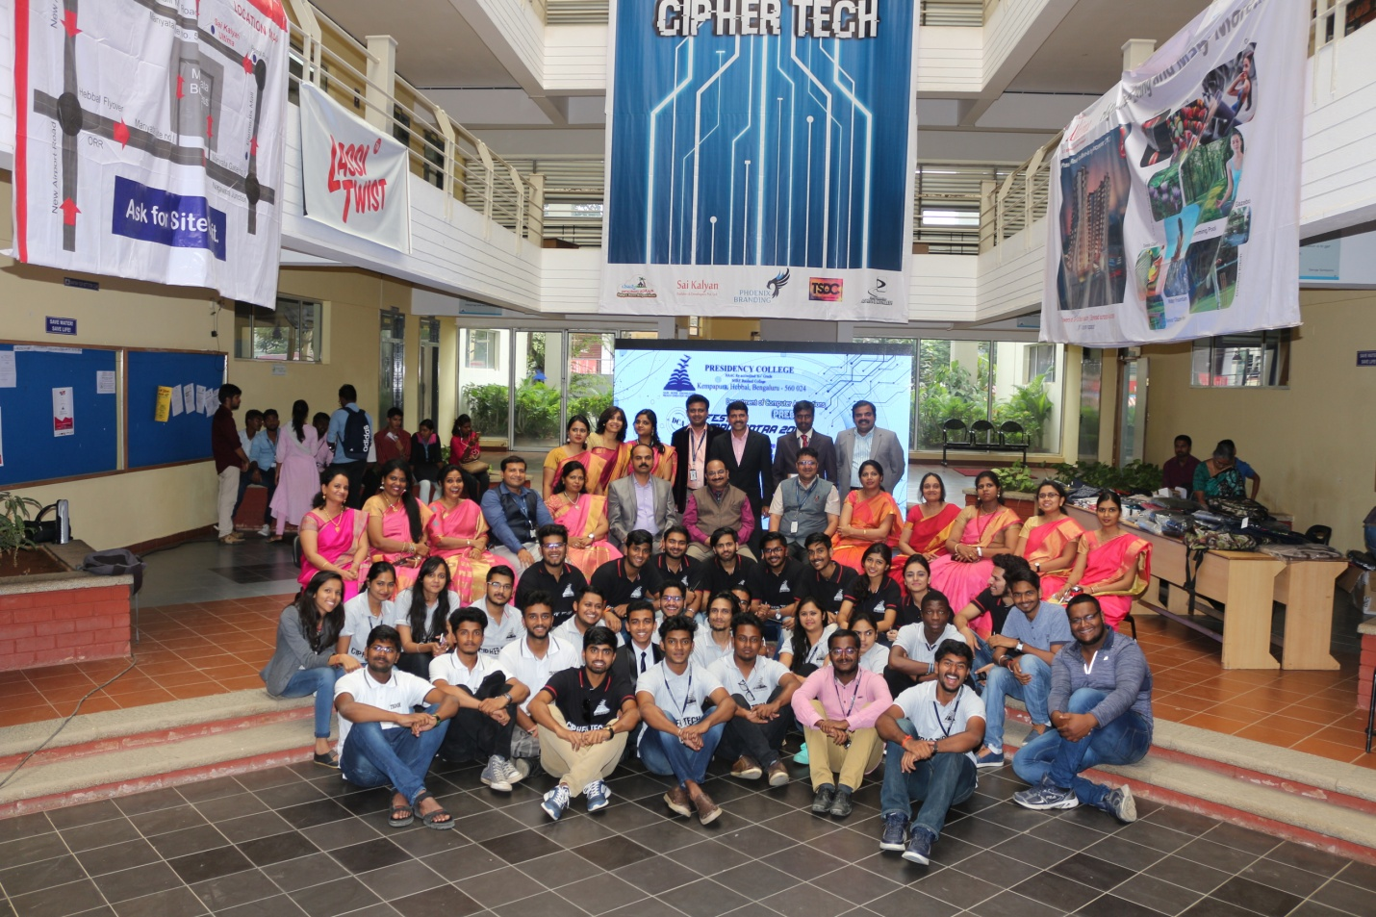
CORE TEAM OF COMPUTANTRA-2017
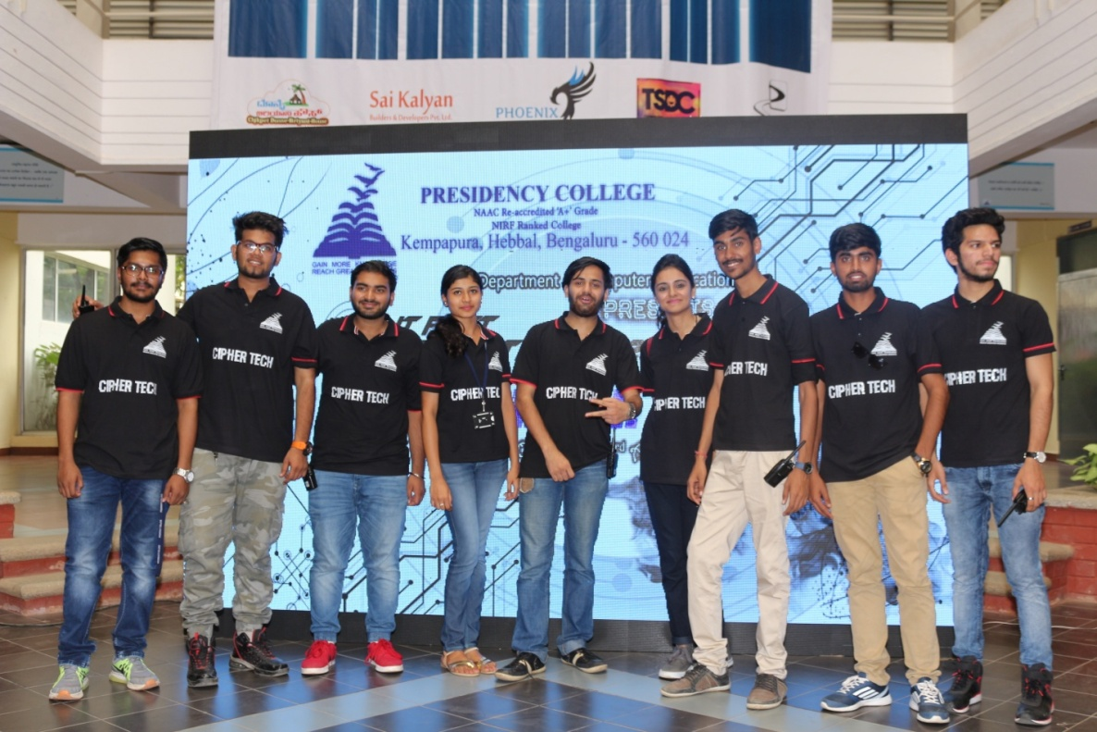
EVENT- COORDINATORS OF COMPUTANTRA-2017
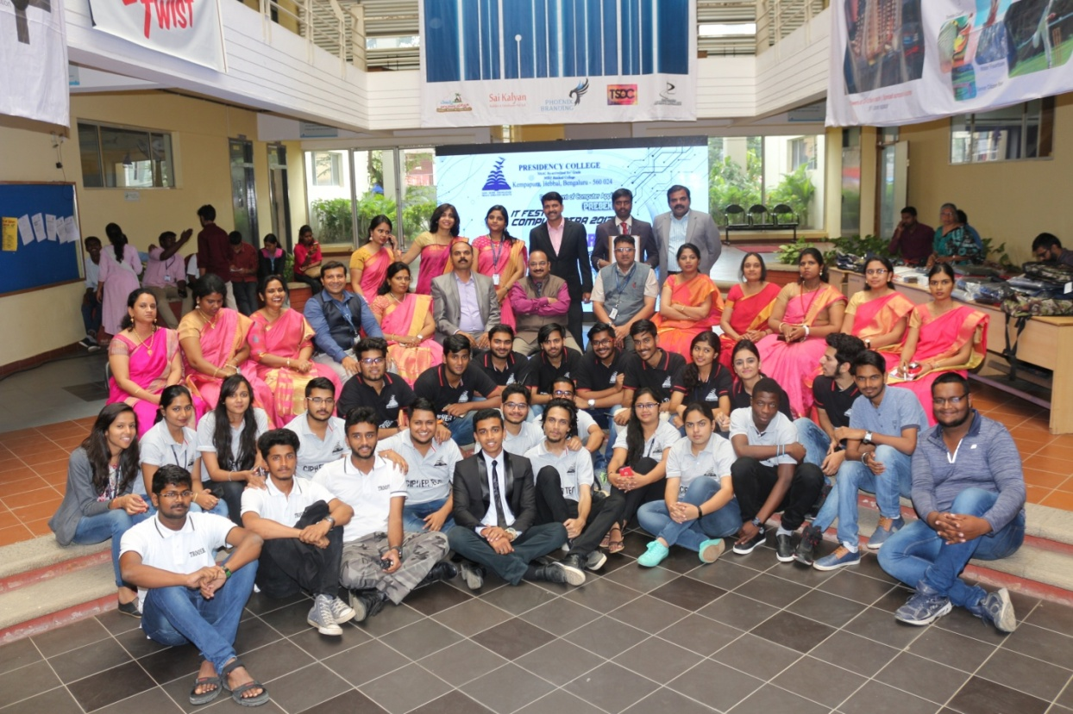
Success of Computantra-2017 “TEAM WORK”
