Presidency College
Reaccredited 'A+' by NAAC
NIRF Top 100 Ranked College
Kempapura, Hebbal, Bengaluru – 560024
www.presidencycollege.ac.in

IT FEST REPORT
The National level IT Fest 2K18 was organized by MCA department of BMSIT on 7th April. They had organized 10 different events in which 8 participants actively took part and won the overall championship with two thousand rupees cash prize. The participants are listed as follows:
S.NO | Participant | Event | Prize
1 | Eddy | IT manager | First Place
2 | Vidhu Sajeevan | NFS | Second Place
3 | Sehal and Prakash | Coding | Third Place
4 | Suraj and Lalith | Treasure Hunt | Second place
5 | Abhinandan and Ansul | Tech Sharads | Second Place
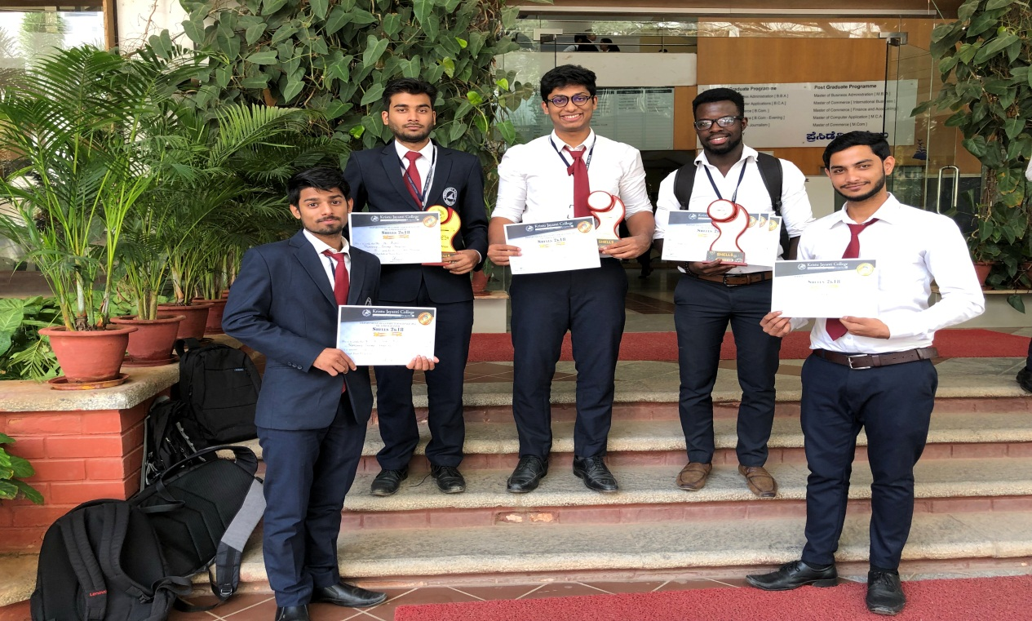
Winners –Intercollegiate IT fest-BMSIT on April 7th 2018.

