IT CLUB – TECHNOZIA – 2021
Program Name: XACTITUDE 2022
Date: 03/03/2022 – 04/03/2022
Time/ Duration: 2 Days
Total Number of Participants: 9
Name of Resource Person(s)/ Organization: Kristu Jayanti College, Autonomous, Bangalore
Venue: Kristu Jayanti College, Autonomous, Bangalore (Online)
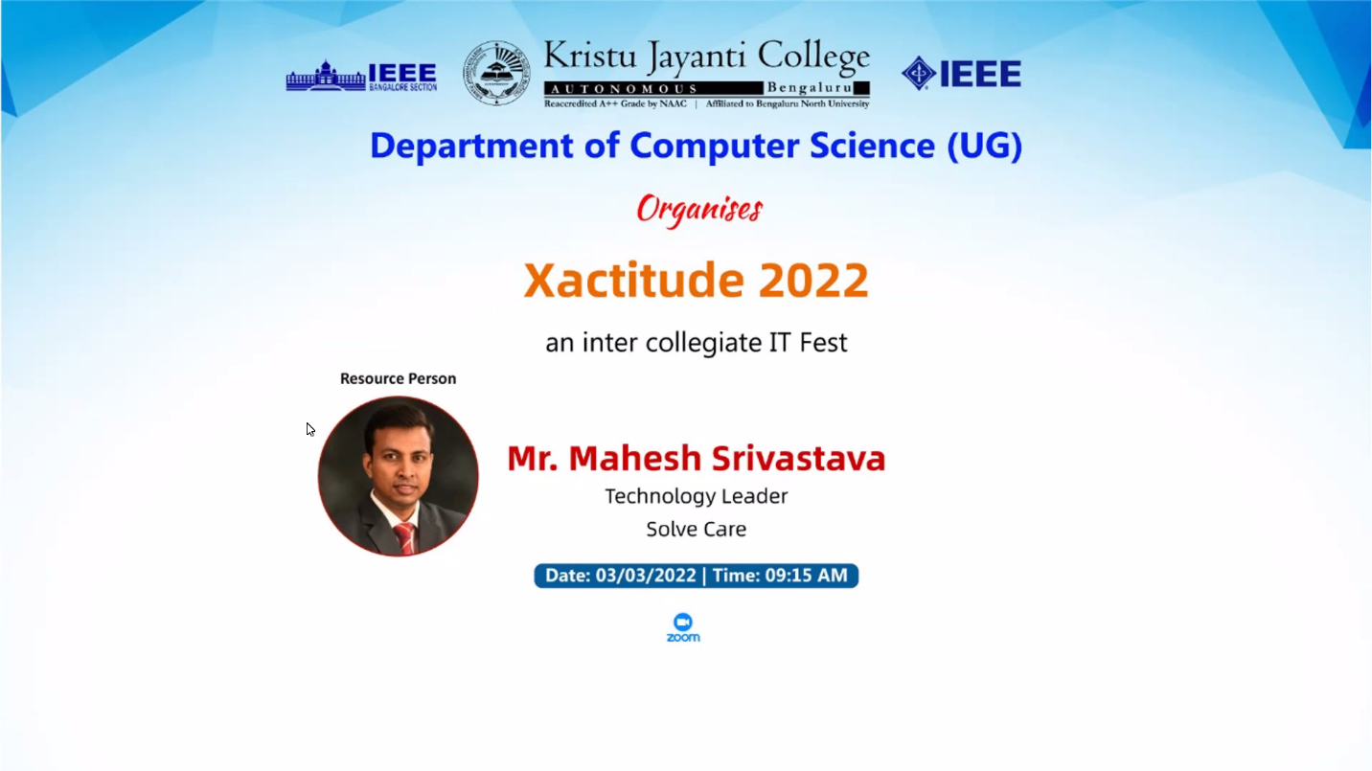
XACTITUDE 2022 is an Annual Science and Technology festival organized by the Department of Computer Science (UG) of Kristu Jayanti College. It’s a National Level Intercollegiate IT Fest held for the UG students, and participants were from all over India contesting against each other. It is one such platform where young minds can showcase their abilities and compete against one another to show off their finest self. Six events are scheduled over the course of two days. CodeX is a coding and debugging event, CSStematic is a web design event, Statsoryx is a statistics event, Pirates is a math event, Electrovolta is an electronic event, and Neutrino is a physics event. Presidency College won the overall competition after a tough battle between the competitors.
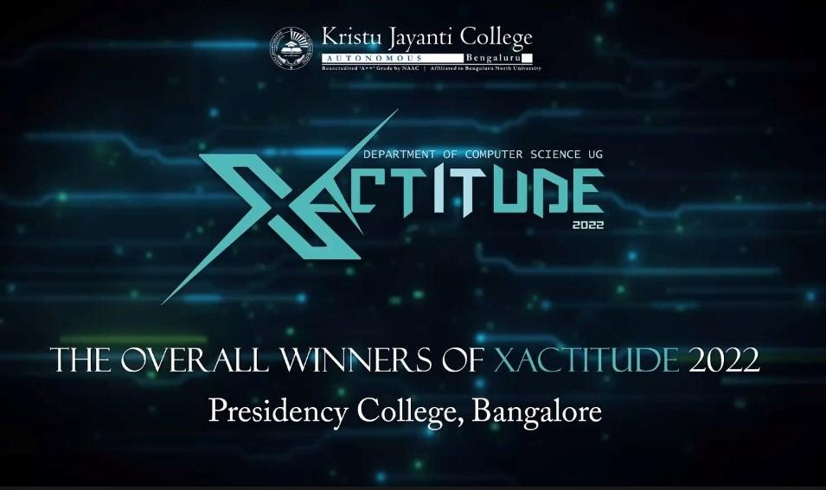

EVENT | PARTICIPANT | POSITION
CodeX | Vansh Shah | Runners Up
 | Tanupam Saha | Second Runners Up
CSStematic | Amr Rawaha | Winner
 | Ritik Makhija | Runners Up
Statsoryx | Tanupam Saha | Winner
Pirates | Tanupam Saha | Winner
Electrovolta | Tanupam Saha | Second Runners Up
Neutrino | Tanupam Saha | Winner

