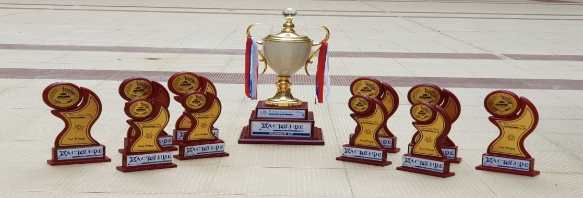

XACTITUDE 2018
  - National level inter-collegiate It Fest
  - Date: 24 january 2018

  - The students of DCA Department took part in national level intercollegiate IT fest competition held on 24/1/2018 at Kristu Jayanti College, Bangalore. They exhibited their talents and won the over all runners up trophy.
  - Event Details:
Event | Prize | Participant
IT MANAGER | - | Naif
IT QUIZ | 1st Prize | Ashish Mittal & Drupad
CODING AND DEBUGGING | - | Gajesh Bhat & Anvika Sharma
LECTURE CONTEST | 1st Prize | Vishnu Kp & Sangam Pandey
ARTIS-TECH | 2nd Prize | Manoj, Sanjeev & Muthahir
EXHIBIT CONTEST | 1st Prize | Rohit Ranjan & Anvika Sharma
RAMPAGE (GAMING) | 2nd Prize | Karthik Maheswaram
MATHEMATICS | - | Sayantan Dey & Asna S
STATISTICS | - | Kavya & Sayantan Dey
ELECTRONICS | - | Sayantan Dey & Manjunath,  Kavya & Vishnu KP
BEST TECH TEAM | 2nd Prize | Sarvesh Kr. Modi, Vishnu Kp & Sangam Pandey
WOMAN WHO CODE | - | Kanika Sharma & Asna

