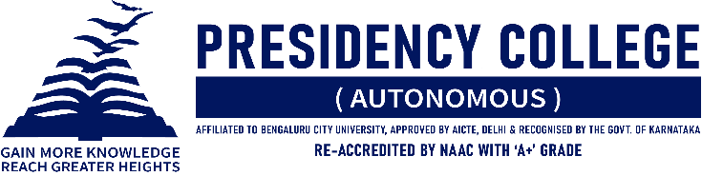
IT CLUB – TECHNOZIA – 2022
Program Name: TECHVINZO 2022
Date: 29/07/2022
Time/ Duration: 1 Day
Total Number of Participants: 15
Name of Resource Person(s)/ Organization: Maharani Laxmi Ammani College for Women Autonomous.
Venue: Maharani Laxmi Ammani College for Women Autonomous.
TECHVINZO 2022 is an Annual intercollegiate fest organized by the Department of Computer Science of Maharani Laxmi Ammani College for Women. It is a celebration that brings students from various streams and colleges to explore, experience and enjoy the wonders of this advancing tech world. It is one platform where young minds can showcase their abilities and compete against one another to show off their finest selves. There’re events such as Code Fuzz, Mind Spark, The Hawk Eyes, Impresario, Timeless Captures, Wordprism, and Technophilia. After a fierce struggle between the competitors, Presidency College emerged victorious and was recognized as the Overall Winner.

EVENT | PARTICIPANT | COURSE | POSITION
Code Fuzz | Tanupam Saha and Mukunthan Nagarajan | BCA | Winner
 | Vansh Shah and Ritik Makhija | BCA | Runners
The Hawk Eyes | Tanupam Saha, Mukunthan Nagarajan, and Mohit Pal | BCA | Winners
Impresario | Ritika Vashist | BCA | Winner
Technophilia | Shubham Singh Rathour | BCA | Winner
Mind Spark | Shubham Singh Rathour and Vansh Shah | BCA | Winners
Timeless Captures | Mohit Pal | BCA | Winner
Wordprism | Anand Choudhury | BCA | Runner

