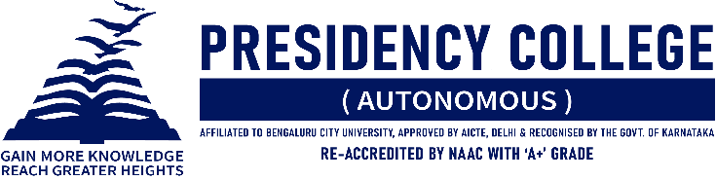
IT CLUB – TECHNOZIA – 2022
Program Name: TECHNOVATION 2022
Date: 19/07/2022
Time/ Duration: 1 Day
Total Number of Participants: 26
Name of Resource Person(s)/ Organization: St. Claret’s College
Venue: St. Claret’s College
Name of the Event | Name of the Participant | Position
Coding | Ritik Makhija and Vansh Shah. | Winner
 | Tanupam Saha and Mukunthan Nagarajan. | Runners Up
Paper Presentation | Vansh Shah, Vikas Sharma, and Shubham Singh Rathour. | Winners
Gaming | Shrey Pandey, Udit Bhalla, Mohamed Sameer, and Ashish Kumar. | Winner
IT Manager | Siddharth Sundar. | Winner
TECHNOVATION 2022 is an annual intercollegiate fest organized by the Department of Computer Science of St. Claret’s College. It is a celebration that brings together students from various streams and colleges to explore, experience, and enjoy the wonders of this advancing tech world. It is one platform where young minds can showcase their abilities and compete against one another to show off their finest selves. Seven events were scheduled in a day. Events included Coding, Paper Presentation, Photography, Videography, IT Manager, Gaming, and Fashion Show. Presidency College won the overall competition after a tough battle between the competitors.

