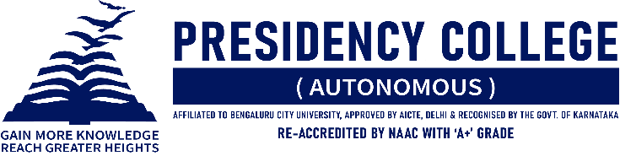
IT CLUB – TECHNOZIA – 2022
Program Name: TECHANNZA 2022
Date: 15/07/2022
Time/ Duration: 1 Day
Total Number of Participants: 15
Name of Resource Person(s)/ Organization: St. Anne’s First Grade College for Women
Venue: St. Anne’s First Grade College for Women
TECHANNZA 2022 is an annual intercollegiate fest organized by the Department of Computer Application of St. Anne’s College. It is a celebration that brings together students from various streams and colleges to explore, experience, and enjoy the wonders of this advancing tech world. It is one platform where young minds can showcase their abilities and compete against one another to show off their finest selves. Five events are scheduled in a day. Spider was a Web Designing event, Hammer Mind was an IT Quiz event, Cyfrowy Flyer was a Poster Designing event, and Typo was a Fast typing event. Presidency College won the overall competition after a tough battle between the competitors.
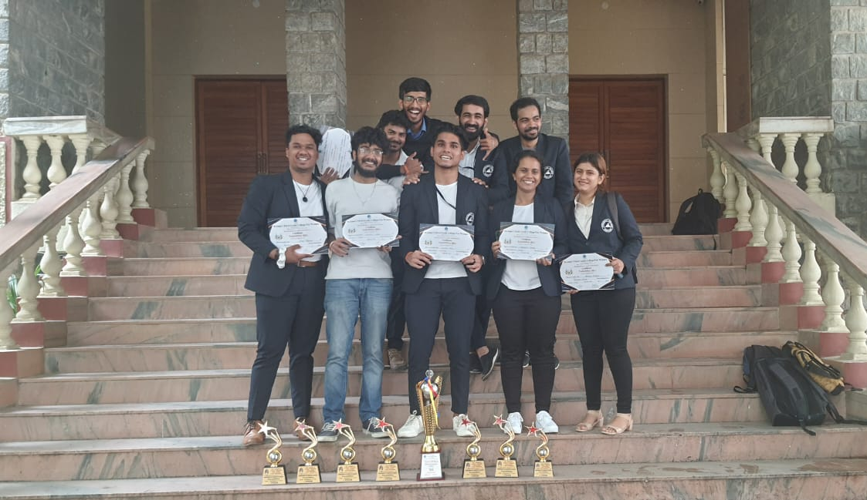

Name of the Event | Name of the Participant | Position
Spider | Arm Rawaha | Winner
 | Ritik Makhija | Runners Up
 | Afiq Ekkeri | Third
Hammer Mind | Tanupam Saha, Siddharth Sundar, Priyadarshan Giri. | Winners
Cyfrowy Flyer | Ameesha Charaniya | Winner
Typo | Siddharth Sundar | Winner
 | Tanupam Saha | Runners Up

