IT CLUB – TECHNOZIA – 2022
Program Name: SYNTAXIA 2022
Date: 16/05/2022 – 17/05/2022
Time/ Duration: 2 Days
Total Number of Participants: 12
Name of Resource Person(s)/ Organization: St. Joseph’s College (Autonomous)
Venue: St. Joseph’s College (Autonomous)
SYNTAXIA 2022 is an Annual National Level intercollegiate fest organized by the PG Computer Science Department of St. Joseph’s College. It is a celebration that brings students from various streams and colleges to explore, experience and enjoy the wonders of this advancing tech world. It is one platform where young minds can showcase their abilities and compete against one another to show off their finest selves. Six events are scheduled over the course of two days. Brother Eye was a coding and debugging event, Riddle Me This was IT Quiz, Future State was a paper presentation event, Court of Owl was Treasure Hunt, Trials of Bane was IT Manager, and Oracle was a video presentation event. Presidency College won the overall competition after a tough battle between the competitors.
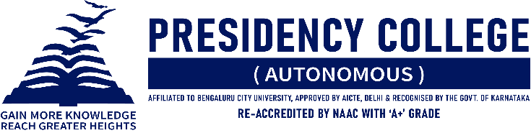
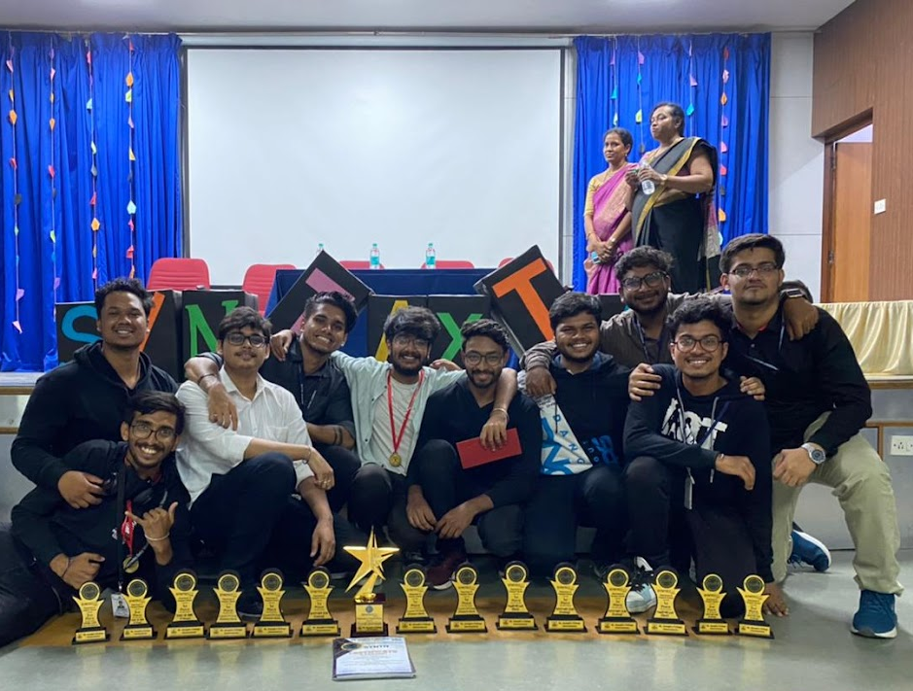

EVENT | PARTICIPANT | POSITION
Brother Eye | Tanupam Saha,  Mukunthan Nagarajan, Anand Choudhary. | Winners
 | Anurag Kumar Singh,  Arindam Hazra,  Divesh Mandhyan. | Runners Up
 | Siddharth Sunar,  Priyadarshan Giri,  Ragul Y. | Third
Riddle Me This | Tanupam Saha,  Mukunthan Nagarajan. | Winner
Trials of Bane | Siddharth Sunar | Winner
 | Priyadarshan Giri | Runners Up
Future State | Anand Choudhary | Runners Up
Court of Owl | Tanupam Saha.  Mukunthan Nagarajan,  Anand Choudhary,  Mohit Pal. | Winner
