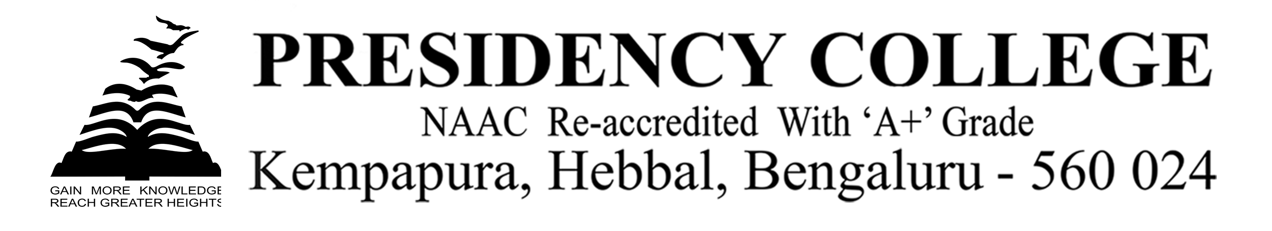
IT Fest-2019
Program Name: IT Fest -2019
Date: 25/9/2019
Time/Duration: 1 day
Total Number of Participants: 20
Name of Resource Person(s)/Organization: ST. Claret College
Venue: ST. Claret College
The students of DCA Department took part in the Intercollegiate IT Fest-2019 on 25-09-2019 at ST. Claret College, Bangalore. They exhibited their talents, skills and won several prizes in the fest. Our students had performed extra-ordinarily throughout the Fest and they had brought laurels to the college by winning the overall runners up with 15 individual trophies for the college.
Dates | EVENT | PRIZE | PARTICIPANT
25/9/19 | IT Quiz | ^{III} | Siddharth & Aneesh
25/9/19 | Graphic Designing | 1st | Jaimin
25/9/19 | Coding | II | Avinash and Utpal
25/9/19 | IT Fashion show | 1st prize with Rs 5000 | Vandana ,Urusa and team

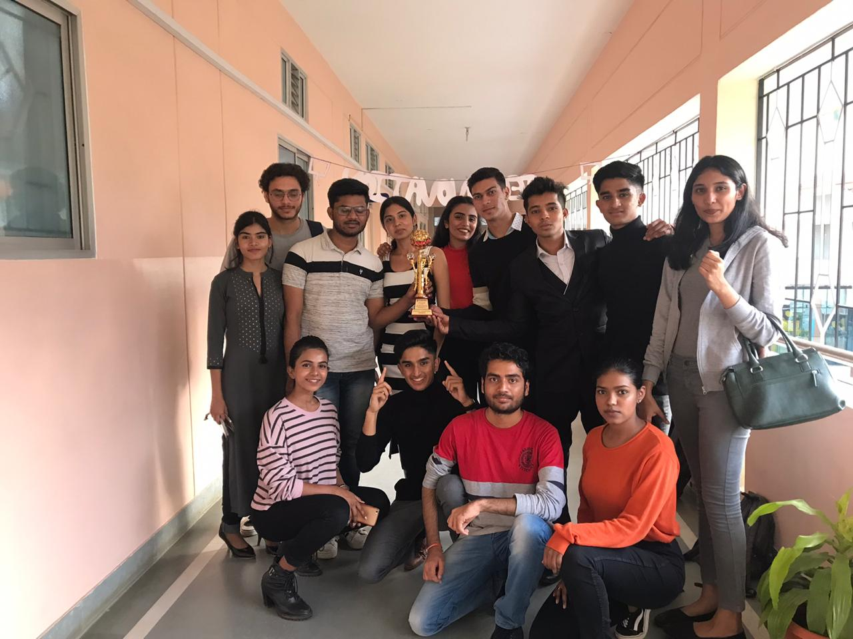
Overall Runners up at ST.Claret College

