Presidency College
Reaccredited 'A+' by NAAC
NIRF Ranked College
Kempapura, Hebbal, Bengaluru – 560024
www.presidencycollege.ac.in

REPORT ON CRUCIBLE 2019
DEPARTMENT OF COMMERCE AND MANAGEMENT
PRESIDENCY COLLEGE

About Crucible:
Crucible is the flagship annual “BizTech” quiz organized by the Morpheus management club of Presidency college for all the departments. It is a quiz event which has rounds that consist of questions based on company histories, business strategies, well known deals, people in news, acquisitions, future business developments, current affairs and a lot more. Its main aim has always been to test the acumen and knowledge of students through its perfectly framed questions.
Crucible was conducted on 25th February 2019.
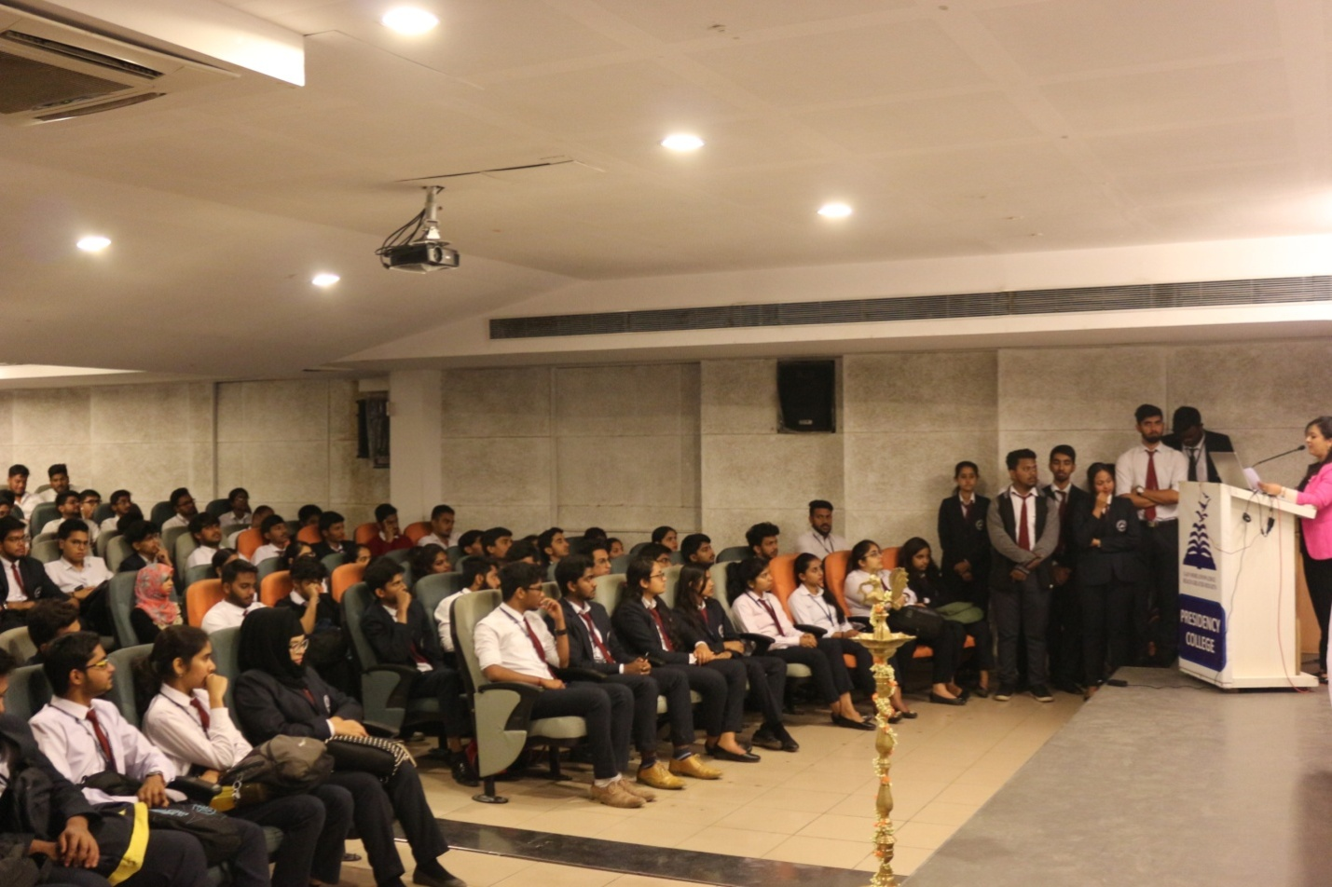

Crucible 2019:
Number of teams that participated – 135 teams from all departments (Each team comprising of 2 members)
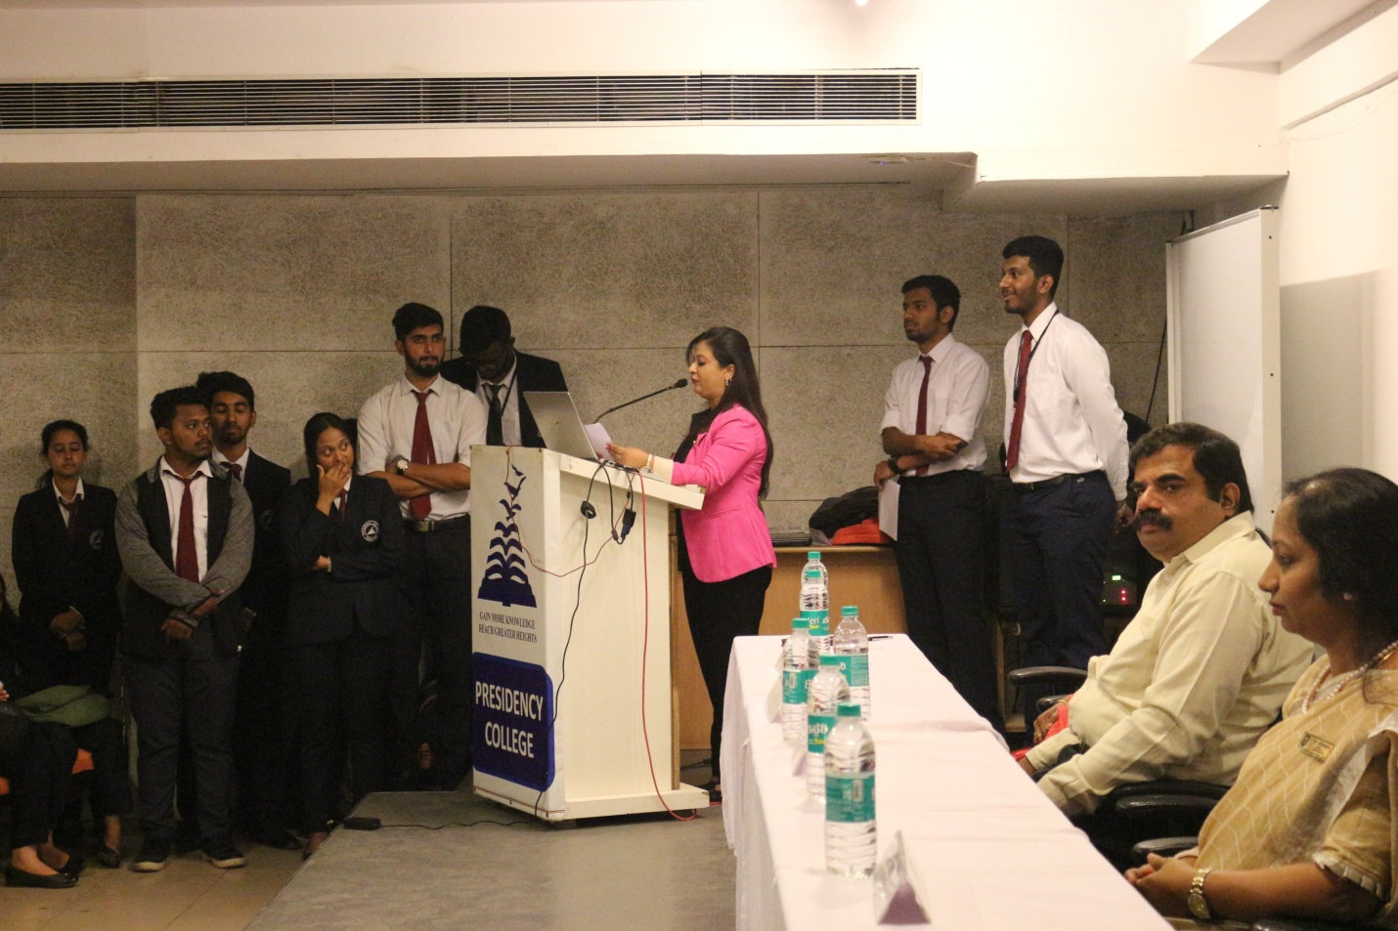

Summary of the Rounds –
There were 5 rounds of questions in total. Eliminations after every round.
Round 1: Questions on company logos/taglines
Round 2: Questions on company histories/ famous personalities.
Round 3: Questions on current affairs.
Round 4: Audio – visual round.
Round 5: Finals (mixed bag & 5 top performing teams in the final)
All the 135 teams could attempt the first two rounds. The first two rounds were conducted between 9:45am to 10:40 am.
Out of 135 teams 16 teams progressed to Round 3. Round 3 was conducted between 11:00 am -12:40pm. After the third round, 10 teams were selected for the semi final which was conducted after the lunch break. And in the end 5 teams progressed to the Finals.

Winners of crucible 2019:
- Gokula Krishnan – II BCom (evening batch)
- Beena Rose – IV BBA ‘A’
Runners up:
- Prajwal Sharma – VI BCA ‘A’
- Kunal Mittal – VI BCA ‘A’
