CRUCIBLE 2020
DEPARTMENT OF COMMERCE AND MANAGEMENT PRESIDENCY COLLEGE

Crucible, the Annual Inter departmental quiz competition conducted by the Morpheus Club (Dept. of Commerce and Management) on 17th Feb, 2020 ignited the young minds of the Presidencians. It proved to be a platform for quizzers to test their acumen and challenge their caliber.
Crucible is a platform where the participants get an opportunity to unlock knowledge at the speed of thought and that is indeed challenging and fun.
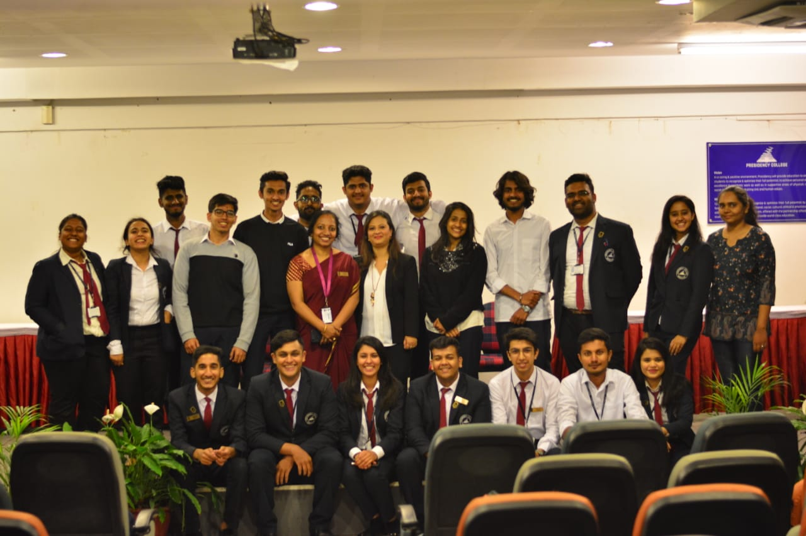
Each team comprised of 2 members.

The event consisted of 4 rounds and the Final round.
It had sixteen teams qualifying for the second round surviving the elimination. Subsequently, twelve teams got into the next round.
After the second round, we had 8 teams qualifying for the next rounds that battled it out for the title. Finally, 4 teams surpassed the vigorous test and performed their best in the finals.
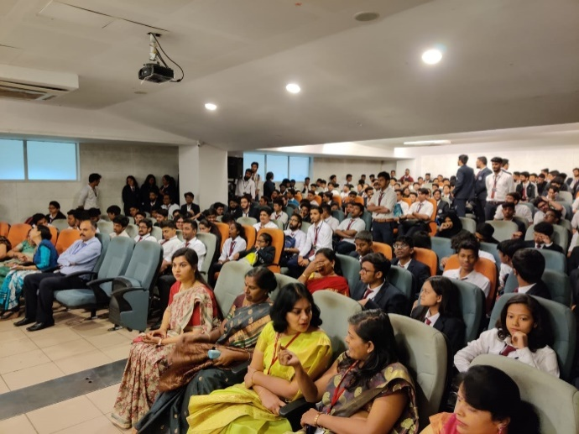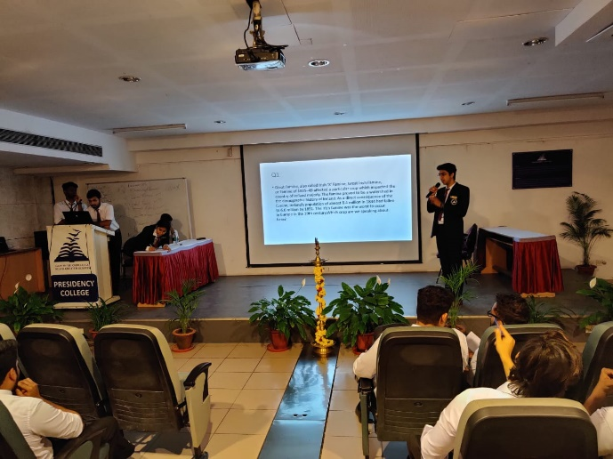
The event consisted of questions from Literature, Sports, Business, Entertainment and Current affairs.
The Event heads (Student Co ordinators) were Harsh Belani, Gokulkrishna, Kenneth George and Arnab Nag
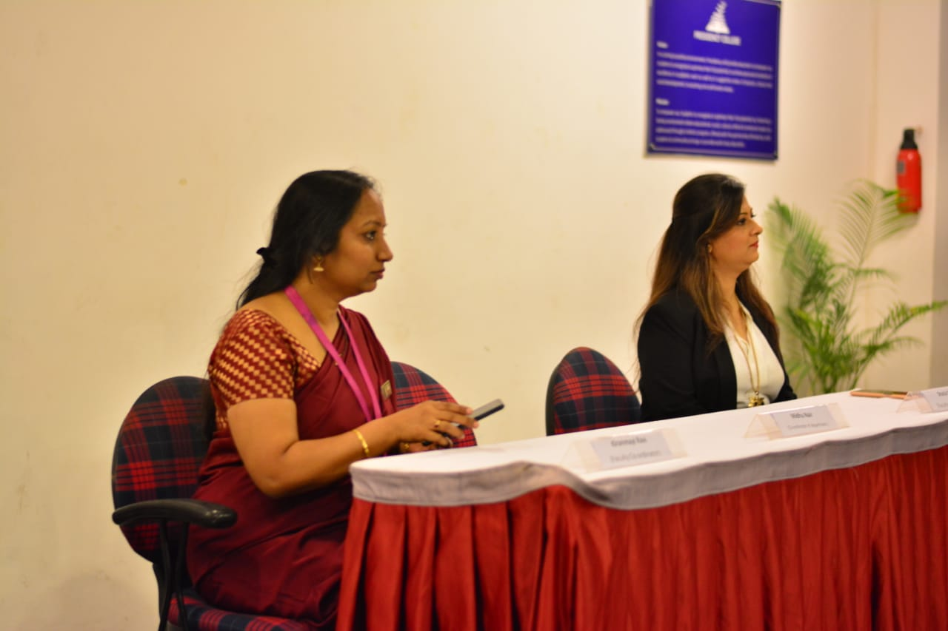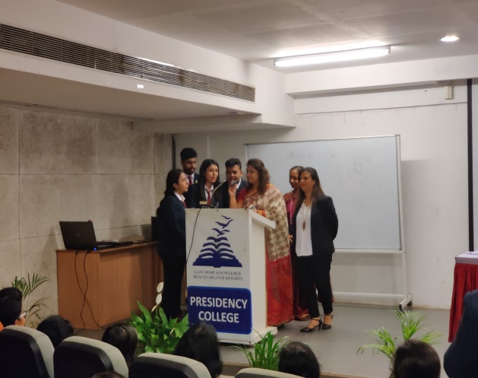

Winners of Crucible 2020:
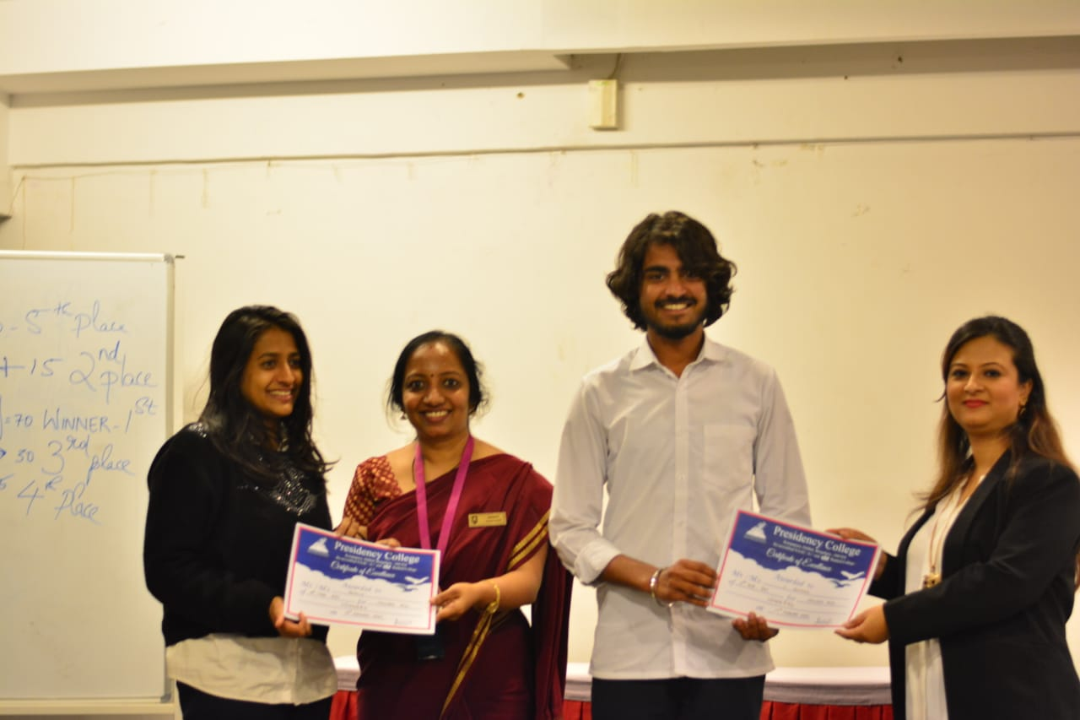
S Aravinda – IV Sem BAJ & Jeshila John – VI Sem BAJ

Runners up:
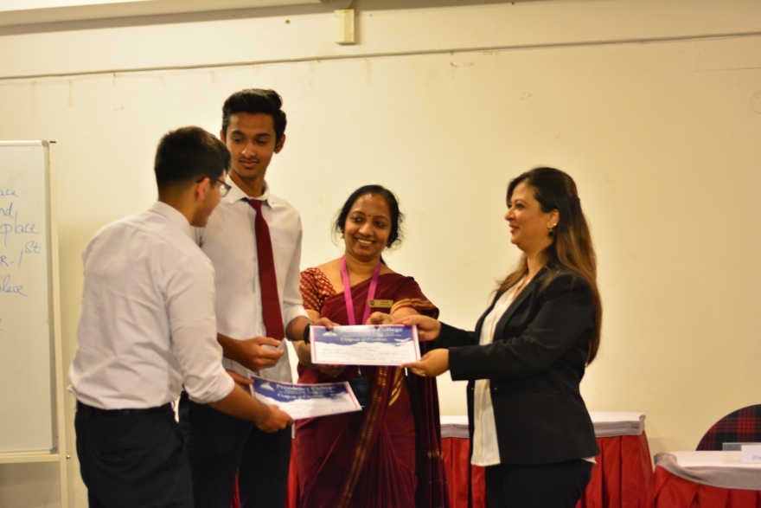
Tausif Ansari- VI Sem Bcom & Mir Jibraan - VI Sem Bcom

