Morpheus Club
ENORM 2018

Dates – 16th and 18th August 2018

The Department of Commerce and Management conducted its Annual Management Fest ENORM 2018 and provided a platform to the students from various colleges to showcase their managerial skills and abilities. The participants were given hypothetical situations from the corporate world and were tested to the limit.
90 participants from 15 colleges, including 3 outstation colleges took part in the fest making Enorm’18 a grand success.

ENORM 2018 – The Continental Accretion
Enorm’18 entailed the journey of a small corporation into becoming a successful establishment across different industry verticals. Mergers and acquisition is the path that business takes to achieve synergy and exponential growth. Over the span of two days the participating colleges faced various situations that a corporation faces in trying to establish their dominance in the market.

The Contingent comprised of 4 members each from the participating colleges, to battle out rounds in the fields of:
- Marketing
- Finance
- Entrepreneurship Development
- Human Resource/Public Relation

The Business Quiz event comprised of 2 participants from each college.

Day 1 – 16th August, 2018
The event kick started at 9:30 AM with the inaugural ceremony and was honored by the presence of Ms. Sumana Iyengar – Founder and CEO of Goavega Software India Pvt. Ltd., as the Chief Guest and Group Captain K.A. Cariappa – Commanding Officer of No. 1 Karnataka Air Squadron NCC, as the Guest of Honor.
Day 1 of Enorm’18 witnessed 13 colleges with a team of 4 members each in the “Contingency” events and 15 colleges with a team of 2 members each in the “Business Quiz” event. There were 5 rounds or case studies that were provided to the participants. These case studies in turn had to be solved and presented by the participants to the external and internal judges of Enorm’18.
Each team gave its best to move into Day 2 as the Elimination Rounds at the end of Day 1 were challenging enough for them to experience the throat competition
 | Contingent Event | Business Quiz
No. of Colleges | 13 | 15
No. of Participants | 52 | 30

Day 2 – 18th August, 2018
The second day of Enorm’18 opened with 6 colleges in the “Contingency” event and 8 colleges in the “Business Quiz” event, after the eliminations of Day 1. Further, the battle for the best was narrowed to 4 teams in the “Contingency” event and to 6 teams in the “Business Quiz” event.
Day 2 of Enorm’18 comprised of an overnighter task and 5 on-spot rounds that led the contingent team into the final stress round, making it an overall of 6+1 rounds.
 | Contingent Event | Business Quiz
No. of Colleges | 6 | 8
No. of Participants | 24 | 16
After Lunch
No. of Colleges | 4 | 6
No. of Participants | 16 | 12

The valedictory ceremony was chaired by the esteemed Campus Director – Dr. Prabhu Dev, the Coordinators of the Department and the Morpheus Club Conveners. The Runners-Up trophies and a cheque of Rs. 15,000/- was presented to Jain University - SCS, while the Winning Trophies and an International Trip was awarded to Christ University – DMS.
The Business Quiz Runners-Up were Christ DMS, while the Business Quiz Winning Trophy was awarded to Jain University CMS.
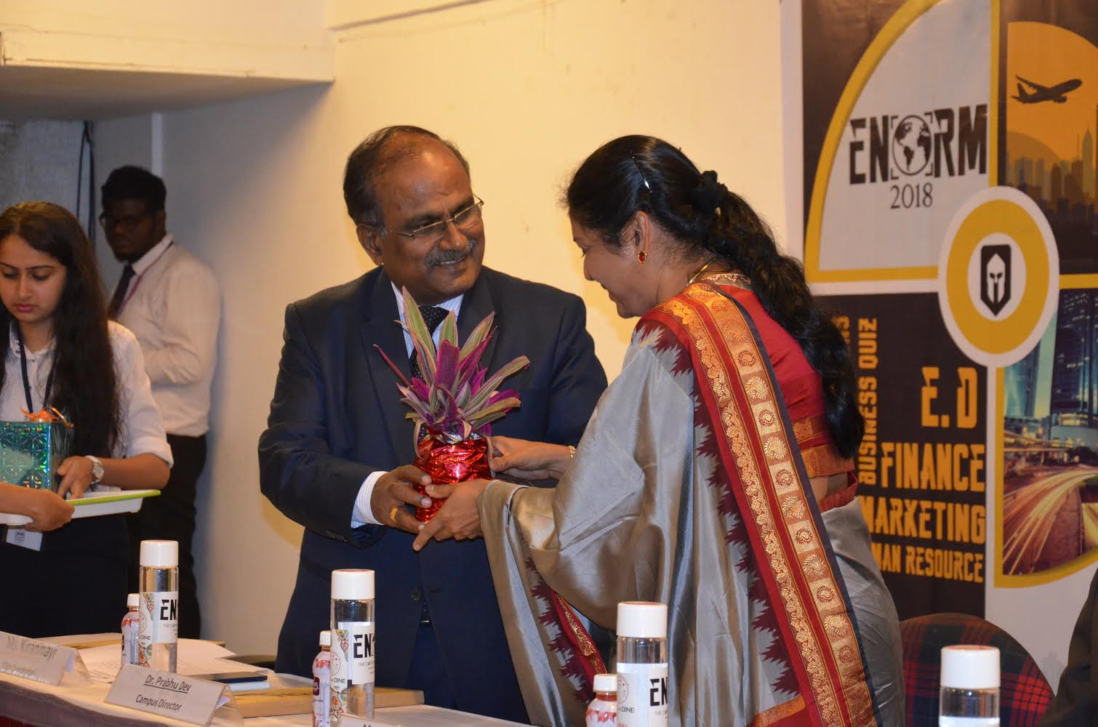
The Campus Director Dr. Prabhu Dev welcoming the Chief Guest Ms. Sumana Iyengar with a token of gratitude

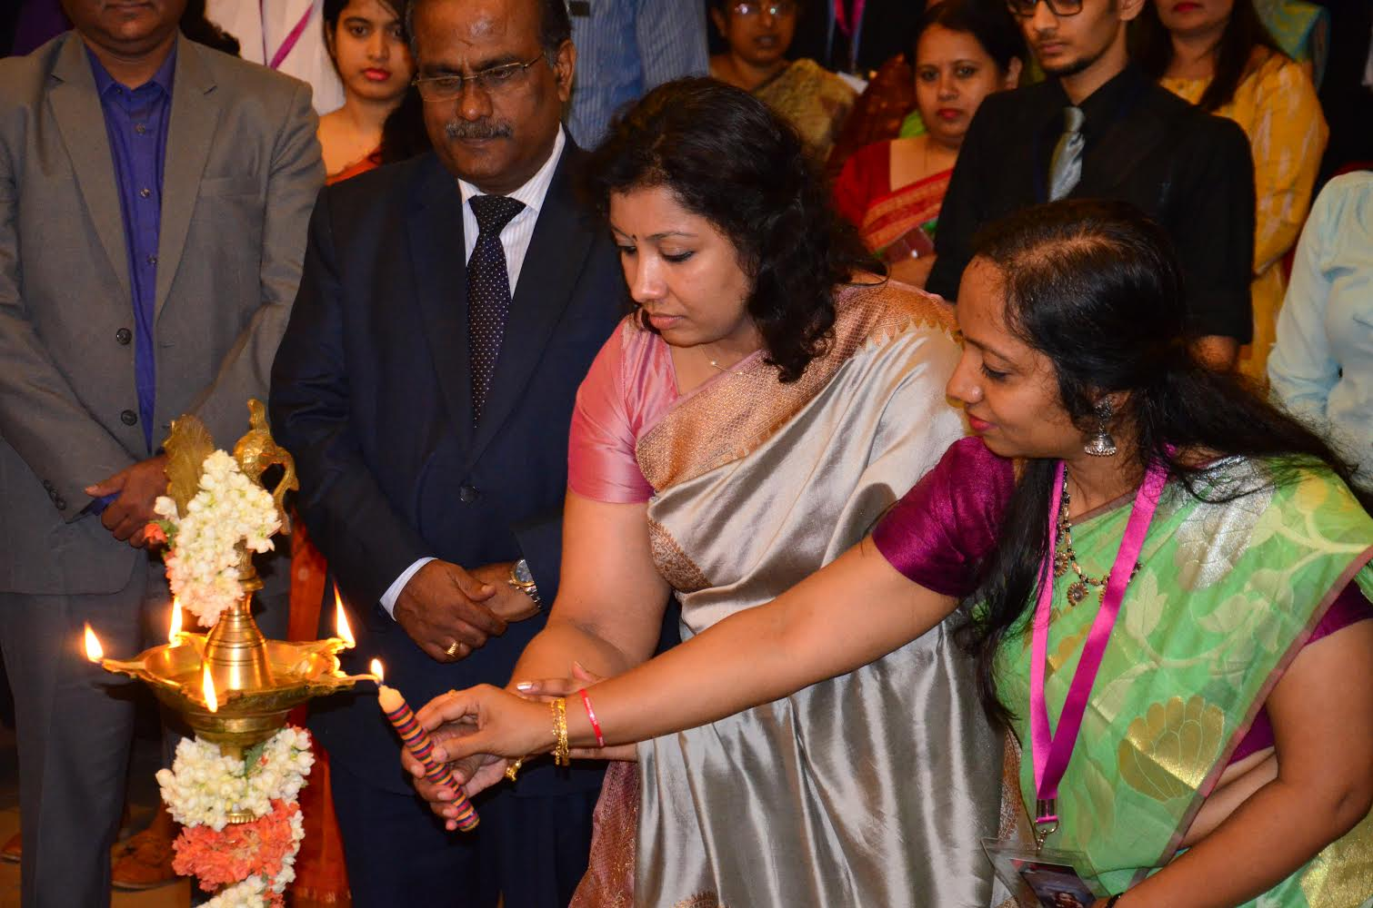
Inauguration – Lighting of the Lamp
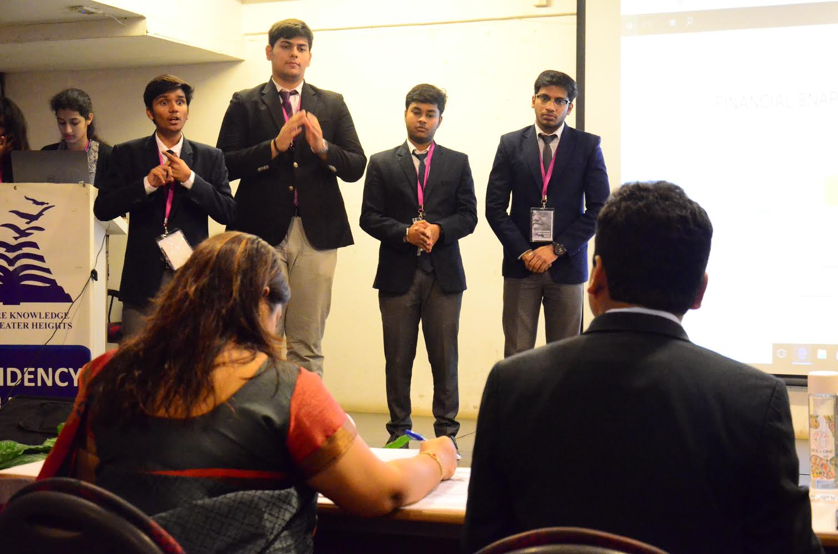
The Team Battle – Health Care Round

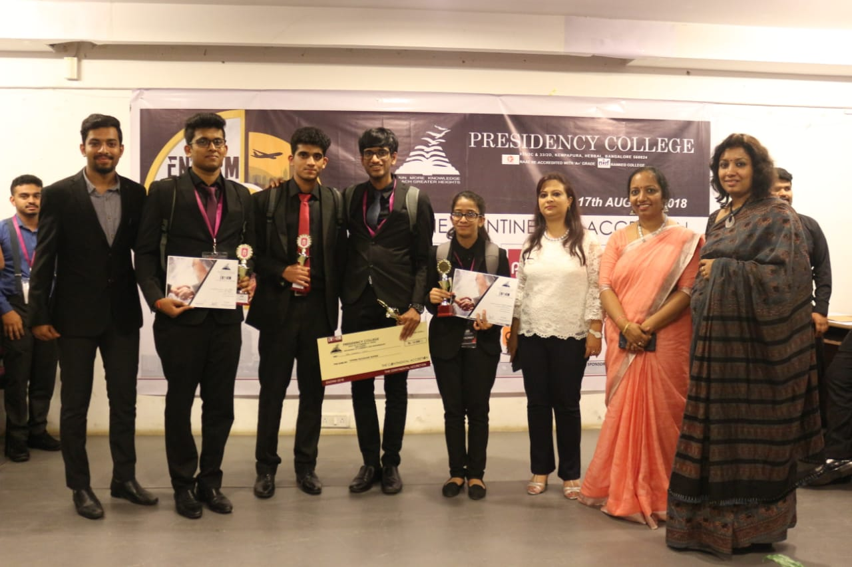
The Runners Up of ENORM 2018 - Jain University – SCS
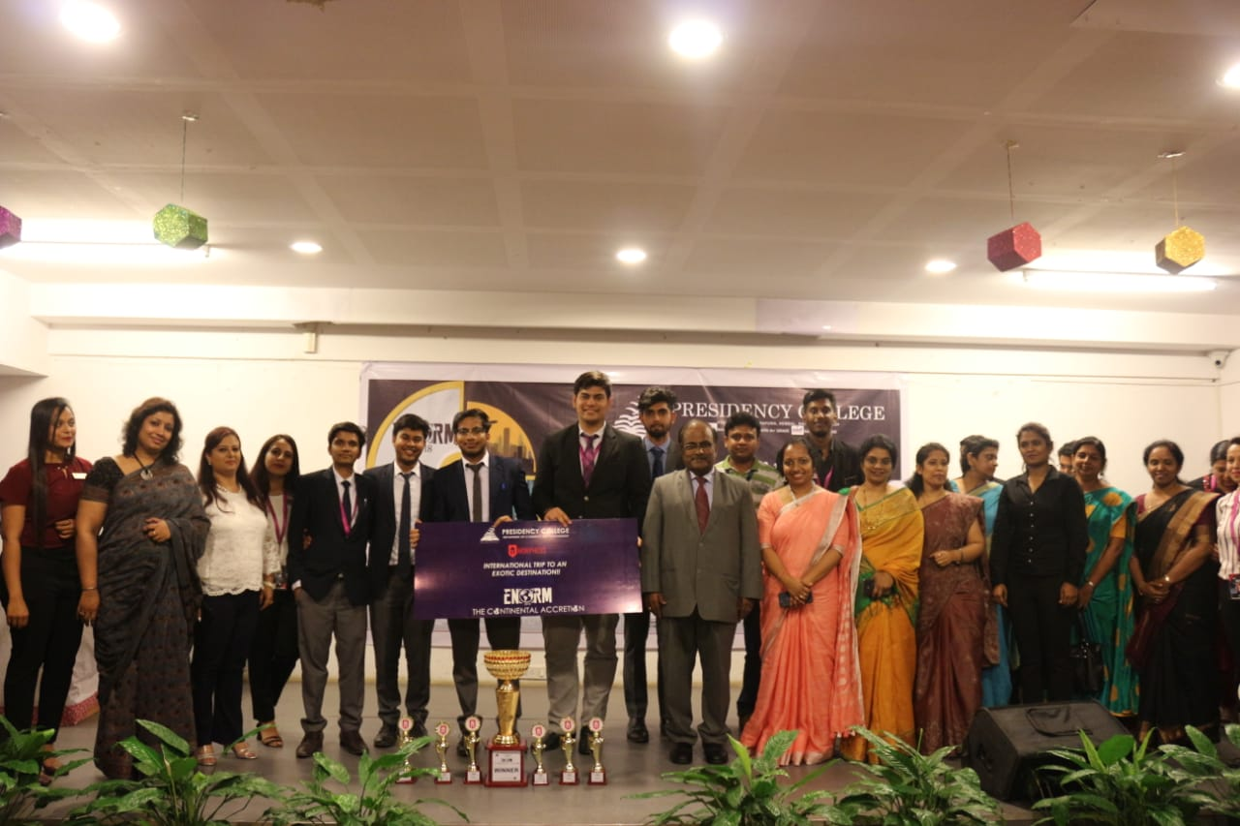
The Winners of ENORM 2018 & Winners of the International Trip
Christ University – DMS.

