PRESIDENCY COLLEGE
Kempapura, Hebbal, Bangalore – 560024
Reaccredited ‘A+’ by NAAC
NIRF Ranked College

Review of ENORM 2017

ENORM 2017– The Consortium Evolution.

This year, ENORM took place on the 18th and 19th of August 2017, with an innovative theme and format of the overall event.
The theme for ENORM was titled The Consortium Evolution depicting the journey of a start-up that expands and diversifies operation to become the biggest Conglomerate in the world. With the tag line "Diversification is the new Evolution" the theme integrated all events that are generally conducted in a management fest (HR, Finance, Marketing, ED and BM) into a four member contingent event with a new scoring format which focused on a team’s consistency in performance. Rounds were designed solely by the students of the Morpheus Management Club, with support and assistance from the faculty of Department of Commerce and Management. Business Quiz was simultaneously held as a separate two member open event but was a crucial part of the fest.

The fest was inaugurated by K. Raghu, Ex Chairman of the Institute of Chartered Accountants of India (ICAI) as the chief guest for the event.
After the inauguration, both events were conducted simultaneously in different venues in the college. 15 teams from renowned colleges took part in the events.
Day 1 rounds began at 11:00 a.m., post the inaugural event. Contingents of the Conglomerate Event worked on various case studies, each involving a new industry that the contingent’s “Conglomerate Establishment” tried to conquer. A lot of interesting concepts, stress rounds, and on spot rounds were integrated throughout both days of the fest. Eliminations took place at the end of Day 1 and 10 teams qualified into Day 2
Day 2 began at 8:00 a.m. with the young management enthusiasts, pitting their skills against each other, competing against each other towards an intense final stress round. By the end of the day, a clear winner emerged which was announced in the valedictory function held at 6.30 pm in the seminar hall. The Principal along with the HOD of Commerce and Management department handed over the trophy and a cash prize of Rs. 15,000/- to runners up Christ University (Bannerghatta Campus), and the overall trophy as well a trip to an exotic international destination to the winners of ENORM 2017, Jain SCS.

Pictures:
1) Inauguration
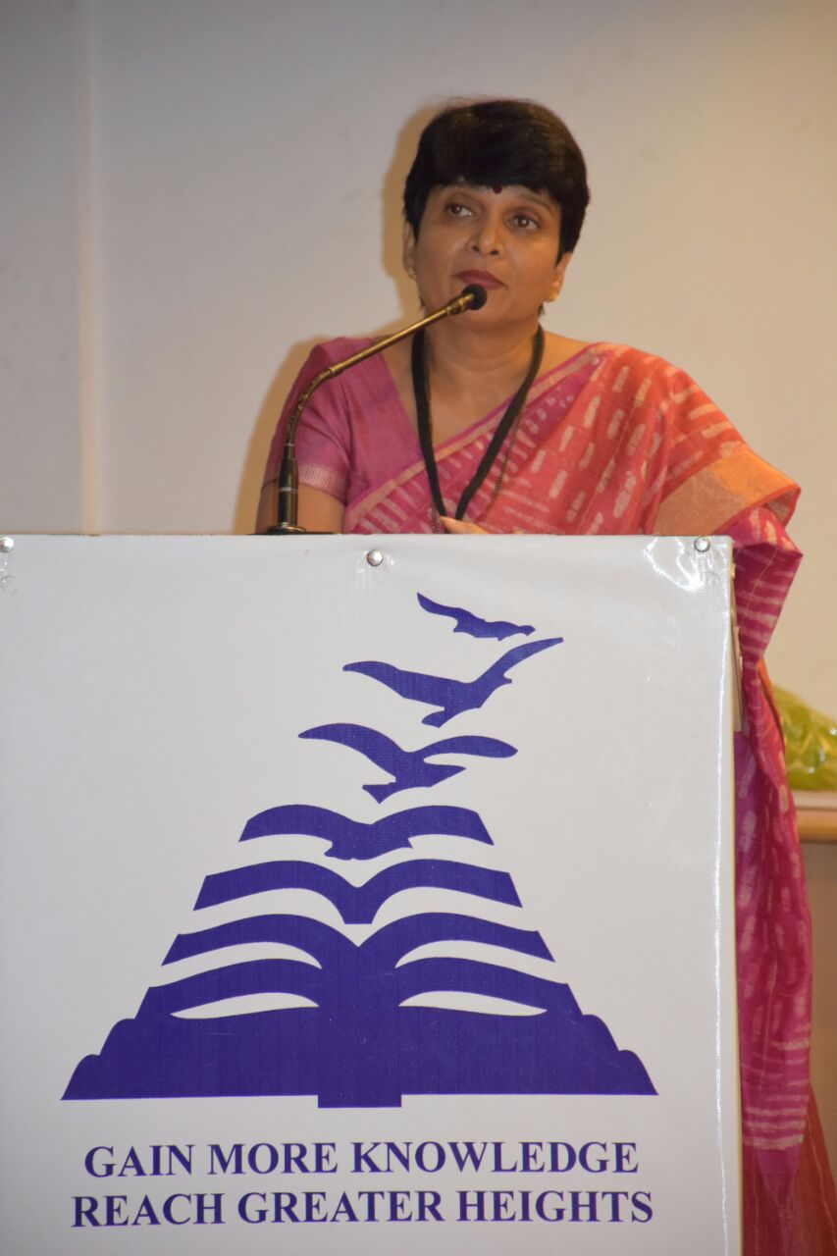
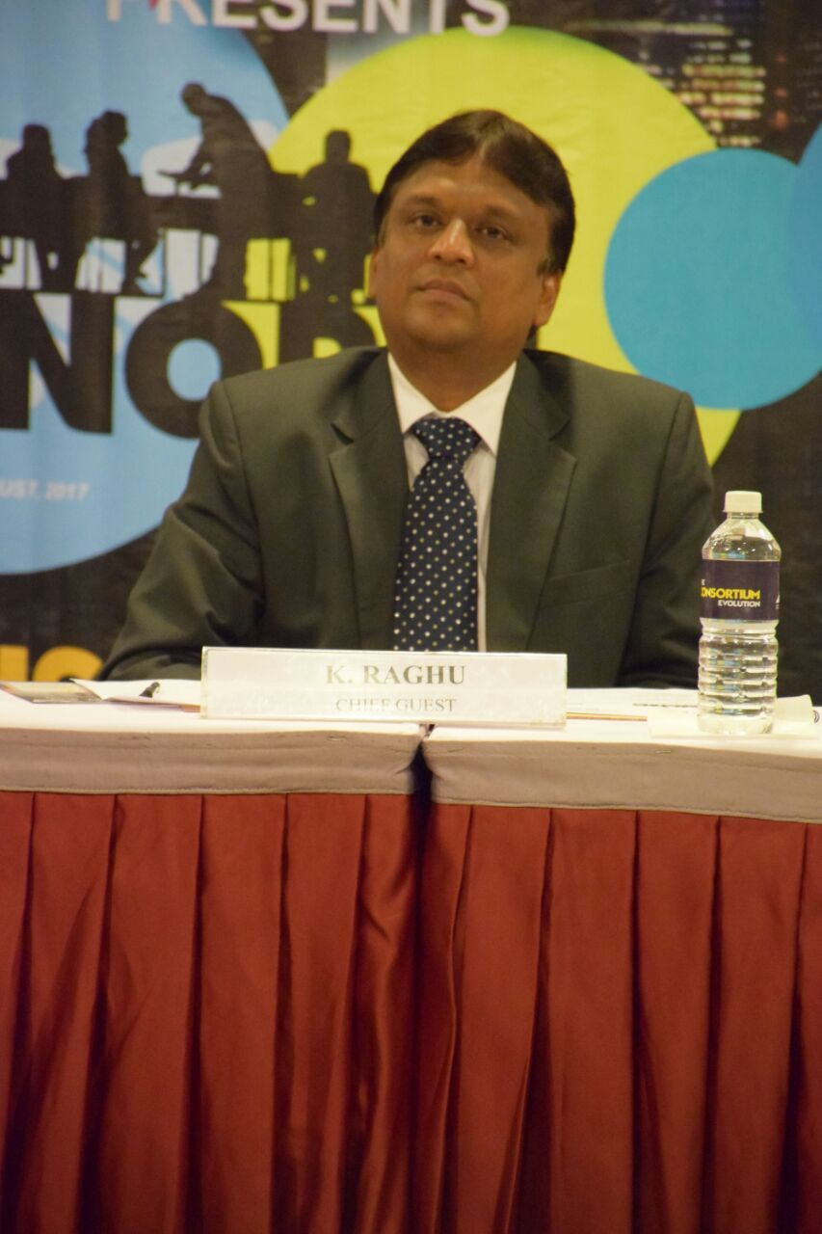

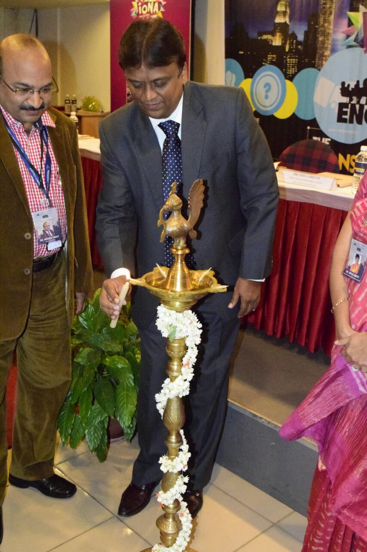
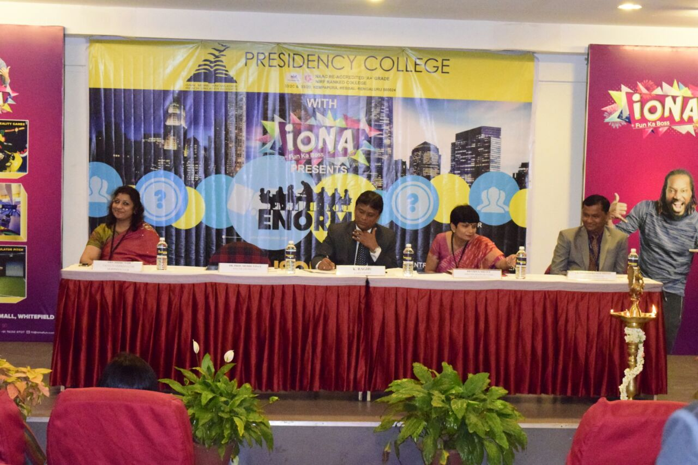
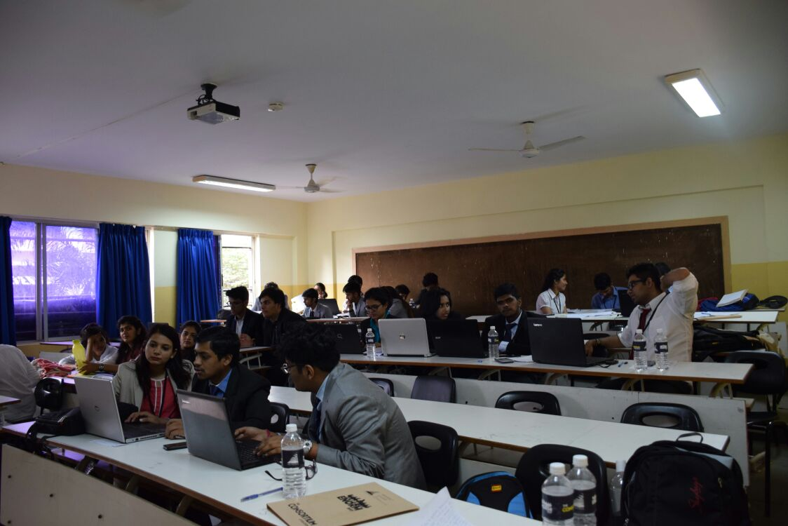
2) Rounds and BQ
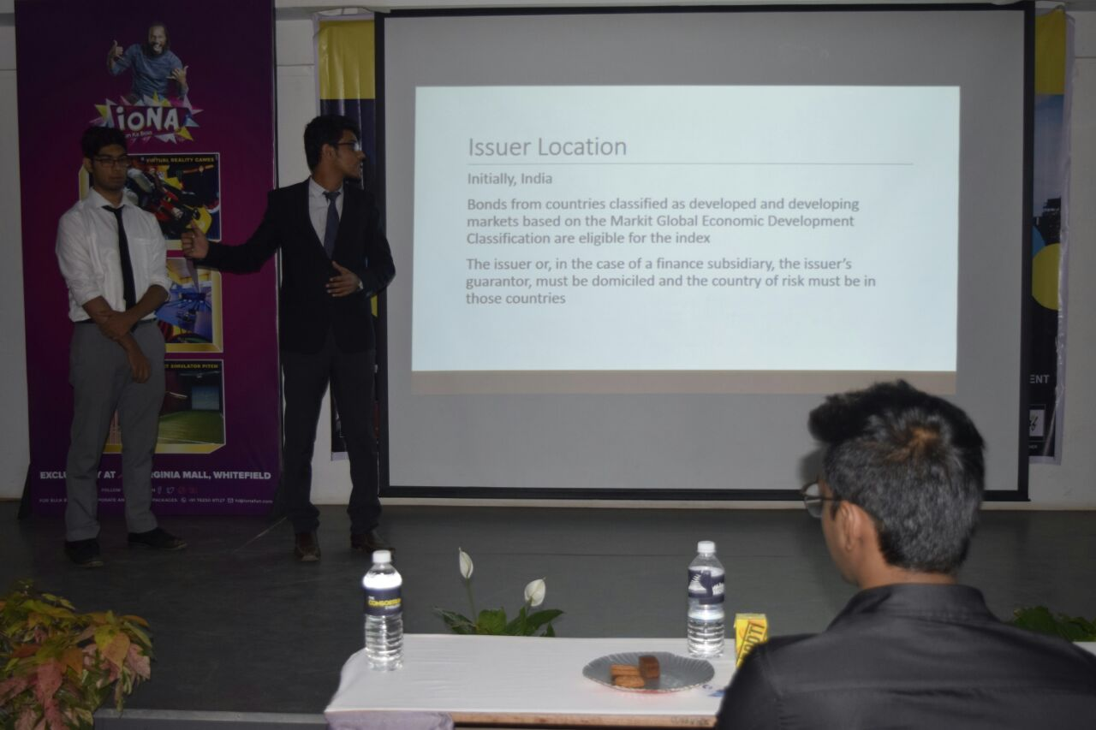
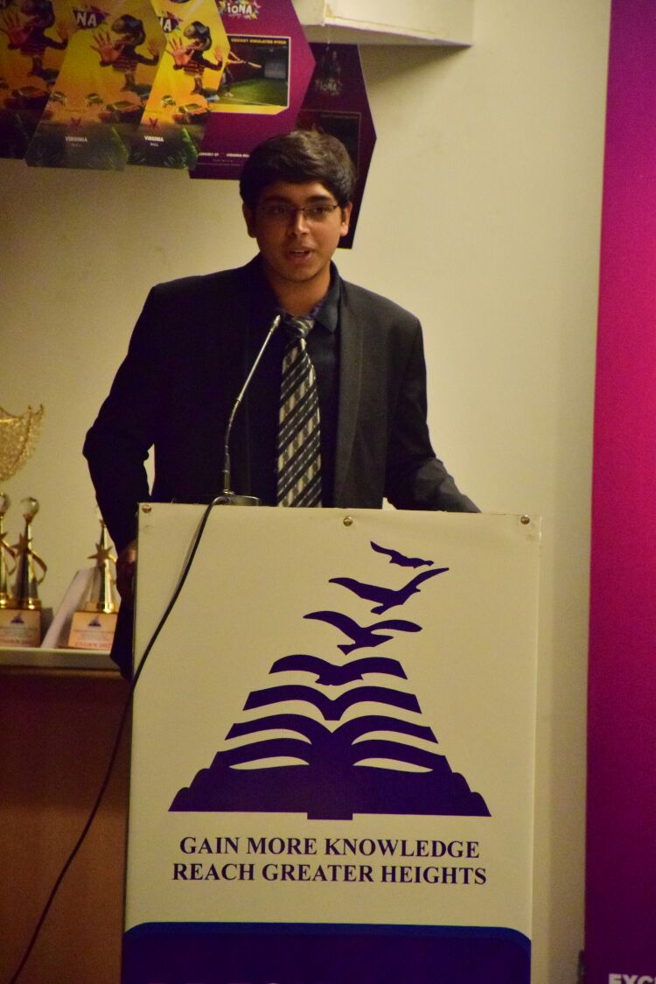
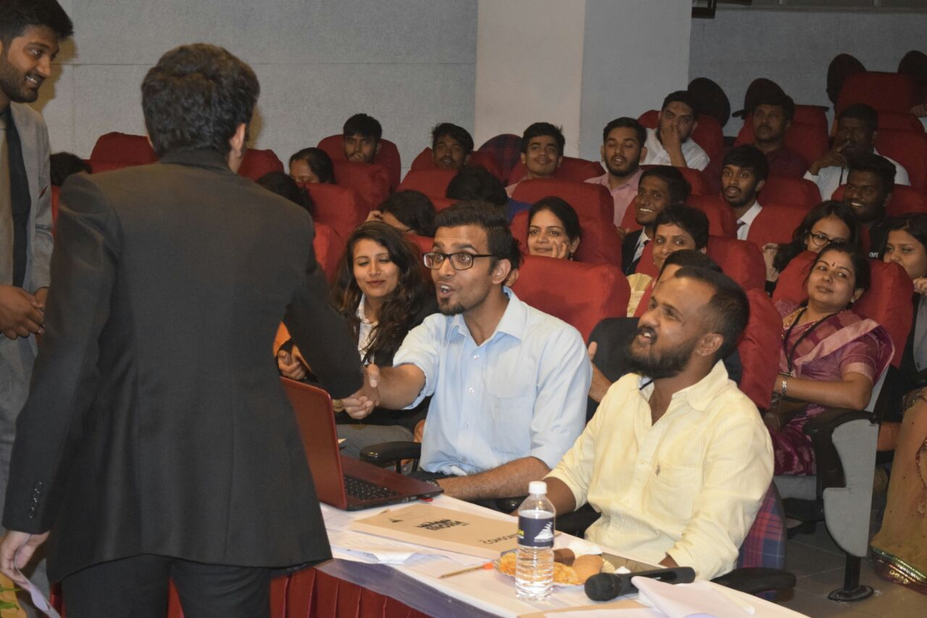

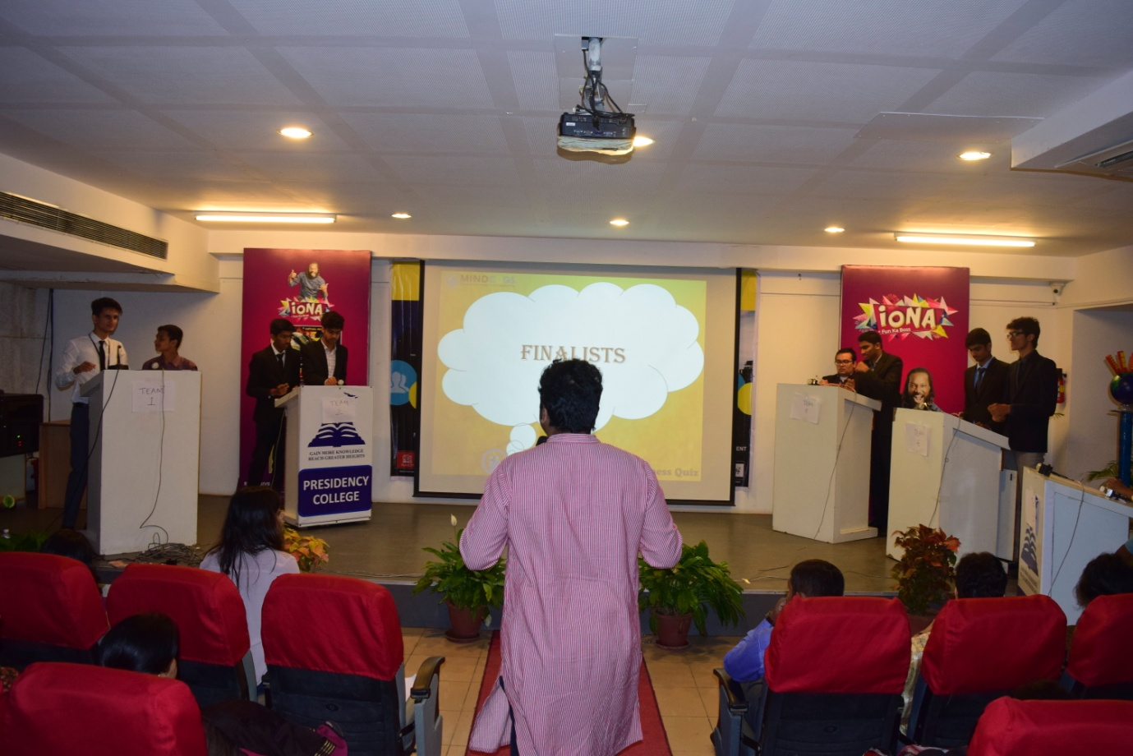
BQ WINNERS

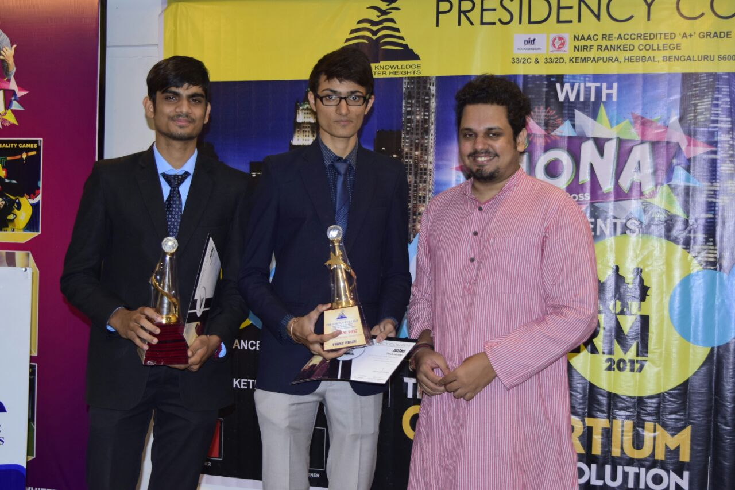
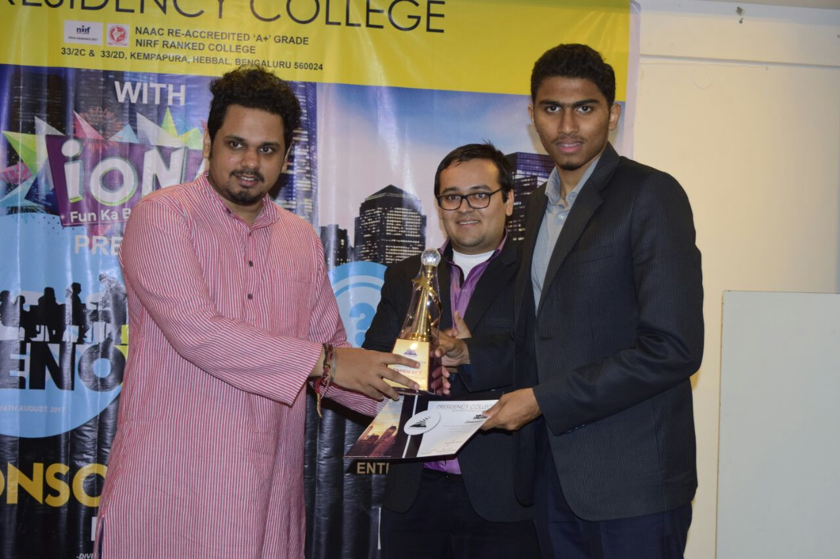
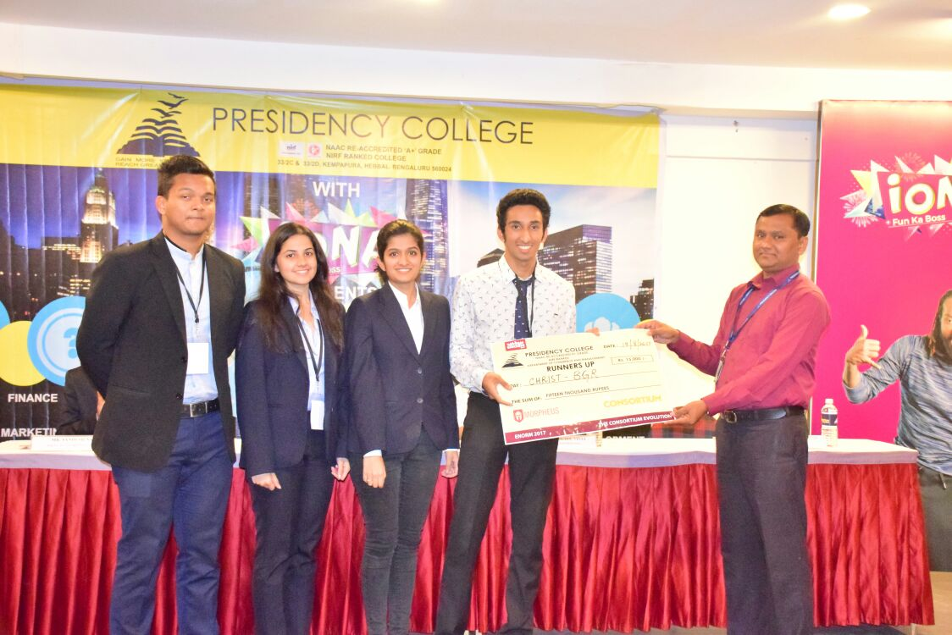
Enorm Runner up

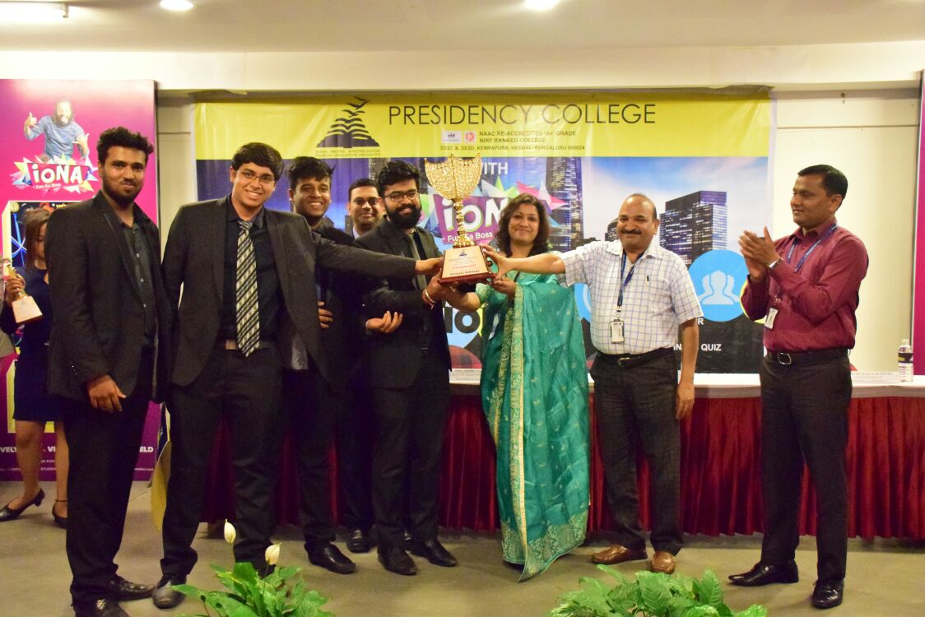
ENORM WINNER

Feedback of the fest
