Asthra- 2K19
Program Name: Intercollegiate IT Fest
Date: 27/2/2019
Time/Duration: 1 day
Total Number of Participants: 15
Name of Resource Person(s)/Organization: KLE College
Venue: KLE College
The students of DCA Department took part in an Intercollegiate IT Fest held on 27-02-2019 at KLE college, Bangalore. They exhibited their talents and skills and won several prizes in the fest. They had put up their great effort and skills, the students won the overall winners trophy for the college.
EVENT | WINNER
IT Quiz | 1ST –ASHISH  -NAIF
CODEING AND DEBUGGING | 1ST –UTPAL  -ANVIKA
POSTER MAKING | 1ST-JAIMIN
IT HUNT | 2ND –NAIF  -SHASHANG  - TUSHAR  - ADEEM
HARWARE GEEK | 2ND –NAIF  -ASHISH

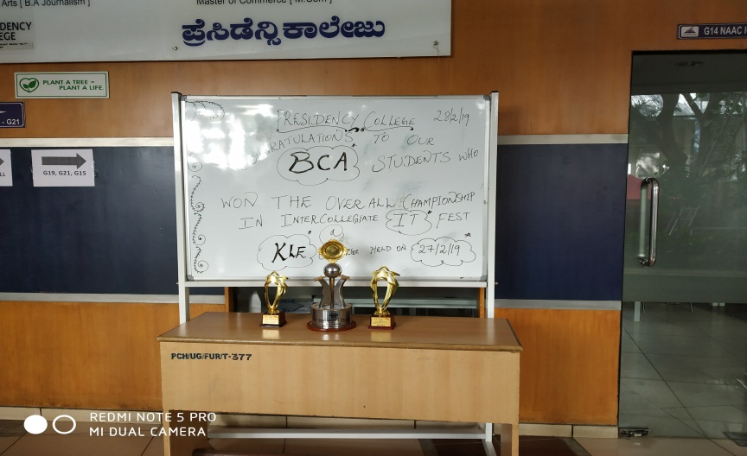
Overall championship at KLE college.

