Kristu Jayanti College
PRODIGY 2020

The Morpheus Club
Dept. of Commerce and Management

Date: 18th February 2020

TEAM

1) BEST MANAGER- KENNETH TONY GEORGE (VI BBA)

2) FINANCE – MATHEEN ARIF AND YASSER SAWOOD (VI BCOM AND II BCOM)

3) MARKETING - RITIKA SINGH AND SAHIL SOGI ( IV BBA)

4) HUMAN RESOURCES - MELISSA S AND RAYYAN KHAN ( VI BCOM AND IV BBA)

5) ENTREPRENEURSHIP DEVELOPMENT – PRERANA S AND MANISH B (IV BBA AND IV BCOM)

ABOUT THE COLLEGE

Kristu Jayanti College, founded in 1999, is managed by "BODHI NIKETAN TRUST", formed by the members of St. Joseph Province of the Carmelites of Mary Immaculate (CMI). The college is affiliated to Bangalore University. The college is recognized by UGC under the category 2(f) & 12(B). The college was accorded autonomous status from 2013 by the University Grants Commission, Government of Karnataka & the Bangalore University.

ABOUT THE THEME

ARMAGEDDON
Armageddon, the theme of Prodigy 2020 signifies the end of the World as cracks of disorder and destruction begin to form in the very foundations of life and civilization.
As the very fabrics of reality start coming apart and threaten to undo.
"Anyone can hold the helm when the sea is calm."
This event calls out emperors to rise up against catastrophes, showcase survival skills, and emerge victorious in times of destructive forces working against them.

PARTICIPANTS PLACED:

1) FIRST PLACE (HUMAN RESOURCE) - MELISSA SAMSON AND RAYYAN KHAN

2) SECOND PLACE (MARKETING) - RITIKA SINGH AND SAHIL SOGI

3) THIRD PLACE (ENTREPRENEURSHIP DEVELOPMENT) – PRERANA SHARMA AND MANISH B

PRESIDENCY COLLEGE WON THE OVERALL RUNNERS TROPHY

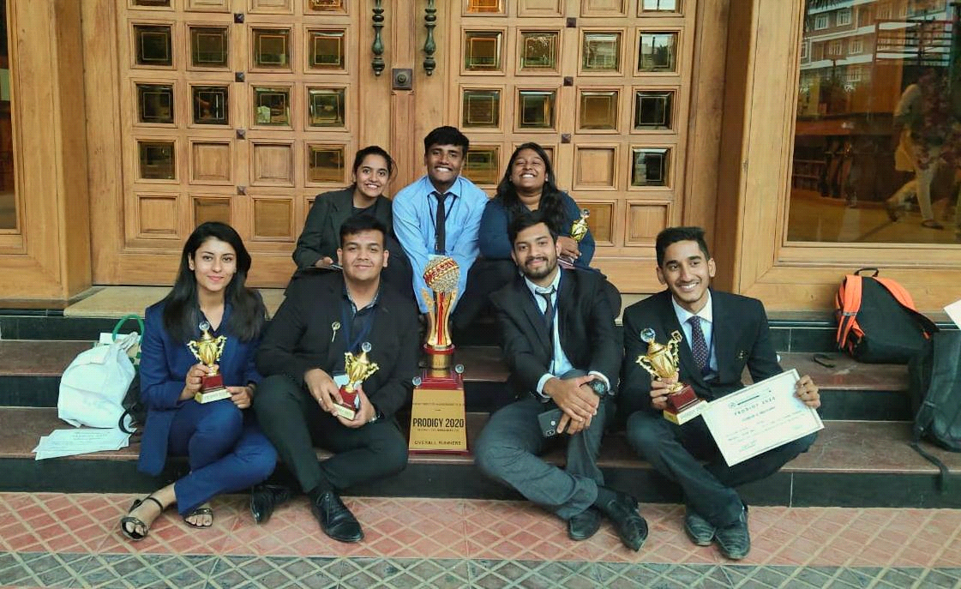
OVERALL RUNNERS TROPHY

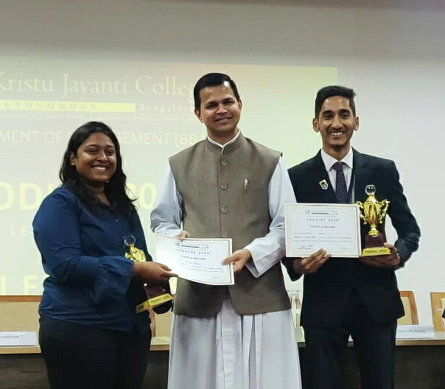
MELISSA SAMSON AND RAYYAN KHAN
(HUMAN RESOURCE - FIRST PLACE)

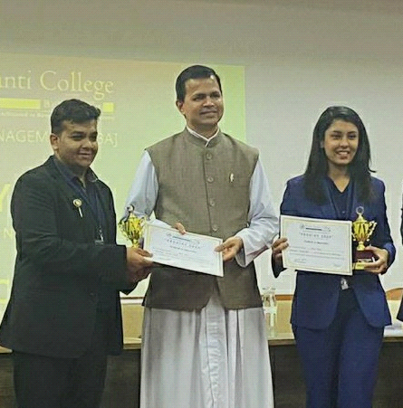
RITIKA SINGH AND SAHIL SOGI
(MARKETING - SECOND PLACE)

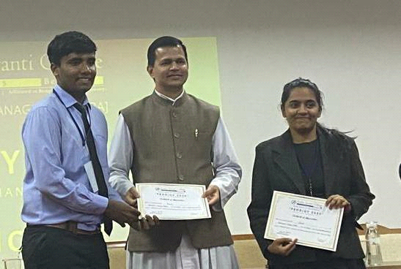
PRERANA S AND MANISH B
(EDP - THIRD PLACE)

