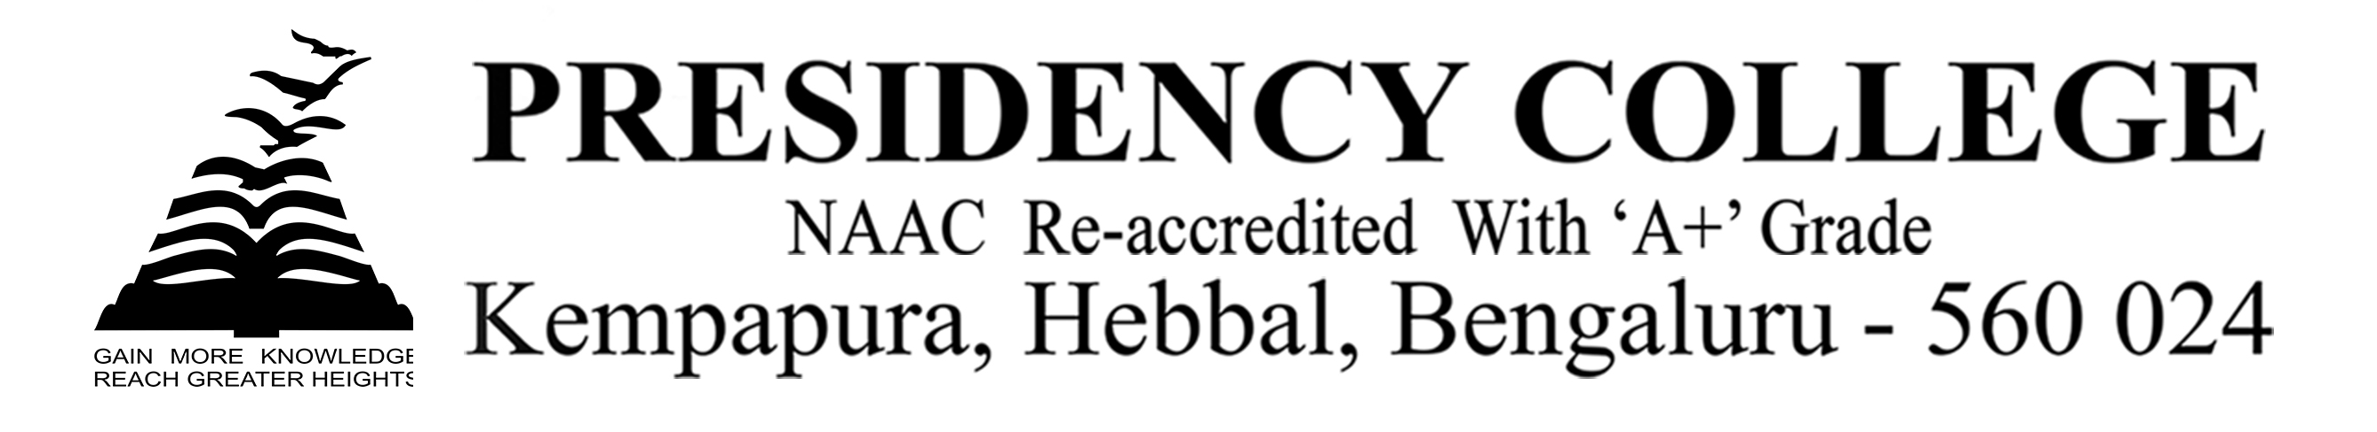

IT Club - 2019
Program Name: Mr And Miss Technozia
Date: 06/8/2019
Time/Duration: 2 days
Total Number of Participants: 20
Name of Resource Person(s)/Organization: Presidency College
Venue: Presidency College
The students of DCA Department took part in the IT Club Audition at Presidency College, Bangalore. They exhibited their talents and skills in the following events.
The events are as follows:
- Coding Round: A total of 20 first semester students participated in the coding round. They were asked to write code for the given problems using any language of their preference(C/C++/Java). The event was hosted on an online platform hacker rank.

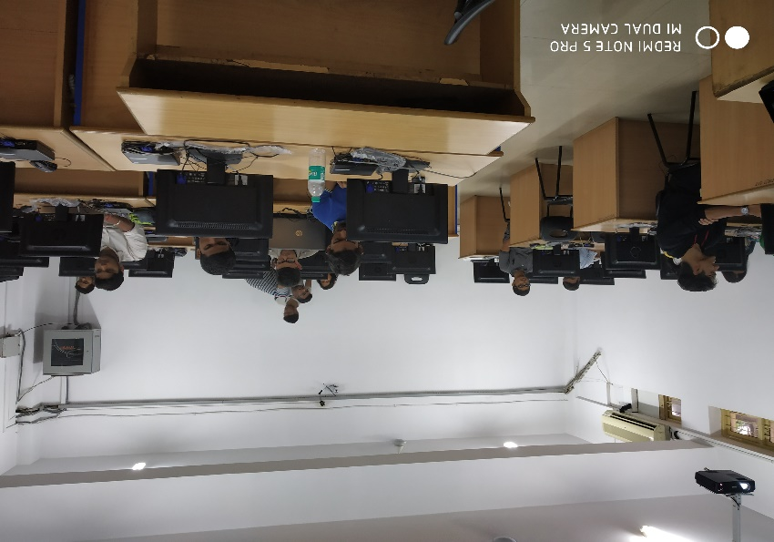

- Quiz and Preliminary Personality Round: Eleven Students were selected for this round based on the results of previous round. IT related questions were posed to them

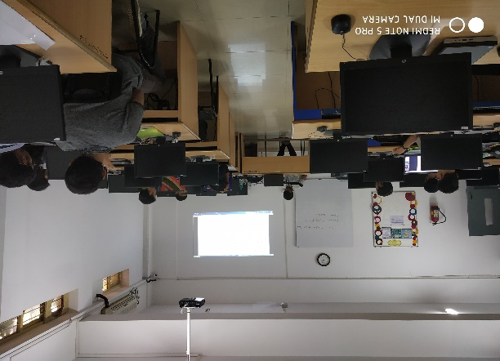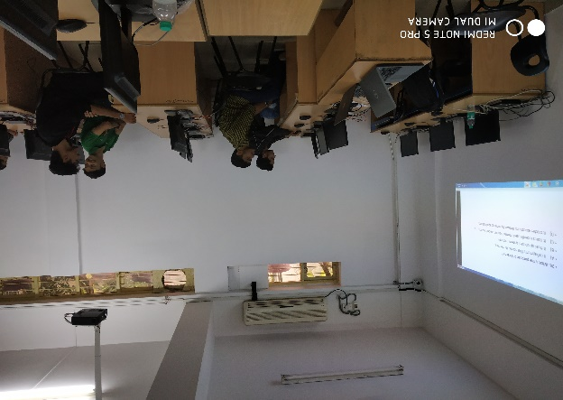

- Final Personality Round: Final rounds were conducted on 06-Aug-2019 and Six students were selected for this round and were judged by Mr.Vijay and Mr and Miss Technozia were selected.

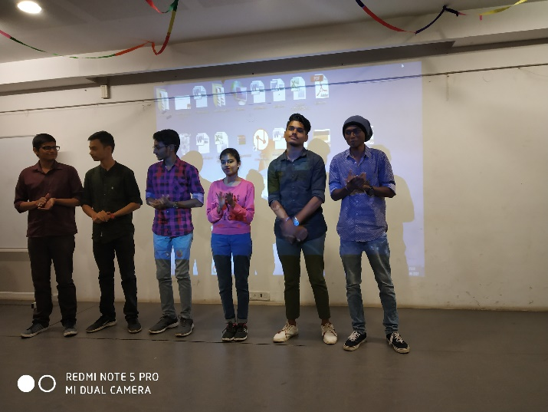

IT Club Audition 2k19 | 1st | Mr. Technozia Anand Kumar - 1st BCA ‘A’
IT Club Audition 2k19 | 1st | Miss. Technozia Anshika - 1st BCA ‘A’

