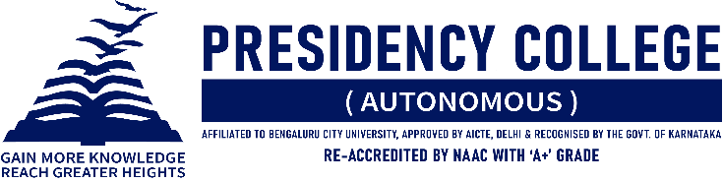
IT CLUB – TECHNOZIA – 2022
Program Name: # (Hash) 2022
Date: 02/07/2022
Time/ Duration: 1 Day
Total Number of Participants: 23
Name of Resource Person(s)/ Organization: Charan’s Degree College, Bangalore
Venue: Charan’s Degree College, Bangalore
# 2022 is an IT Fest organized by Department of BCA to host events related to various technical aspects of what students learn. It is a means for students to showcase their practical talent in the IT field they’re learning, not just limit themselves to bookish knowledge. The underlying spirit of our IT fest is to promote technology, scientific thinking, and innovation among young minds by providing them the opportunities to participate in various IT-related events. The events were WEB-BEE which is Web Designing, CODE-STORMING AND SPEED BUGGING which is Coding and Debugging, Q-FIESTA which is IT Quiz and Connection, ALPHA TECHIE which is IT Manager, TECH-SCAVENGERS which is Treasure Hunt, I TECH SHOW which is Project Presentation, and GAMER’S UNITE which is Gaming.
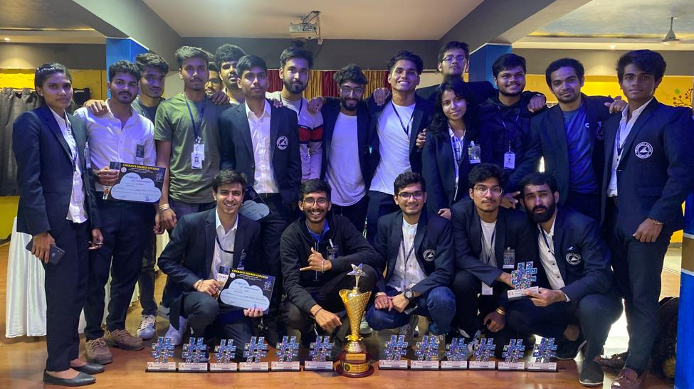
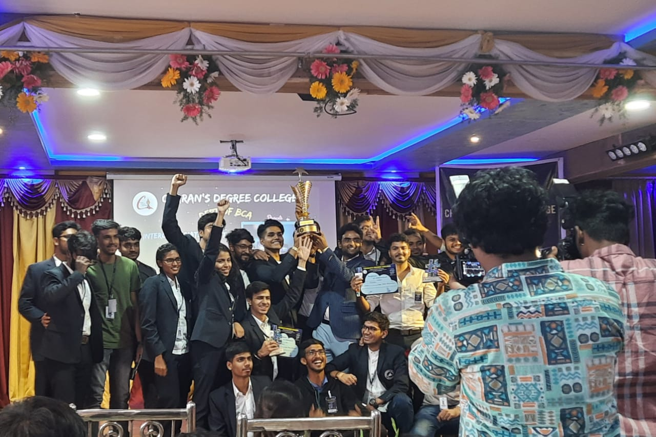
EVENT | PARTICIPANT | POSITION
Code-Storming and Speed Bugging | Anurag Kumar Singh,  Arindam Hazra, | Winners
Q-Fiesta | Tanupam Saha,  Mukunthan Nagarajan. | Winners
Alpha Techie | Priyadarshan Giri | Winner
I Tech Show | Shubham Singh Rathode,  Sidhra Kounain V. | Runners Up
Tech Scavengers | Tanupam Saha.  Mukunthan Nagarajan. | Winners
Gamer’s Unite | Nikki Kumar H,  Rizwaan Ansari,  Raj M M,  Prem Sagar Mishra. | Runners Up

