Faculty development program on Data Analytics with R
Program Name: Data Analytics with R

Date: 15/10/19 and 16/10/19

Time/Duration: 2 days

Total Number of Participants: 29

Name of Resource Person(s)/Organization:
Dr Narayana Swamy
Dr Deepa
Mr Vishweswarsastry
Mr Kartik

Venue: Lab 3
Two days faculty development program was conducted on 15/10/19 and 16/10/19. There were 29 participants from various colleges in Bangalore. The Workshop started with an inauguration session. Dr Binoy Mathew, (Associate Professor & Centralised Placement Cell, VTU), Mr Fayaz(Federal Consulting) and Dr. Narayana Swamy(HOD- Department of Computer Applications) were present during the inauguration. Dr Binoy Mathew stressed upon the new skill sets to be learned by students to be employable. Mr Fayaz talked about data and how it should be handled with efficiency; Federal Consulting sponsored the kits to the participants.
Each session was well planned starting with a theoretical explanation of concept followed by practical implementation of the concept in R software. Participants were completely engaged in hands-on session on both the days. Day 2 of the workshop continued with the advanced topics of analytics. The following topics were covered during two days:
- Introduction to Data Analytics
- Introduction to R Programming
- Exploratory Data Analysis
- Hypothesis & Correlation
- Simple and Multiple Linear Regression
- Classification
- Logistic Regression

Online feedback was taken at the end:
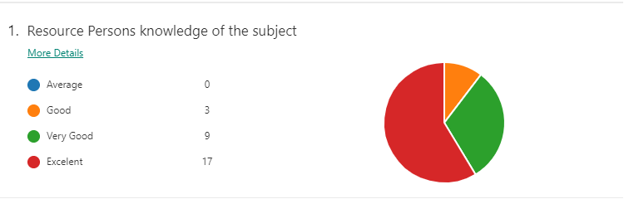
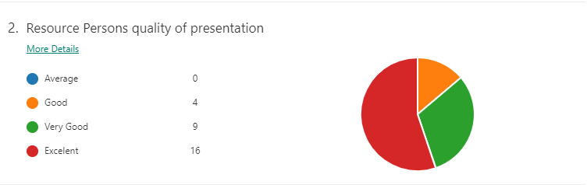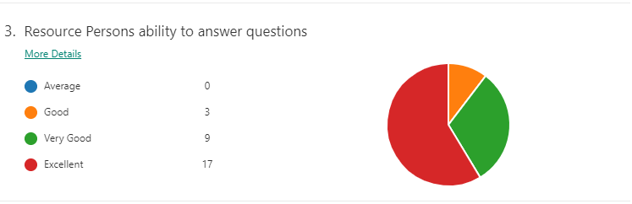
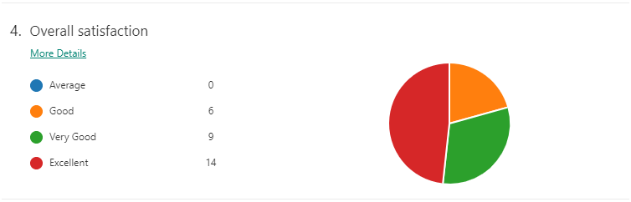
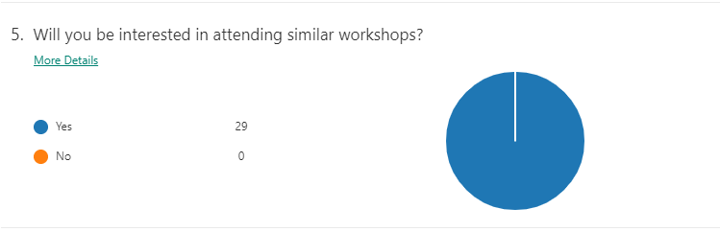

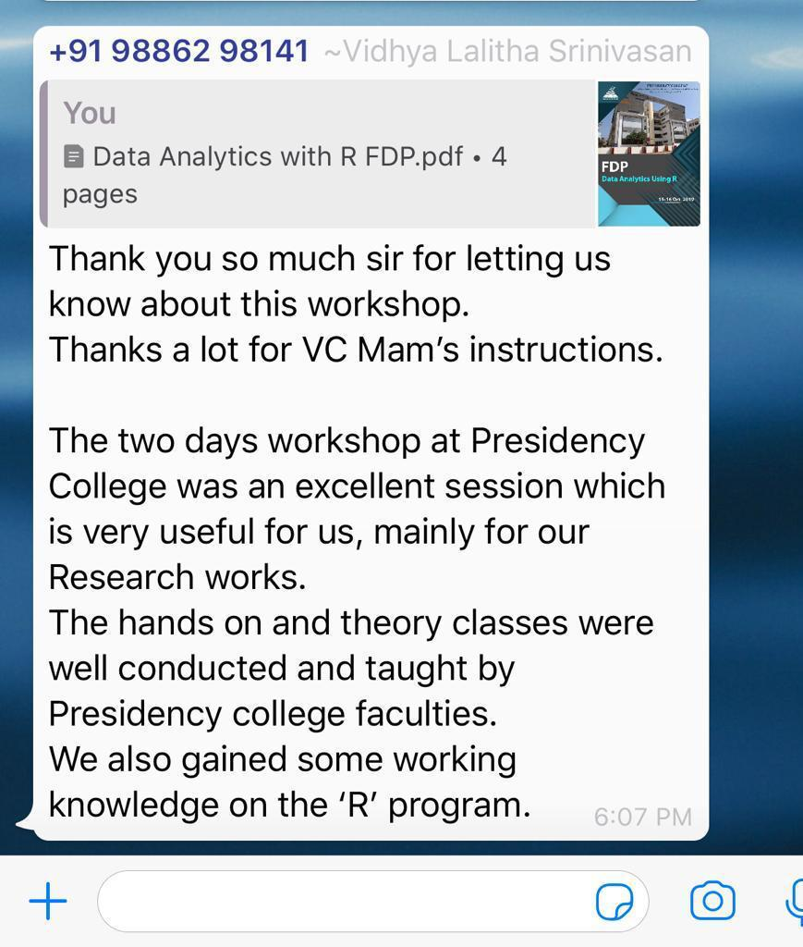

pses of Two days sessions:
