Morpheus – The Management Club
ENORM 2019 – The Nexus “Liaisons to Ascension”

The Department of Commerce and Management conducted its Annual Management Fest ENORM - 2019 ‘THE NEXUS’ on the 3rd & 4th September, 2019 providing a platform to the students from various colleges to showcase their managerial skills and abilities. The participants were given hypothetical situations from the corporate world and were tested to the limit.
48 participants from 12 colleges, including 2 outstation colleges took part in the fest making ENORM 2019 a grand success.
With the tag line - “Liaisons to Ascension” the theme integrated all events that are generally conducted in a management fest (HR, Finance, Marketing, ED and BM) into a four member contingent event with a new scoring format which focused on a team’s consistency in performance. Rounds were designed solely by the students of the Morpheus Management Club, with support and assistance from the faculty of Department of Commerce and Management. Business Quiz was simultaneously held as a separate two member open event but was a crucial part of the fest.
ENORM - 2019 ‘THE NEXUS’ - “Liaisons to Ascension” entails the journey of a small corporation to becoming a successful establishment across different industry verticals.

‘THE NEXUS’ “Liaisons to Ascension” is the connection or a series of connections with different components like Technology, Aviation and Trade Wars.

Over the span of two days, the participating colleges faced various situations in the fields of Aviation, Trade Wars & Technology and tackled case studies, provided solutions and showcased their managerial abilities, time management skills, knowledge, intellect and above all, their professional attitude.

Day 1 – 3rd Sept, 2019

The event started at 9:30 AM with the inaugural ceremony and was honored by the presence of Dr. Ali Khwaja, Chairman, Banjara Academy, Bangalore as the Chief Guest.
Day 1 of Enorm’19 witnessed 12 colleges with a team of 4 members each in the “Contingency” events and 10 colleges with a team of 2 members each in the “Business Quiz” event. There were 5 rounds or case studies that were provided to the participants. These case studies in turn had to be solved and presented by the participants to the external and internal judges of ENORM’19.
Each team gave its best to move into Day 2 after the Elimination Rounds that took place at the end of Day. The Elimination Rounds were extremely challenging where the participants experienced throat competition.

Day 2 – 4th Sept, 2019
The second day of Enorm’19 opened with 6 colleges in the “Contingency” event and 8 colleges in the “Business Quiz” event, after the eliminations of Day 1. Further, the battle for the best was narrowed to 4 teams in the “Contingency” event and to 6 teams in the “Business Quiz” event.
The Valedictory Ceremony was chaired by our esteemed Principal, Dr. Pradeep Kumar Shinde, the Coordinator of the Department, Ms. Midhu Nair and the Morpheus Club Conveners, Ms. Kiranmayi & Ms. Shazia Sait.
The Runners-Up trophy and a cheque of Rs. 15,000/- was presented to Jain University - SCS, while the Winner’s Trophy and an International Trip was awarded to Jain University – CMS .
The Business Quiz Runners-Up were Christ DOC who took home a Cash Prize of Rs 3000/- while the Business Quiz Winning Trophy was awarded to Christ DPS along with a Cash Prize of Rs 6000/-
The end of a story is the new beginning for many others. ENORM 2019- The Nexus was an enormous, remarkable and a memorable event for the participants as well as the Organizers. The Department promises to bring such events even in the future to instill a healthy spirit of competition and push students ahead to make the best of their knowledge and talents.

The Most Coveted ENORM Trophy
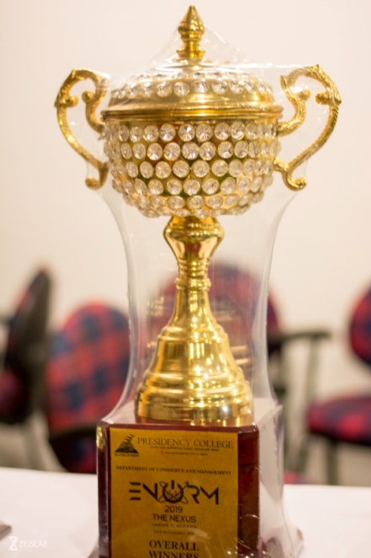

Inauguration – Dr. Ali Khwaja, Chief Guest lighting of the Lamp
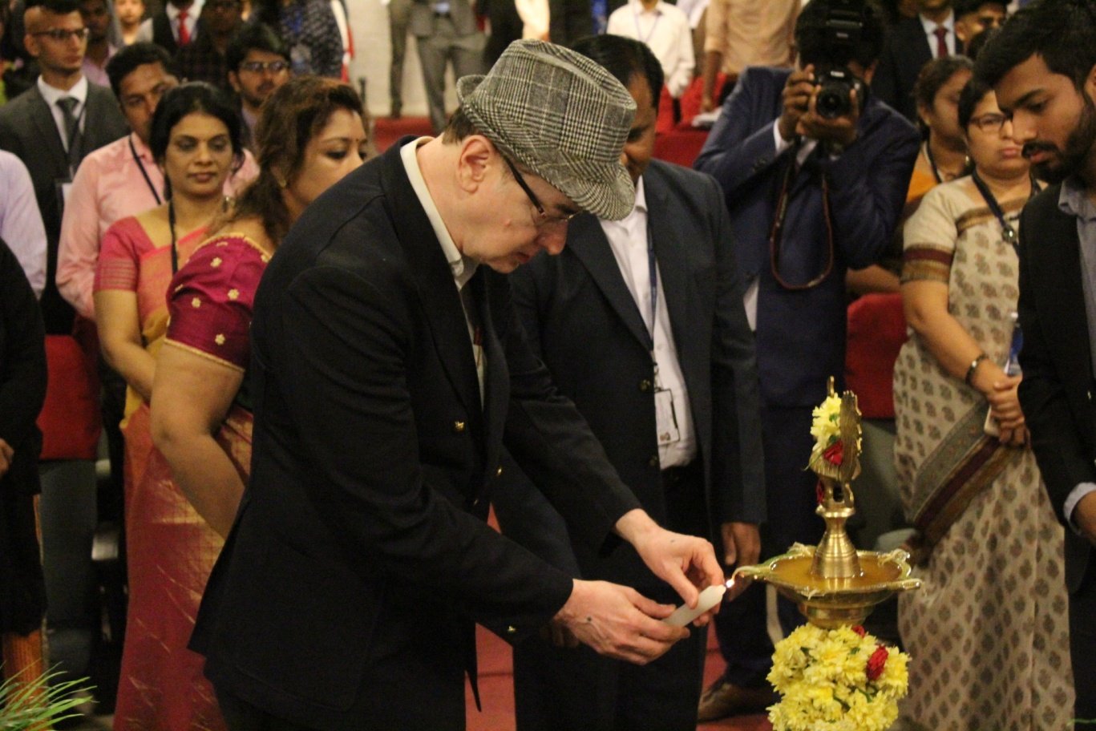

The Stress Round
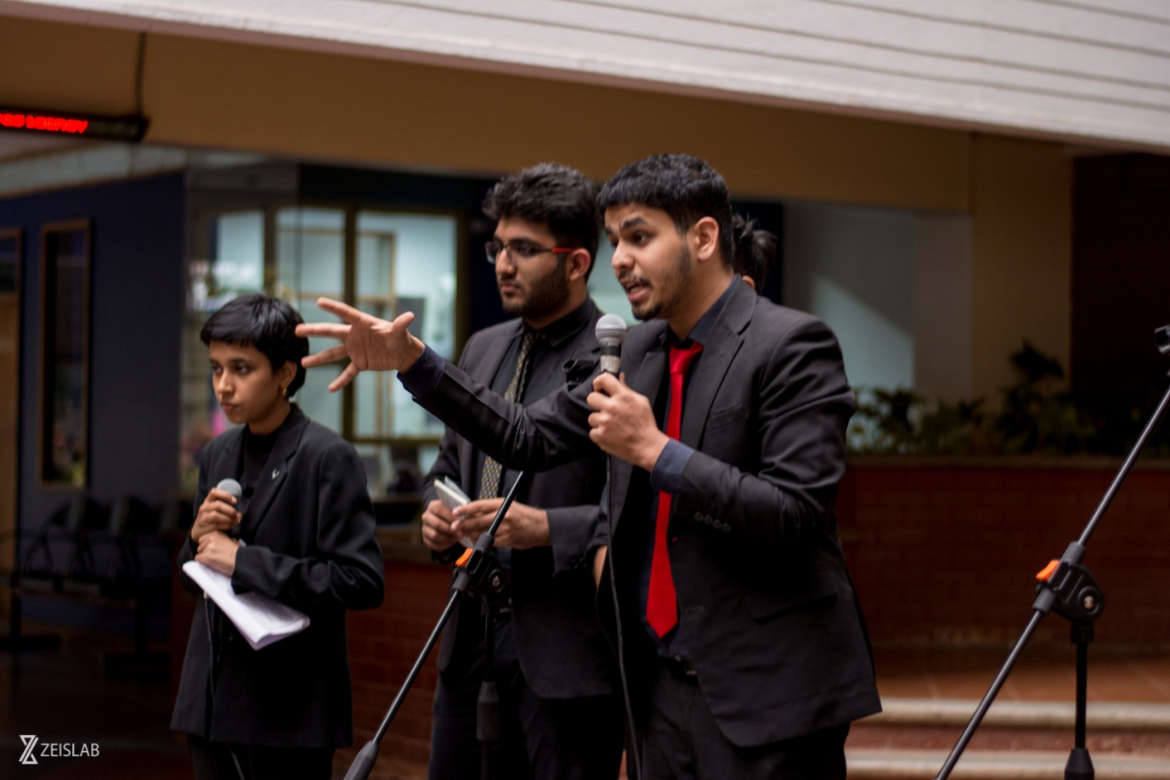

The Runners Up of ENORM 2018
Jain University – SCS
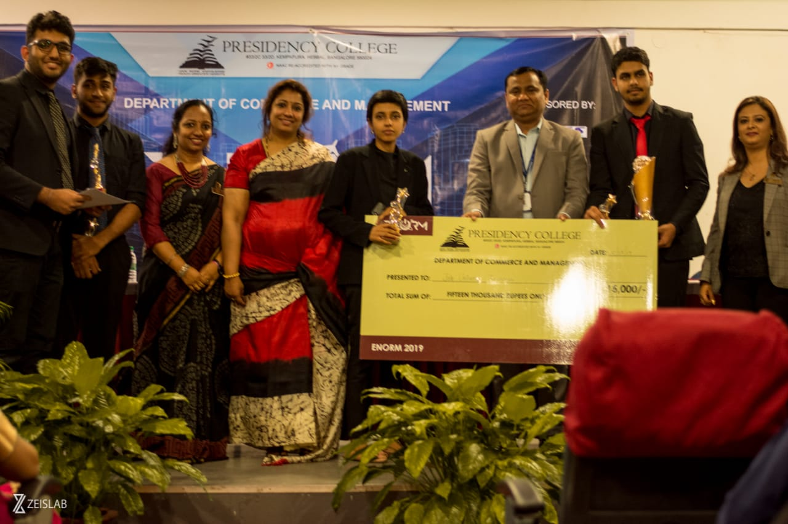

The Winners of ENORM 2019 & Winners of the International Trip
Jain University – CMS.

