Computantra-2019
Program Name: IT Fest Computantra-2019
Date: 30/8/2019 & 31-Aug-2019
Time/Duration: 2 days
Total Number of Participants: 300
Name of Resource Person(s)/Organization: Dr.Hanumanthappa and Mr.Ashish
Venue: Presidency College
The Department of Computer Applications had organized an intercollegiate IT fest on August 30th and 31st in the college premises. The theme for the fest was “TECHDROID” which is a perfect blend of innovation and technology. We had received an overwhelming response from 29 different colleges in Bangalore. The Chief Guest for the inauguration ceremony was Dr. M .Hanumanthappa – Professor , MCA Department, Bangalore university, Bangalore and Mr.Ashish –Software Engineer from Global tech. was the guest of honour for the fest.
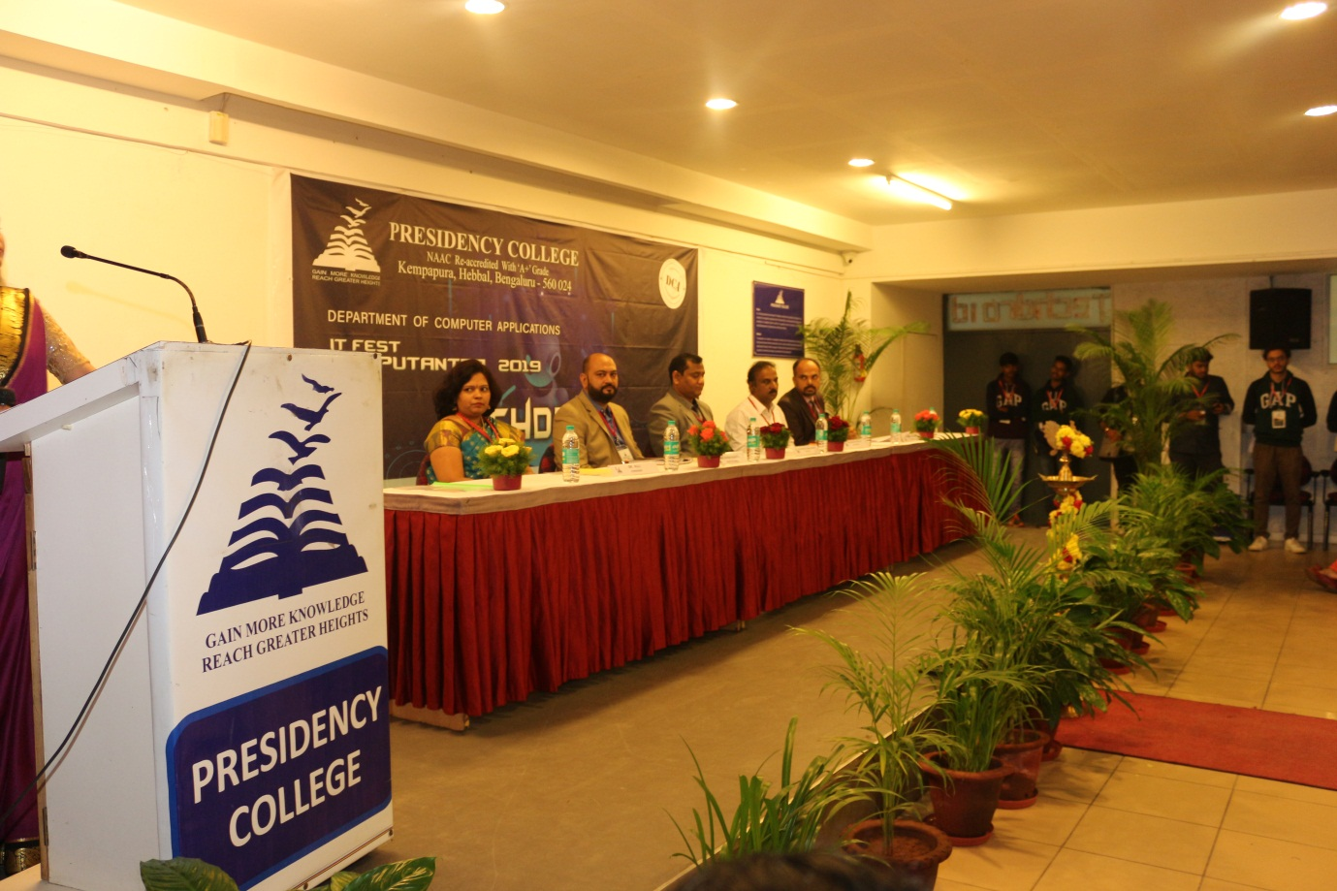
Inauguration chief guest-Dr.M.Hanumanthappa, Guest of Honour-Mr.Ashish
The events that were held on the first day were Gaming, Coding and Debugging, Movie making, Hackathon, IT Manager and IT-quiz. The preliminary rounds of IT-Manager and IT-Quiz were conducted on the same day.
The events that were held on the second day were the finals of IT-Manager, Hackathon, Coding ,Gaming and Movie making.The participants from 29 different colleges actively took part and exhibited their talents, skills and won several prizes in the fest.
EVENT DETAILS:
S.NO | Event Name | Number of teams | Number of participants
 | Hackathon | 5 | 10
 | Coding and Debugging | 28 | 56
 | IT-Quiz | 37 | 74
 | IT-Manager | 19 | 19
 | Movie Making | 13 | 26
 | Counter Strike | 13 | 65
 | NFS | 13 | 13

The Overall Winners trophy was bagged by Christ University whose participants exhibited exceptional IT Skills and expertise, followed by Kristu jayanti College who took the Overall Runners up trophy.
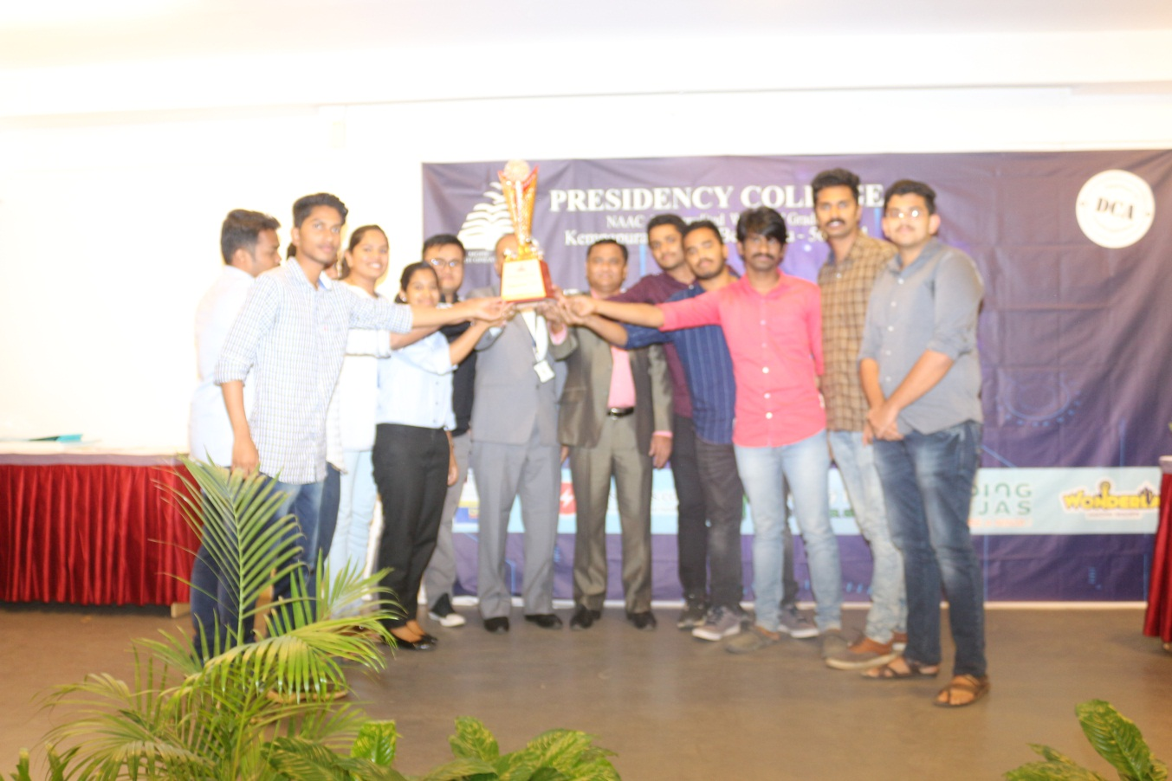
Overall Championship Computantra 2019,Techdroid - Christ University

The list of Colleges who took part in our IT-fest Computantra-2019.
S.no | College Name
 | ST CLARET COLLEGE
 | AIMS INSTITUTE
 | SRN ADHARSH DEGREE COLLEGE
 | CHRIST UNIVERSITY
 | DAYANANDA SAGAR
 | NEW HORIZON COLLEGE
 | ST.JOSEPHS COLLEGE
 | JAGADGURU RENUKACHARYA DEGREE COLLEGE
 | ST.VINCENT PALLUTIN COLLEGE
 | KLE COLLEGE
 | NAGARJUNA DEGREE COLLEGE
 | KRISTU JAYANTI COLLEGE
 | INDOASIAN DEGREE COLLEGE
 | ST.ANNES DEGREE COLLEGE
 | OCEANIK PREUNIVERSITY AND DEGREE COLLEGE
 | VAGDEVI VILAS DEGREE COLLEGE
 | RPA COLLEGE
 | SHESHADERIPURAM COMPOSITE
 | SINDHI COLLEGE
 | VET FIRST GRADE COLLEGE
 | SRI BAGAVAN MAHAVEER JAIN COLLEGE
 | SHESHADERIPURAM FIRST GRADE COLLEGE
 | ASIAN INSTITUTE OF DESIGN
 | CMR INSTITUTE
 | SURANA COLLEGE
 | RAMAIAH
 | SOUNDARYA INSTITUTE OF MANAGEMENT
 | JAIN COLLEGE
 | SESHADRIPURAM MAIN COLLEGE

Glimpses of Computantra-2019
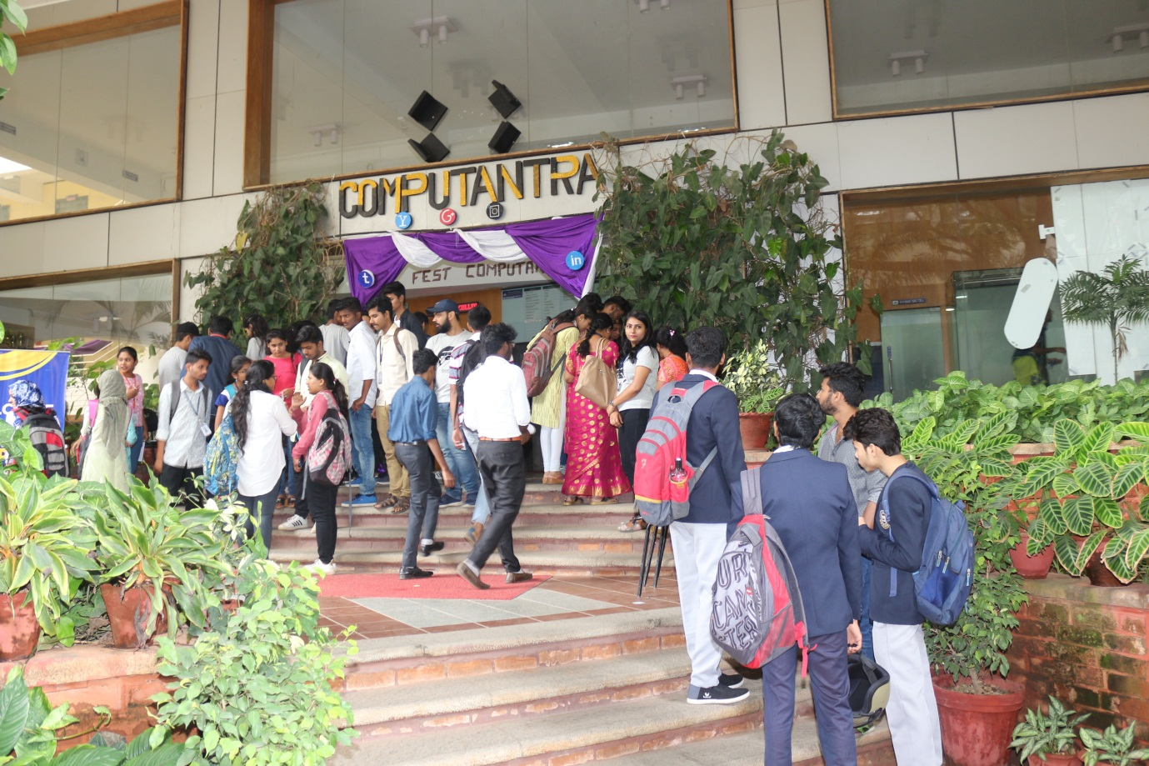

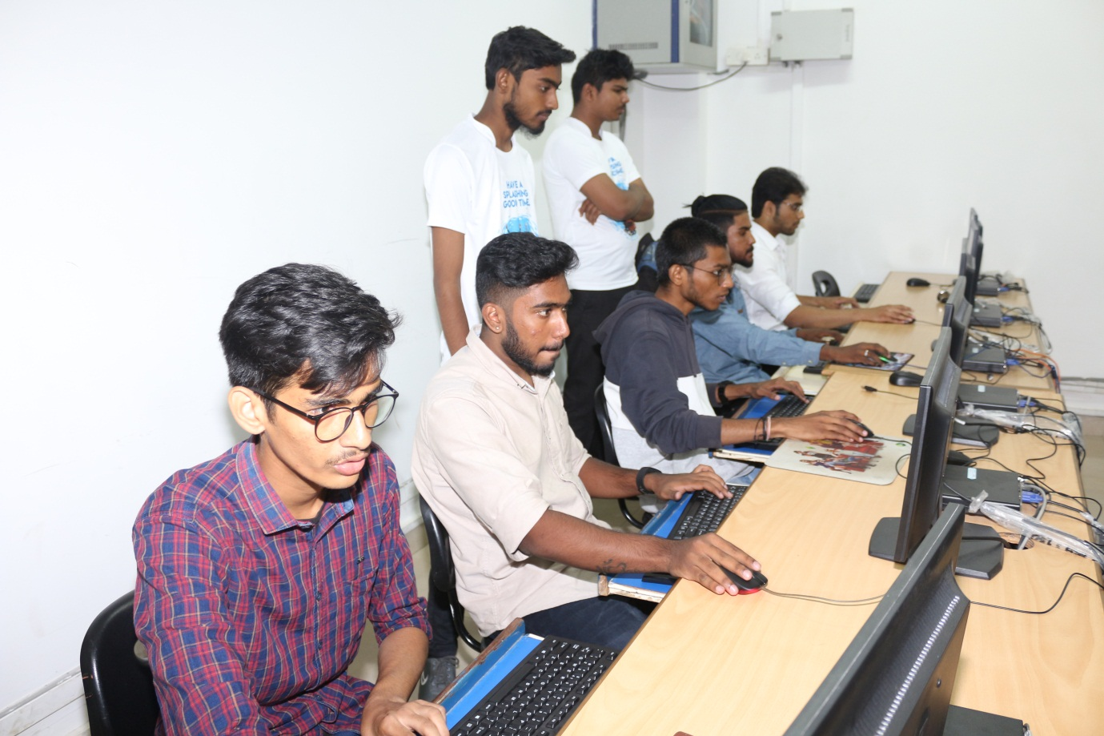

Computantra-2019 Team
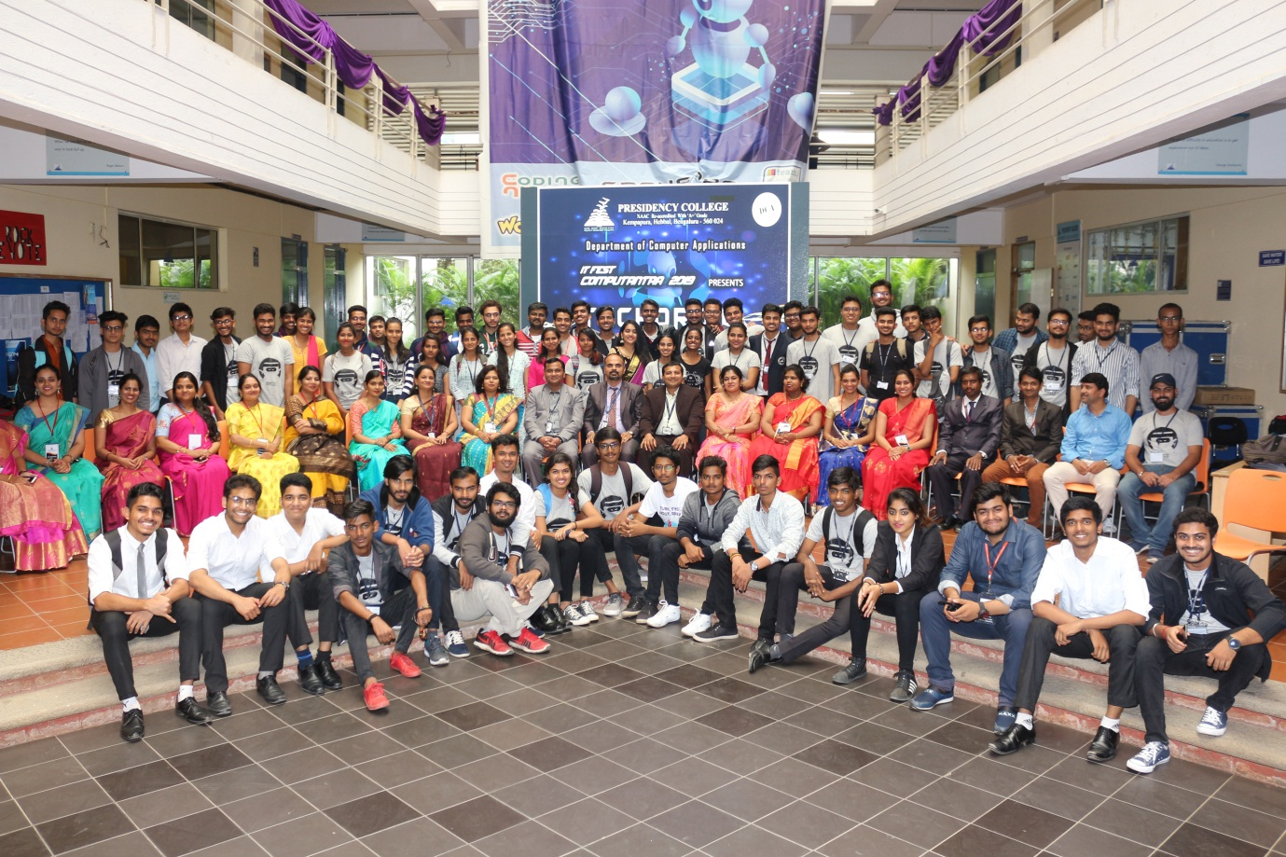

Success of Computantra-2019 “TEAM WORK”
