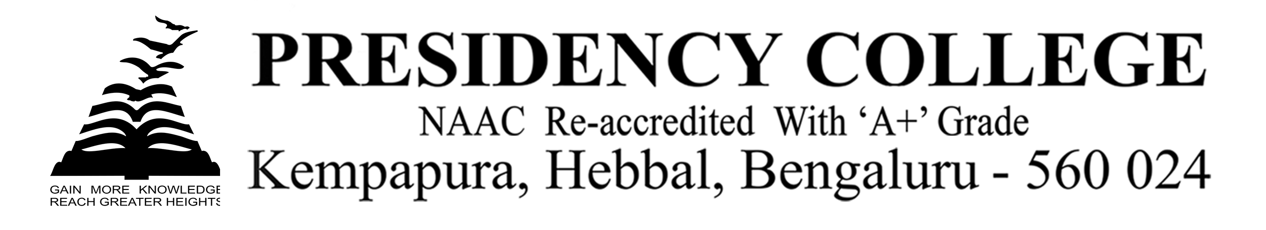
INTERFACE-2019
Program Name: IT Fest INTERFACE-2019
Date: 20/8/2019 & 21-Aug-2019
Time/Duration: 2 days
Total Number of Participants: 21
Name of Resource Person(s)/Organization: Christ University
Venue: Christ University
The students of DCA Department took part in the Intercollegiate IT Fest INTERFACE-2019 on 20-08-2019 & 21-Aug-2019 at Christ University, Bangalore. They exhibited their talents, skills and won several prizes in the fest. Our students had performed extra-ordinarily throughout the Fest and they had brought laurels to the college by winning the overall Championship with 23 individual trophies for the college.
Dates | EVENT | PRIZE | PARTICIPANT
20-Aug-2019 | IT Manager | 1st | Sreedhar
21-Aug-2019 | IT Quiz | ^{1st} | Siddharth & Aneesh
21-Aug-2019 | Web Designing | 1st | Jaimin
20-Aug-2019 | Graphic Designing | 1st | Jaimin
20-Aug-2019 | Event X | 1st | Manish, Ayush, Abhishekh & Ganesh
21-Aug-2019 | Hackathon | 1st | Sanjeev, Karthik & Anshika
20-Aug-2019 &  21-Aug-2019 | Photography | 1st | Akash & Subham
21-Aug-2019 | Tech-wizard Tournament | 1st | Utpal Sreedhar Shivank
20-Aug-2019 | Counter Strike | 1st | Rishu, Jeet,  Abhishekh & Awaiz
20-Aug-2019 | Tag-Coding | 2nd | Avinash, Utpal & Siddharth
20-Aug-2019 | FIFA | - | Shivank
20-Aug-2019 &  21-Aug-2019 | Videography | - | Vetrivel & Vijay

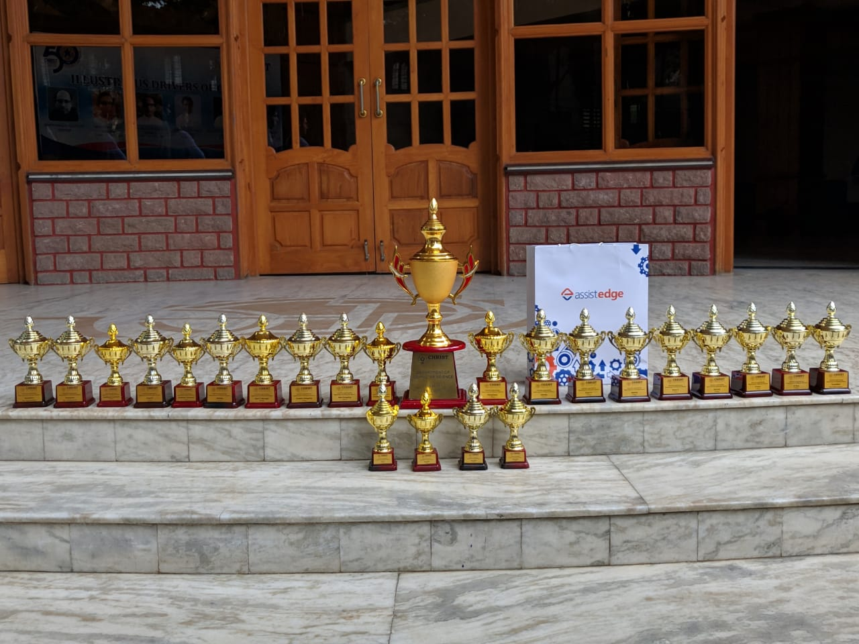

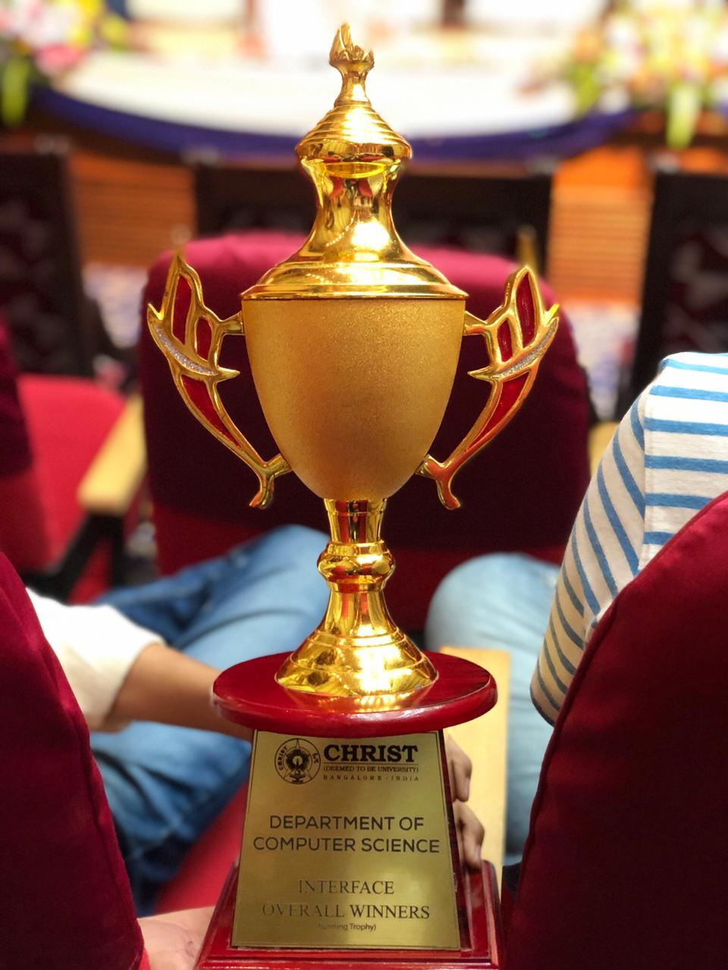

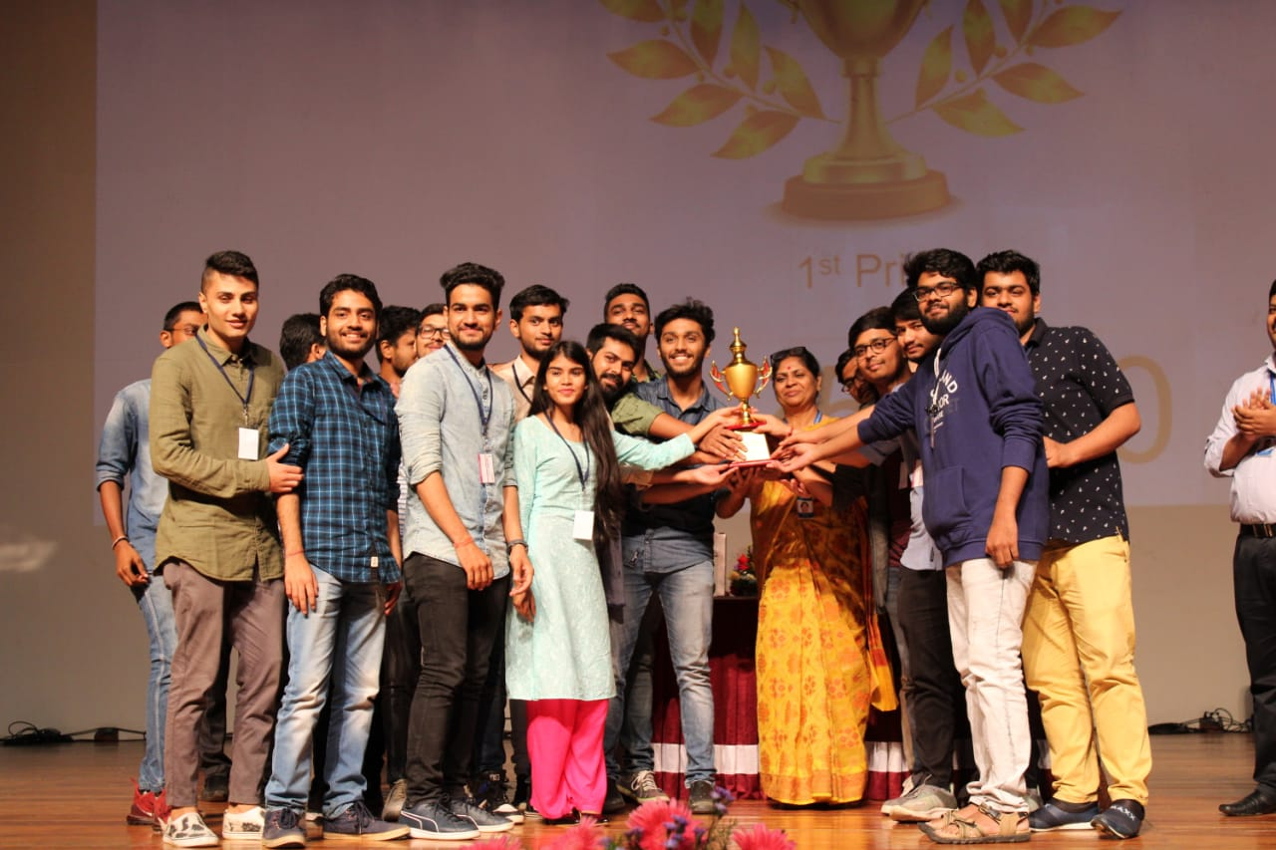

Overall Championship Christ University

