Presidency College
Reaccredited 'A+' by NAAC
NIRF Ranked College
Kempapura, Hebbal, Bengaluru – 560024
www.presidencycollege.ac.in

BIG FIGHT 2019
Illusion of Time

Presidency College
Reaccredited 'A+' by NAAC
NIRF Ranked College
Kempapura, Hebbal, Bengaluru – 560024
www.presidencycollege.ac.in

INTRODUCTION:
Big Fight is the flagship annual debate and oratory competition organized by the Management Club of Presidency College, Morpheus. The competition aimed at pitting the best orators and speakers in one arena and challenged their intellect, speech, vocabulary, and overall the delivery of their thoughts through various rounds and tasks.
Big Fight 2019, adopted the trend of creativity and innovation, and embraced the undergraduate wing of Presidency of all departments - BA Journalism, BCA, BBA and BCOM.

BIG FIGHT- ORGANISING TEAM
SL NO. | NAMES | SEMESTER
01. | Mohammed Adil | 6th Semester
02. | Allen Tessy | 6th Semester
03. | Pavan Krishnaa | 6th Semester
04. | Raj L H | 6th Semester
05. | Harold Nixon | 6th Semester
06. | Mohammed Ahad | 4th Semester
07. | Puja Jumnani | 4th Semester

VOLUNTEERS TEAM
SL NO. | NAMES | SEMESTER
01. | Bhawana | 6th Semester
02. | Harold | 6th Semester
03. | Bhushan | 6th Semester
04. | Aditi | 6th Semester

REGISTRATION TEAM
SL NO. | NAMES | SEMESTER
01. | Melissa | 4th Semester
02. | Rida | 4th Semester
03. | Madhushree | 4th Semester
04. | Madhumita | 4th Semester

MC TEAM
SL NO. | NAMES | SEMESTER
01. | SahilSogi | 2th Semester
02. | Rithika Singh | 2th Semester

SCHEDULE OF THE EVENT
SL NO. | TIMINGS | ROUNDS | NAME OF THE ROUND | JUDGES
01. | 9:30 – 10:00 | Inauguration
02. | 10:00 – 12:00 | Round 01 | Group Discussion | Pavithra Ma’am  &  Shalini Ma’am
03. | 12:00 – 02:00 | Round 02 | JAM | Noorien Ma’am
04. | 02:00 – 02:30 | Round 03 | Lunch Break
05. | 02:30 – 3:30 | Round 03 | Stress Round | Prachi Ma’am
06. | 03:30 – 3:45 | Valedictory

INAUGURATION CEREMONY
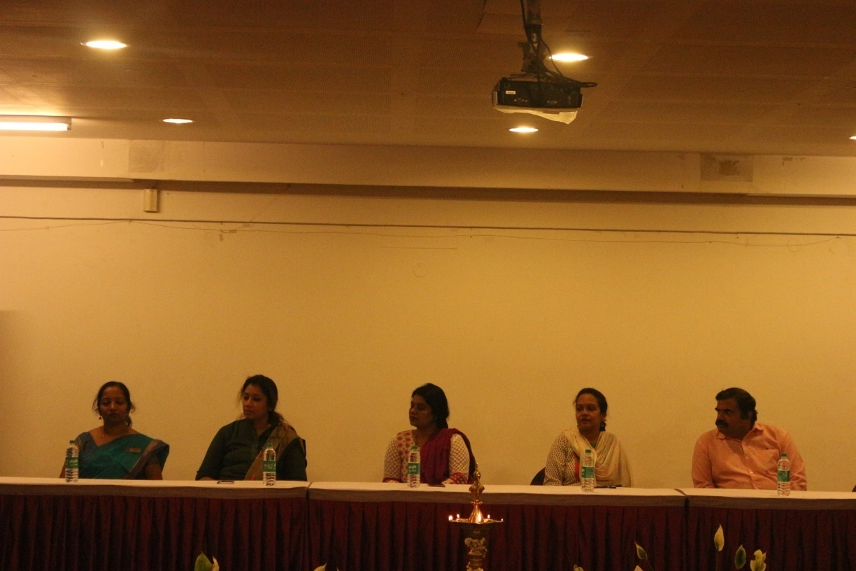
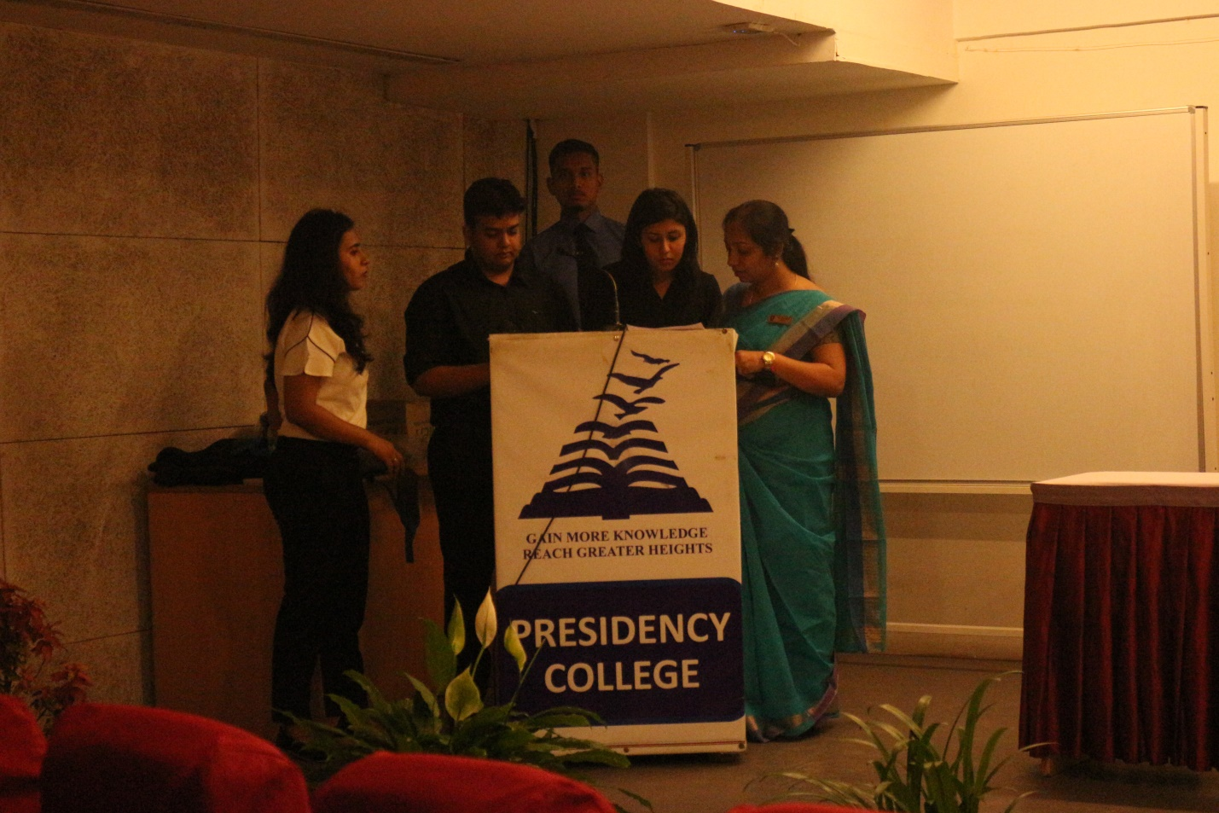
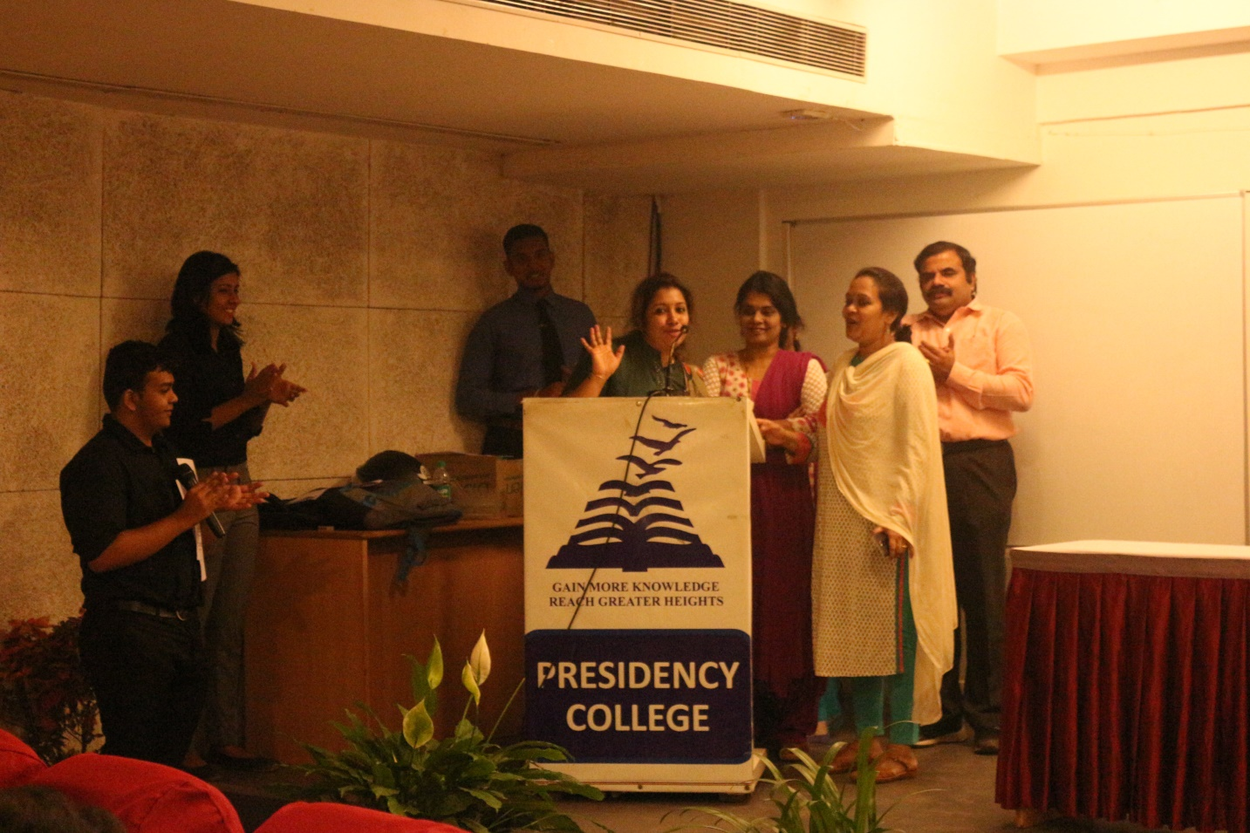
Round 01:
Group Discussion: 90 enthusiastic participants went in for the Group Discussion. It was planned and executed with 15 set of panels consisting of 7 members in each set, and they were given a time limit of 5+2 minutes. Our judges were Pavithra Ma’am and Shalini Ma’am from the placements department who had a mission to select 31 participants out of 90.
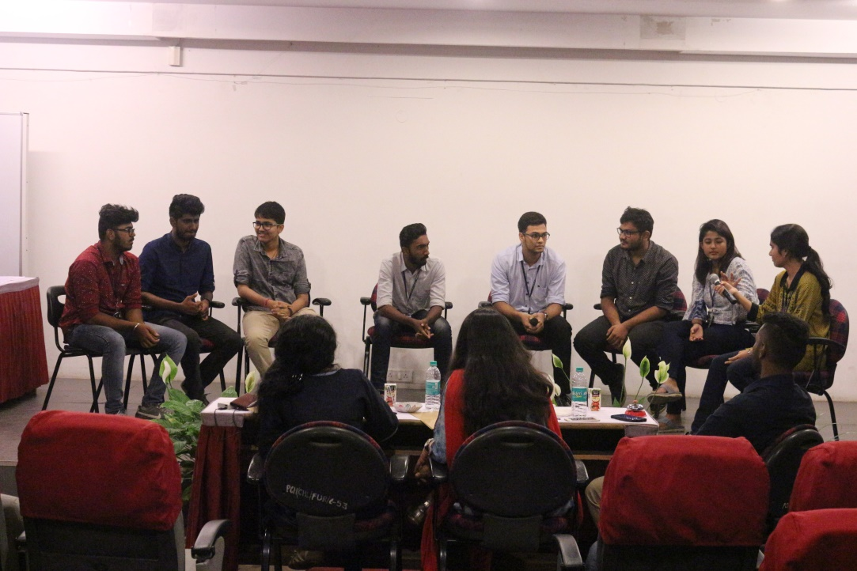
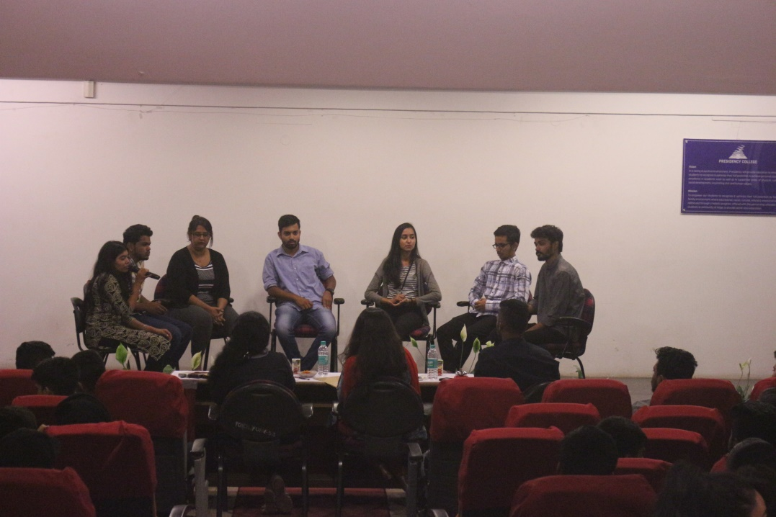

Round 02:
JAM: This was a new round which was introduced this year 2019. We had 6 sets consisting of 5 participants in each set. During the first round of JAM, the participants had 3 minutes to talk on a topic and if they detected any error with regard to Content of the speech like Repetition, Grammatical Error, Hesitation, Deviation of the topic or Foul language in their fellow participants on stage they had to JAM (hit) the table and announce the fault. The person JAMMED has to state the fault and continue with his content. Our judge Noorien Ma’am had to choose 6 participants out of 31.
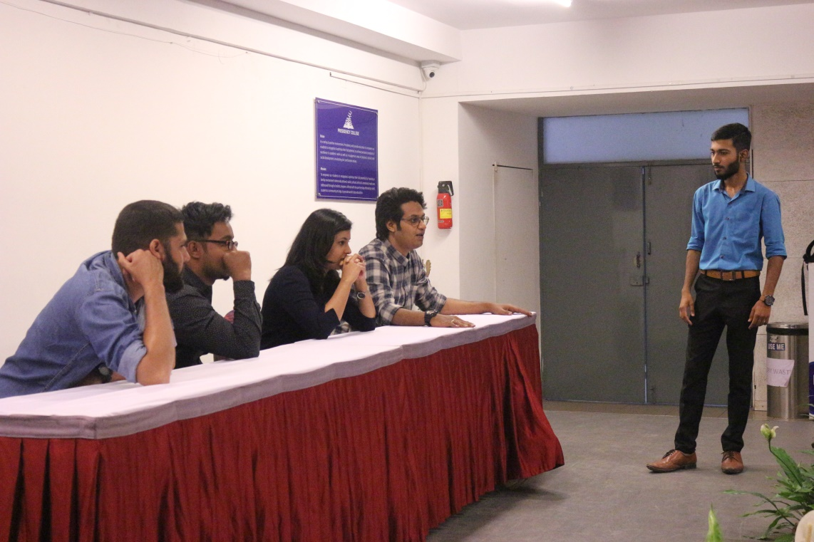
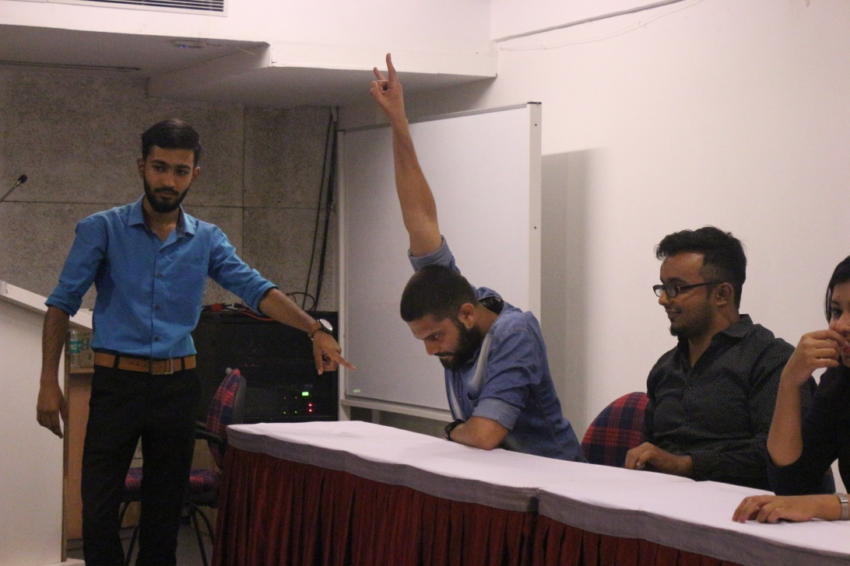
Round 03:
Stress Round The participants were provided with a case study in which they had to assume themselves to be the Public Relation (PR) of that particular company and defend themselves. The audience present there raised a lot of questions and the participants had to answer all their queries, and the time allotted to them was 2+5 minutes each. We had Prachi Ma’am to judge this round where we got our winner and the runner ups.
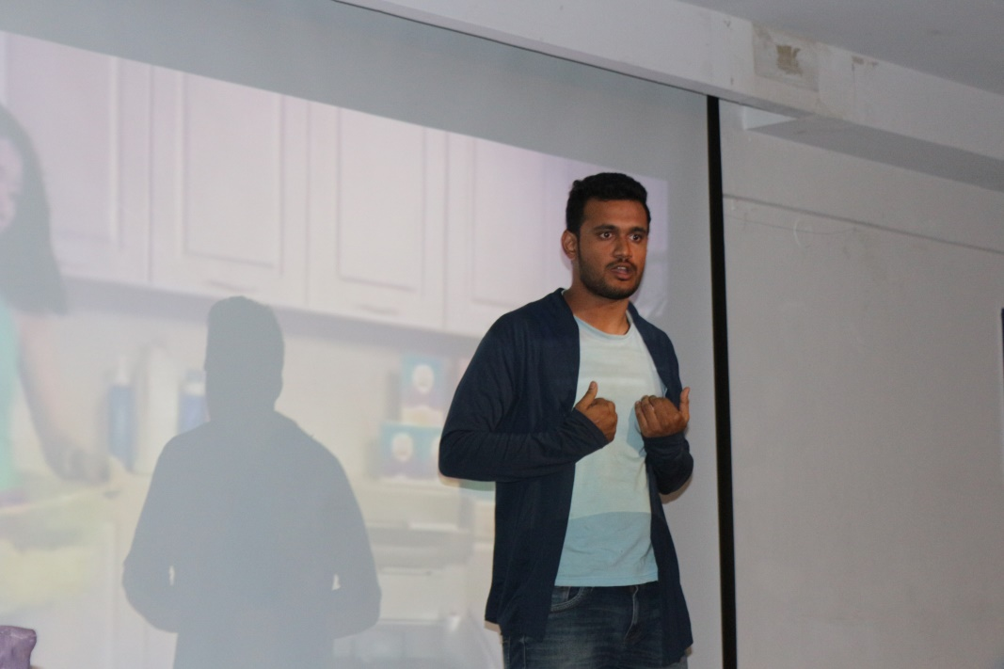
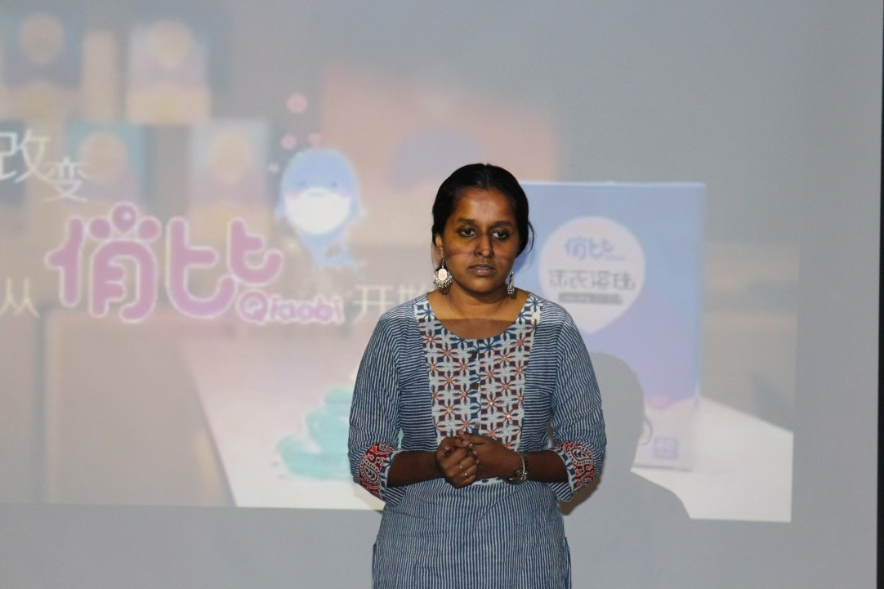

WINNER AND RUNNER UPS:
SL NO. | NAMES | SEMESTER | DEPARTMENT
01. | Aakash | 6th Semester | BAJ
02. | AishwaryaPrakash | 6th Semester | BAJ
03. | Ryaan | 2ndSemester | BBA

The Winner walked away with a cash prize of Rs. 1000/- and the 1st Runner up with Rs. 500/-

WINNER: AAKASH
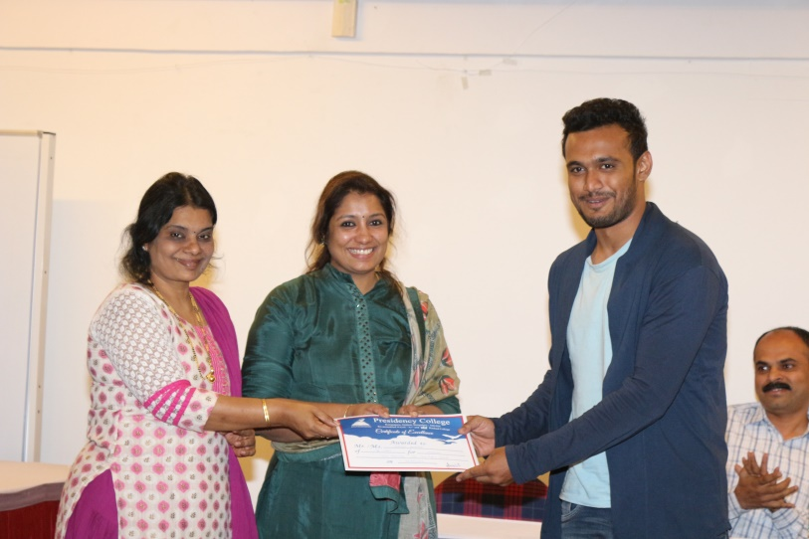

1st RUNNER UP: AISHWARYA PRAKASH
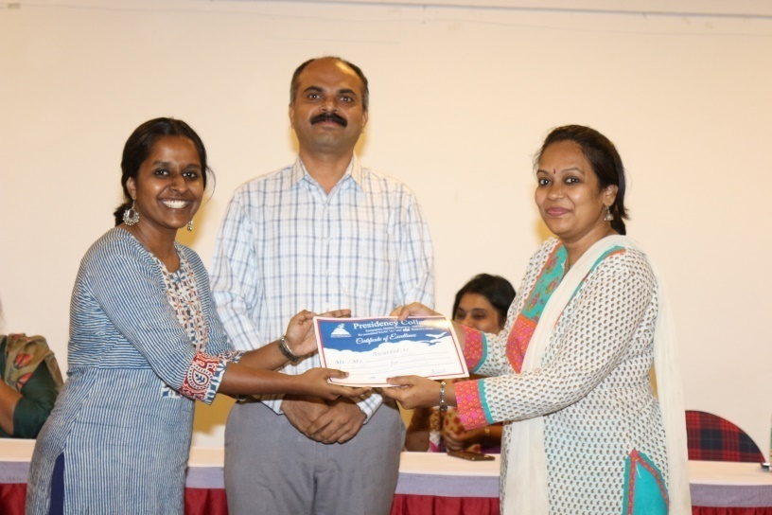
2nd RUNNER UP: RAYAAN
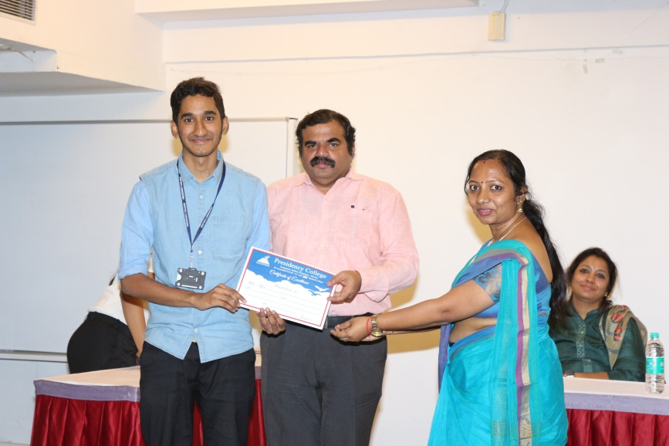

PICTURE WITH THE WINNER AND RUNNER UPS
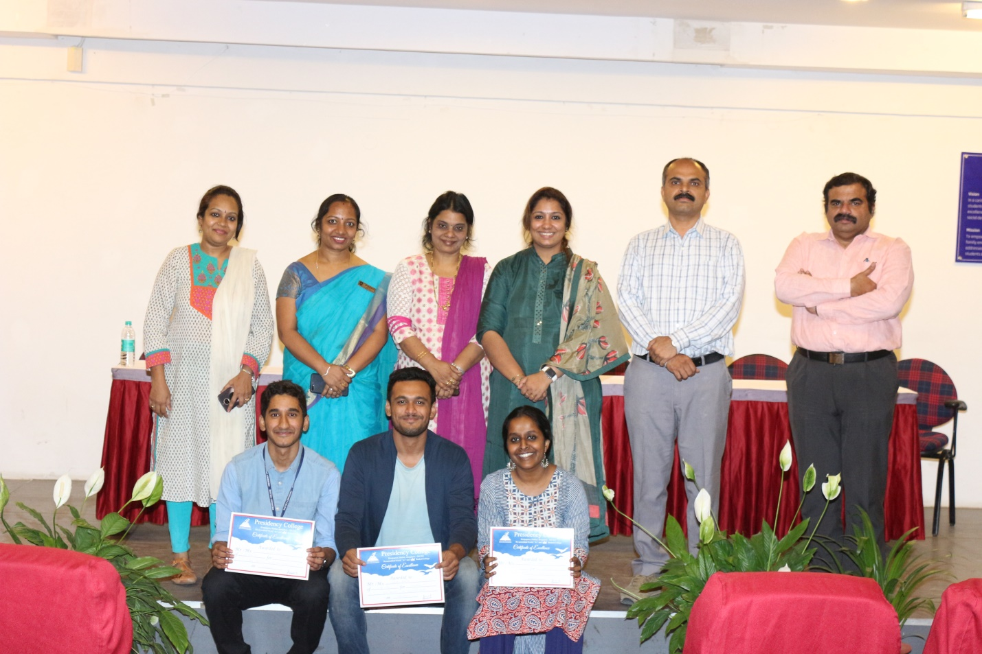

PICTURE WITH THE BIG FIGHT TEAM
