MBA Ethnic Fest
Date: 23/7/2022
Time: 12:00 – 3:00 p.m.
An Ethnic Fest was organized as by the SDC seniors for the entire MBA department and it was a huge success. A food fest was organized and stalls of paani puri and sweets were put up in MBA corridor.The students and faculty thoroughly enjoyed and the best costume (Male & Female) for both the batches were judged and prizes were announced. Certificates and Trophies will be given out later.
Best Costumes:
Ist Prize (Male): Victor Kevin (MBA IV SEM)
Ist Prize (Female): Nandhini (MBA IV SEM F&M-B)
2nd Prize: (Male) Vinay Raj (MBA II SEM , SEC E)
2nd Prize (Female) Preethi K.R. (MBA IV SEM MHR-B)
Below is the Instagram link of the Ethnic Fest
https://www.instagram.com/reel/CgWUwxopGp5/?igshid=MDJmNzVkMjY=
The Paani Puri stall setup by Preethi, Shilpa Shetty, Pooja, Nisha and Poornima was judged the best for food.
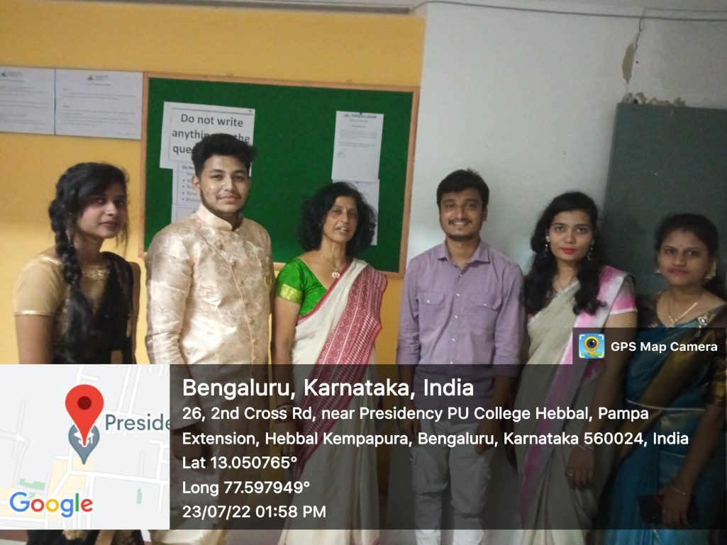
SDC Coordinator MBA (Seniors)
Radhika Arora
