CENTRE FOR MEDIA STUDIES

WORKSHOP

HYPNOSIS

Facilitator – Mr. Jini K Gopinath, RCI Certified Clinical Psychologist

Duration – 28th Feb 2020

A walk through the mind

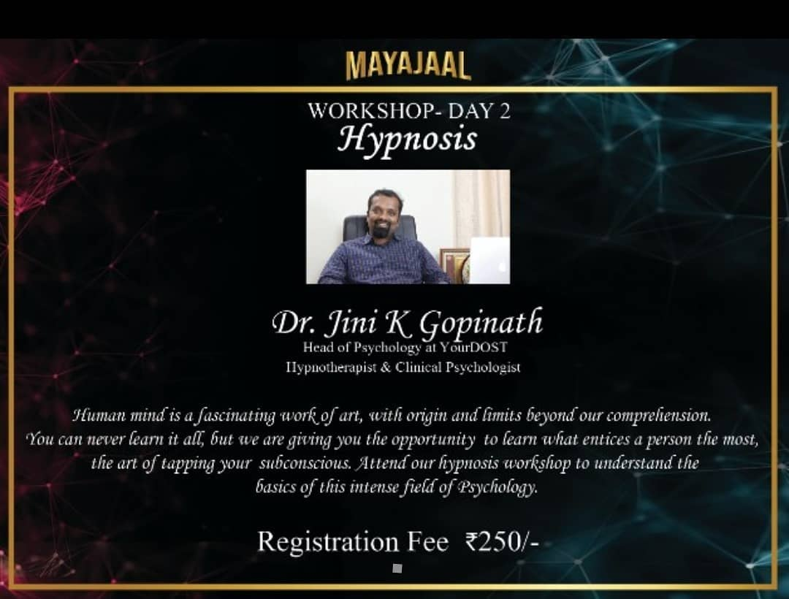
The CMS Department of Presidency College organised a workshop on Hypnosis on the second day of Vrittanta, i.e., on 28th of February. The workshop had an overwhelming response from over 20 colleges all over Bangalore with registrations not only from students but from teachers as well.

The workshop was conducted by Mr. Jini K Gopinath, who is an RCI certified clinical psychologist with more than 15 years of expertise.He is one of the most renowned hypnotherapists in India, and has also been trained under the legendary founder of CBT, Aaron Beck.His psychological practice includesCognitive Behaviour Therapy (CBT), Transactional Analysis (TA) and hypnotherapy.
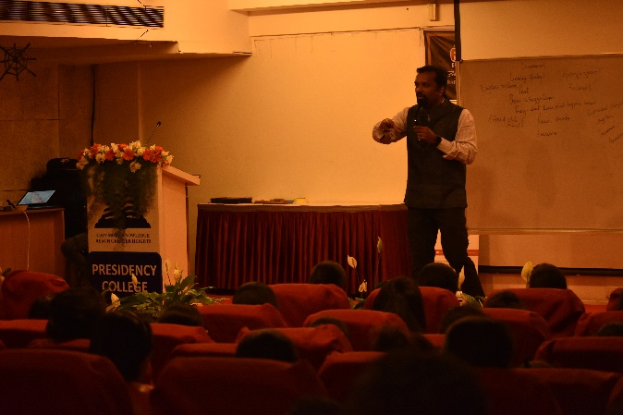
Mr. Jini defined Hypnosis as a trance-like mental state of highly focused attention, diminished awareness, and heightened suggestibility. He went into detail about the history of hypnosis and the coinage of the word as well. Franz Mesmer introduced the concept of hypnosis and named it Mesmer, he considered this as the power of the hypnotherapist transferred to the client. James Braid coined the term hypnotism. He also added that Sigmund Freud was the reason for the downfall of hypnosis, by rejecting it claiming that people came back with symptoms even after therapy.

After covering the basics of hypnosis, he called five people up on the stage and started a live demonstration of what is called an induction hypnosis. This started with a pre induction talk to prevent resistive mode and eliminate misconceptions about hypnosis. He briefed the audience about the technique used, i.e., eye fixation technique which involves staring at one point that works on principle of ocular fatigue (a person cannot focus on one point for a long time). The next step in induction technique was the breath-work wherein they were asked to focus on their breathing pattern.

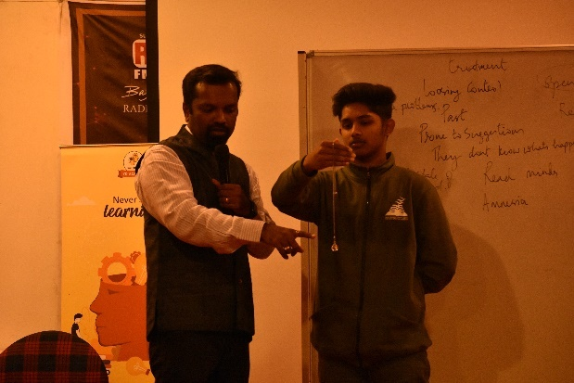
He also mentioned that it is important to maintain a hypnotic rapport phase, i.e., use future tense in order to compel a person to do what is being suggested. Each person responded to this technique differently, depending on their level of suggestibility.

He then conducted the arm drop induction hypnosis test on the entire audience, which he said was based on ide motoric response, to which there were different responses as well.

Towards the end of the workshop, he answered the questions raised by the audience and concluded by stating that the reference for the workshop was the book ‘Trancework’ by Michael D. Yapko(3rd edition), who was also his teacher.

-ZebaSaher

