CENTRE FOR MEDIA STUDIES

WORKSHOP

NEUROFEEDBACK

Facilitator – Prof. Sai Kiran Kumar, Senior Manager for organisational development and training, a certified Neuroclinician and a Board-Certified Neuro-Feedback trainer

Duration – 27 Feb 2020

TRAIN THE BRAIN

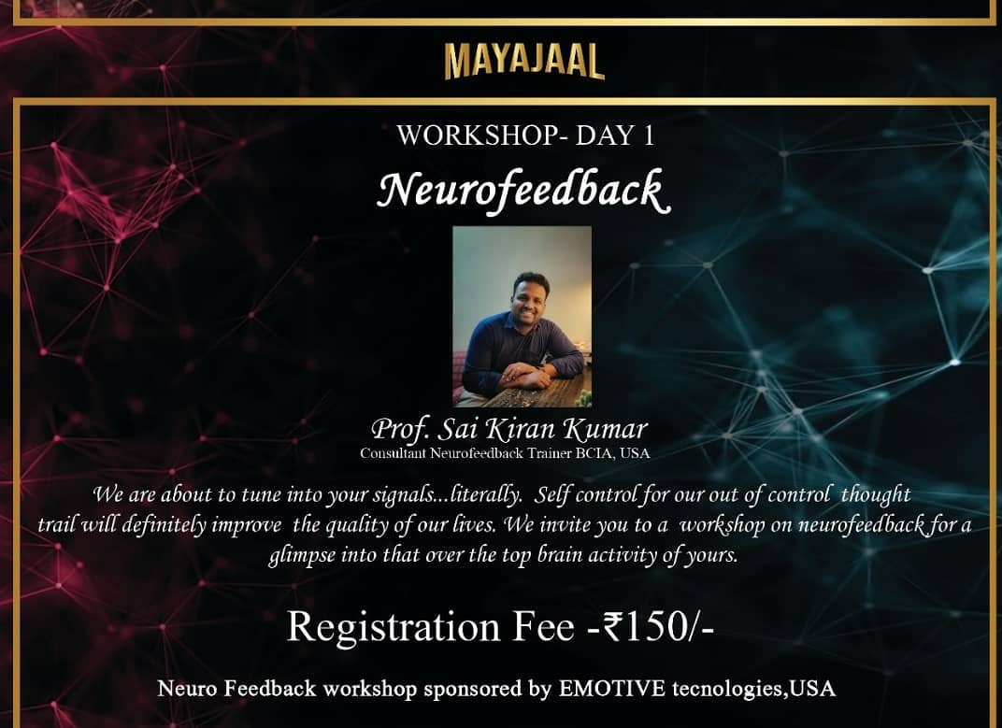
The Centre for MediaStudiesDepartment of Presidency College organised a workshop on Neurofeedback on the first day of Vrittanta, i.e., on 27th February, which had an overwhelming response from students of different colleges all over Bangalore.

The workshop was headed by Mr Sai Kiran Kumar, senior manager for organisational development and training, a certified Neuroclinician and a Board-Certified Neuro-Feedback trainer. He has also developed specialized protocols for ADHD, Autism, and for students requiring specialized cognitive development strategies.
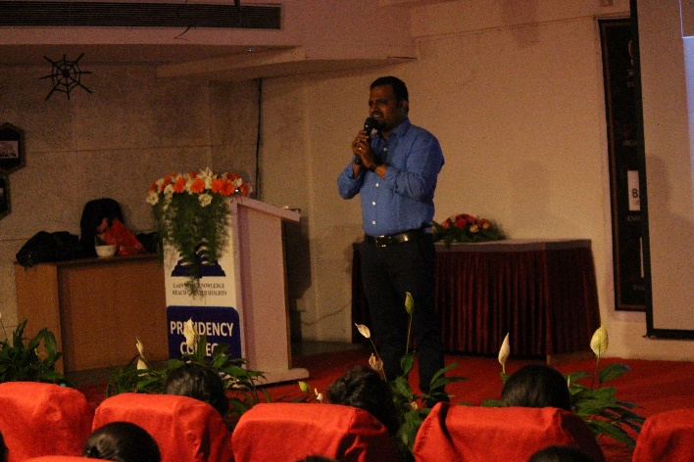
Mr. Kiran defined Neurofeedback as a specialised and effective technique that makes use of EEG (electroencephalography) assesses a person’s brainwave activity, identifies irregular brain wave patterns and simultaneously gives real-time feedback to train the brain. The method is an amalgamation of physiological, mental and environmental factors. This treatment allows the diagnosis of various disorders such as anxiety, depression, insomnia and ADHD. It also determines levels of stress, focus, interest, relaxation, engagement and other criteria which creates an algorithm in the background that helps evaluate one’s complete mental activity.

The students were provided with information regarding various aspects of the brain in terms of physiology, anatomy, pharmacology, neurotransmitters, mental health disorders, and several examples of clinical case conditions were given that aided in better understanding of various disorders.

The students also had an opportunity to witness live brain mapping, and observe the activities taking place in different areas of the brain with different colour coded waves. They also saw the brain engagement to different music intensities, indicated by different colours.

The session then turned into an interactive and enticing one as Mr. Kiran engaged all the students in an interesting l discussion and finally ended with an enriching question-answer session which was pepped up with subtle humour and was very informative. It certainly impacted each and every one present there, and intrigued the students to know and learn more about the subject.
-ZebaSaher

