Presidency College
Reaccredited 'A+' by NAAC

Kempapura, Hebbal, Bengaluru – 560024

www.presidencycollege.ac.in

WORKSHOPS
DIGITAL MARKETING 27 February 2019
Facilitated by Ms. Ranjini Rao, Marketing Communication Expert
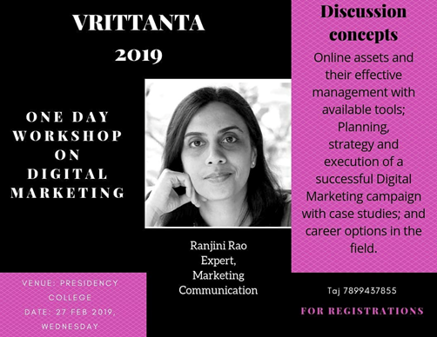
As part of media fest Vritantta this year on popular demand many workshops were organized and one such workshop was on – DiGITAL MARKETING. One day long workshop was facilitated by Ms Ranjini Rao who is an expert in the area of digital marketing with over 15 years of experience. The worksop witnessed participations from various colleges from Bangalore. It was a grand success.

