CENTRE FOR MEDIA STUDIES
GOOGLE NEWS INITIATIVE
TWO DAYWORKSHOP
Program Name: Media Workshop
Date: 26 and 27 July 2019
Time/Duration: Two-day
Total Number of Participants: 50
Name of Resource Person(s)/Organization: Ms Geethika Rustagi, Google News Lab Trainer and Mr.Bharath Nayak, Founder and Editor – The Logical Indian
Venue: Seminar Hall

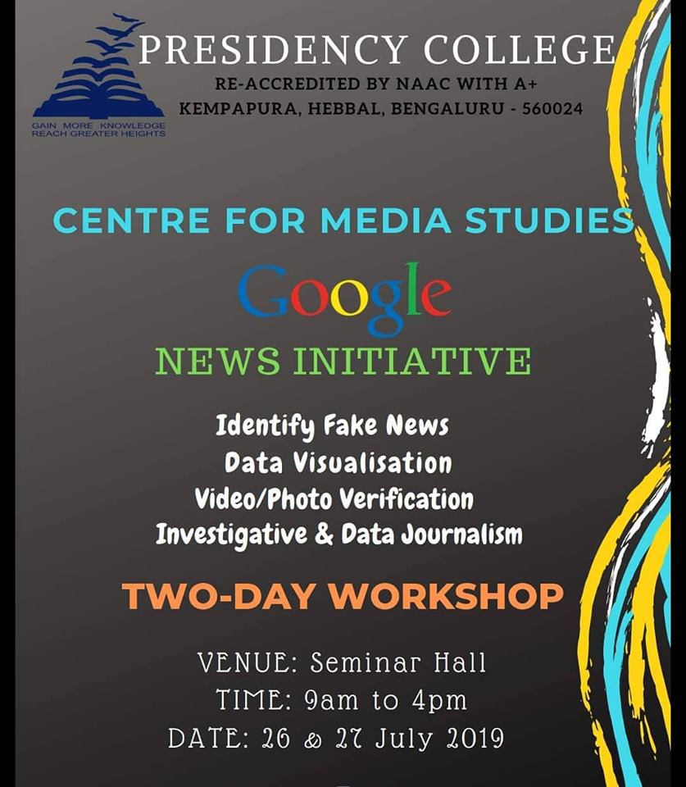
The students of Centre for Media Studies at Presidency College, were a part of the two-day workshop in collaboration with Google News Initiative. The workshop had interesting sessions curated by the Media Studies department. Fundamentals of Research, Investigative and Data Journalism, Data Visualisation, Geo Tools, Identifying Fake News + Types of Mis/dis-information, Video/Photo verification, Digital Safety and Security, Using social audit + Geo tools for verification were among the sessions during the workshop. Each session was approached with training students with practical applications of the concepts.

Day one of the workshop aimed at equipping aspiring journalists with the necessary tools required for surfing the web with ease for churning out desired content. Investigative and Data journalism tools like search refinements enlightened the students on how to optimise the search tools to get accurate, relevant and desired results. Step by step instructions were given to help students master the technique of using search engines. This session was conducted by Ms Geetika Rustagi, who is proficient in the field of online journalism. Geo mapping tools were introduced to the students in the afternoon session, which enabled them to use the features of maps in a manner which facilitates in-depth research.
The second day of the workshop laid emphasis on countering the dangerous trend of "Fake News". This session was conducted by Mr.Bharat Nayak, the founder and Editor of the news portal The Logical Indian which aims at providing quality stories of human interest. Students were taken through various methods that can be applied in identifying fake news and uncovering the truth. Fundamental concepts like mis/disinformation, types of misinformation, the impact and implications of the same were discussed elaborately. Options like image search refinements, paying attention to details, date filter, pixel filter and so on were shown as tools to help in finding legitimate content from the illegitimate ones. Industry expertise was offered by both the trainers while they put forward their organisation experience to help students in understanding the intricate details of media houses. Interesting case studies were shared to reiterate the significance of being digital media literate. The BBC Africa Case study which is one of the break through cases in the recent past was discussed to throw light on how geo tools were effectively used in investigative journalism. The final session of the second day on Online Safety and Security alerted students to secure their online presence with suitable steps.
The overall reception for the workshop was definitely on the positive spectrum as it managed to create aware citizens and smarter future journalists.

- S. Aravinda
III semester BA

