CENTRE FOR MEDIA STUDIES
WORKSHOP
SHORT FILM MAKING

Facilitator – Mr.Adarsh Eshwarappa, Film Maker
Duration – 2 Days 26th and 27th Feb 2020

What’s behind the frame?
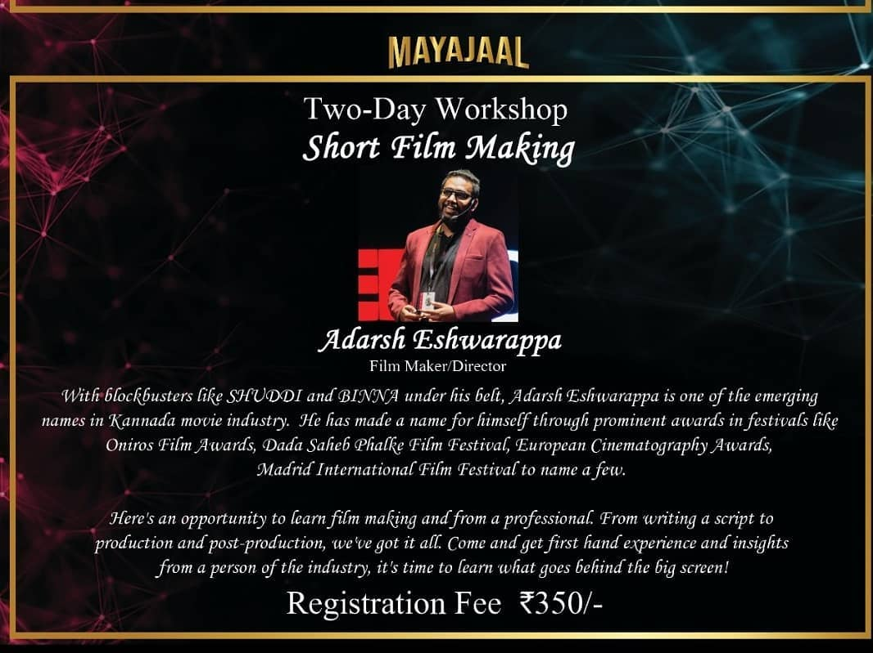
Presidency College’s annual media fest, Vrittanta, was organized on 27th and 28th of February, 2020. There were various events and workshops conducted within these two days, one among them being Short Film-making Workshop handled by Mr. Adarsh Eshwarappa, a film actor, screenwriter and director who works in Kannada Cinema. Mr. Eshwarappa quit his job to follow his passion and he is well known for directing SHUDDHI(2017) and BHINNA(2019).

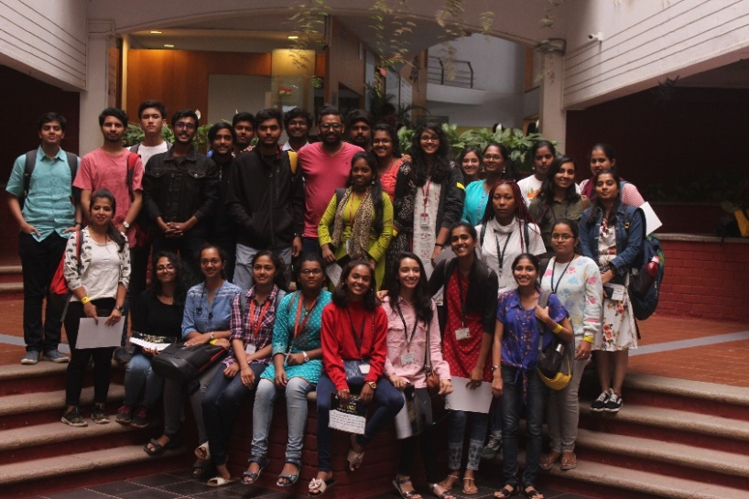
The workshop began at 10:00am on Day 1. The seated crowd consisted of students from various colleges as well as working professionals who were eager for the launch of the session. Mr. Eshwarappa soon began his session introducing himself and interacting with the seated crowd, one by one all the seated members introduced themselves. Mr. Eshwarappa then spoke about his journey, abouthis time in an engineering college, his struggles and difficulties, etc. He then spoke about how he came up with the idea of becoming a film director and screenwriter. He then started with various presentations and explained the process of screenwriting. After 2 hours of explanation it was time for a break. And after the break we saw a greater number of participants in the hall which made Mr. Eshwarappa even happier and he extended the session till 02:00pm. Mr. Eshwarappa spoke about his film SHUDDHI and how hard the journey was to get this movie in the theatre’s and then on Netflix. Soon the day 1 session came to an end.
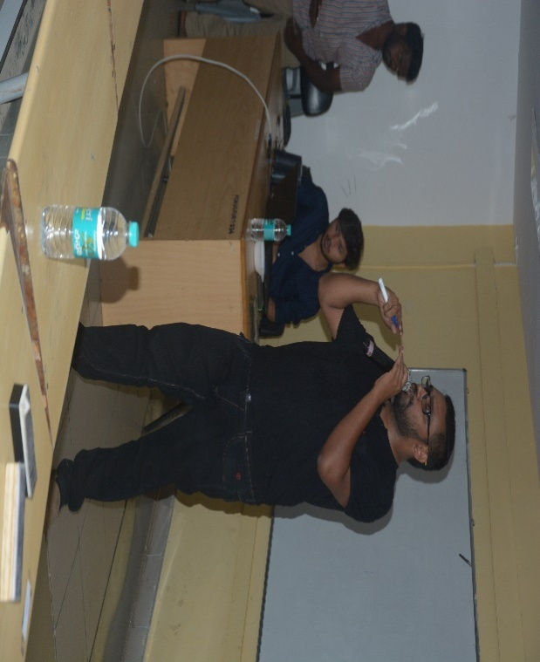
On day 2,session 1 started at 11.00am. There was a more participation compared to Day 1 which was really good to see. Mr. Eshwarappa started with scene to scene narration of his movie SHUDDHI, where he spoke on the various references used in the movie and also where and how the audience’s attention can be captured the most. Mr. Eshwarappa then gave an exercise to the participants where they had to form a team of three people each and had to come up with a self-created scene. He was quite surprised to see all the participants come up with quite a lot of interesting scenes. He used various Hollywood movie scenes to show the participants, how important attention to detail gets while directing a movie and what are the essentials required for the art of good direction.

The session went on till 04.00pm.All the participants were very happy at the end of the last session and Mr. Adarsh Eshwarappa was exhausted but quite satisfied with the audience interaction. He handed over the participation certificates to all the participants and he was handed over a token of appreciation and a thanksgiving note from the student coordinator. Finally, the workshop came to an end, bringing smiles to the face of everyone who was part of the workshop and leaving them with an enriching and memorable experience.

By: Aviral Singh
2nd B.A(J)
Presidency College

