CENTRE FOR MEDIA STUDIES
PSYCHOLOGY DAY - METANOIA

Date: 25 Sep 2019
Resource Person: Ms Veena Jain( Psychologist), Prof Nizam ( Psychologist) and Mr Suresh Ramanath ( Mr Gay India)
Topic:
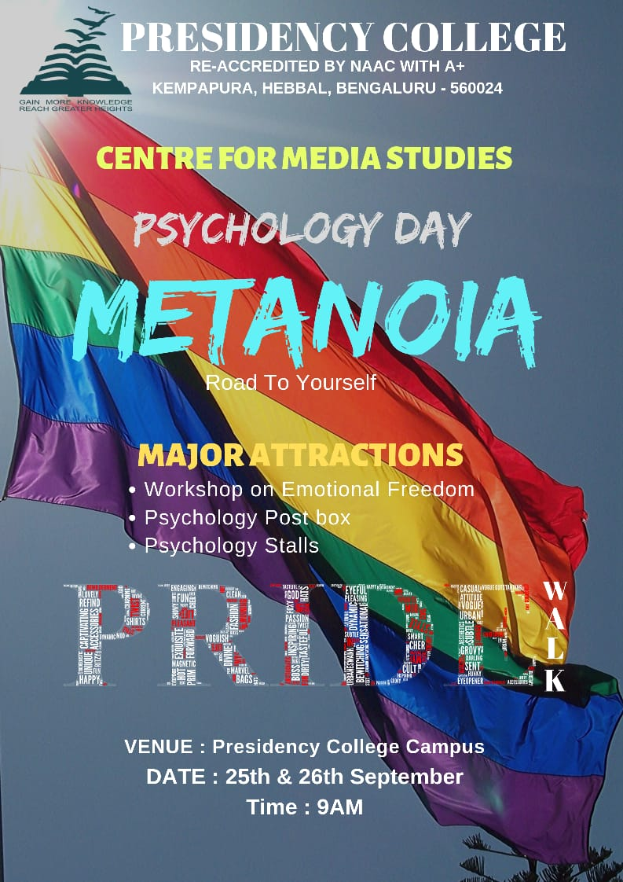
Venue: Seminar Hall and Room 117
Metanoia- road to yourself, began in the year 2017 to discover and explore oneself. The third edition of Metanoia was a two day event that was organised on the 25th and 26th of September,2019. The underlying themes were mental disorders and pride. The agenda was remove to the stigmas attached to the respective themes. The two day event was filled with various psychological activities. Day one of Metanoia commenced by the arrival of Mr T Nizam, Ms Veena Jain and professor Mr Sai Kiran Kumar. The guests kindled the lamp after which an introduction to Metanoia was given by Ms Navya Shree. The head of the CMS department, Dr Shilpa Kalyan, lauded and encouraged the students. It was followed by a beautiful poem with the title ‘Harkate Uski alag thi,Par galat nahi.’ by Ms Shruthi. A video on Mental disorders and the LGBTQ+ done by Taj and team was shown. The main agenda of the video was to remove the myths revolving around the main themes. The students who completed their internship at Manali, Himachal Pradesh were given a certificate of appreciation from the management for the community service offered by them. Later the psychology students experienced how EFT works as a therapy through the Emotional Freedom Training workshop conducted by the resource person. Mr T Nizam demonstrated how EFT works by conducting a session with minimal procedures. The students were equally involved and volunteered to participate in the session. The workshop helped the students gain an insight of EFT as a counselling intervention. Day one came to an end with the screening of an award winning short film ‘Kriti’.
Day two witnessed the psychology students coming together to pledge their support to the LGBTQ+ community. It began with the speech of Mr Suresh Ramdas, an activist. He addressed the students about the community and the challenges faced by them in the society. This was followed by the ‘Pride Walk’ around Kempapura. The students and the teachers painted their faces with rainbow colours and marched with banners and flags. As they returned from the March, the stalls were set up for the other students in the college. There were ten stalls with various psychological activities. There was an active participation and every stall was visited by various students. Each stall collected a certain amount for participation. The total amount from all the stalls will be donated to the LGBTQ+ community. Added to this, were a promise tree and a psychology post box placed for the students in the quadrangle.
That brings an end to the chapter 3 of Metanoia. It brought together bonding and a path to get closer to oneself. The most important lesson in this chapter is ‘Pride’ and that one needs to be proud about who they are. The students were enthusiastic and are eagerly waiting for the next edition.

Navyashree
V Semester BA

