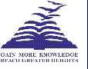
Presidency College
Reaccredited 'A+' by NAAC

NIRF Top 100 Ranked College
Kempapura, Hebbal, Bengaluru – 560024

www.presidencycollege.ac.in

CENTRE FOR MEDIA STUDIES – BA
WORKSHOPS
MULTIMEDIA JOURNALISM – 23 February 2018
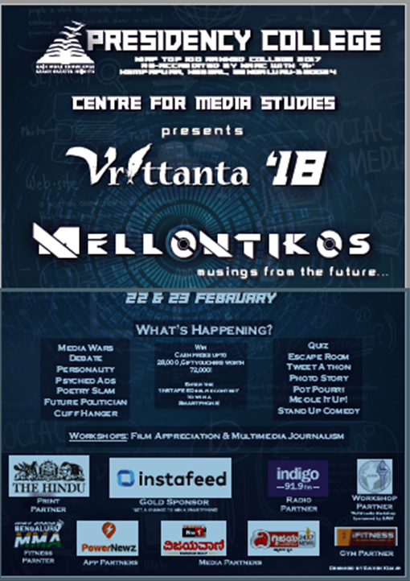

The second day of the fest had a workshop on Multimedia Journalism sponsored and conducted by the faculty from IIJNM. The fest had registrations from over 23 colleges in and around Bengaluru which made sure that the event coordinators’ had hardly a minute to breathe!
The campus was flooded with more than 200 students from colleges like MS Ramaiah, KristuJayanthiCollege, Commits, Jain CMS, Mount Carmel, Christ University, Sindhi College attending various events and the workshop.

