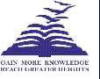
Presidency College
Reaccredited 'A+' by NAAC

NIRF Top 100 Ranked College
Kempapura, Hebbal, Bengaluru – 560024

www.presidencycollege.ac.in

CENTRE FOR MEDIA STUDIES – BA
WORKSHOPS
FILM APPRECIATION – 22 February 2018

The Centre for Media Studies of Presidency College launched the sixth edition of Vrittanta which went on the floors on 22nd and 23rd February. Mellontikos, the Greek word for future aptly sums the theme of Vrittanta 2018 thus denoting – the musings from the future.
With fourteen events lined one after the other, the first day of the fest also had a workshop on Film Appreciation facilitated by veteran actor, film maker and theatre personality Mr. PrakashBelawadi and Dr. Uma Vangal. This was received very well by all the participants and was a grand success.

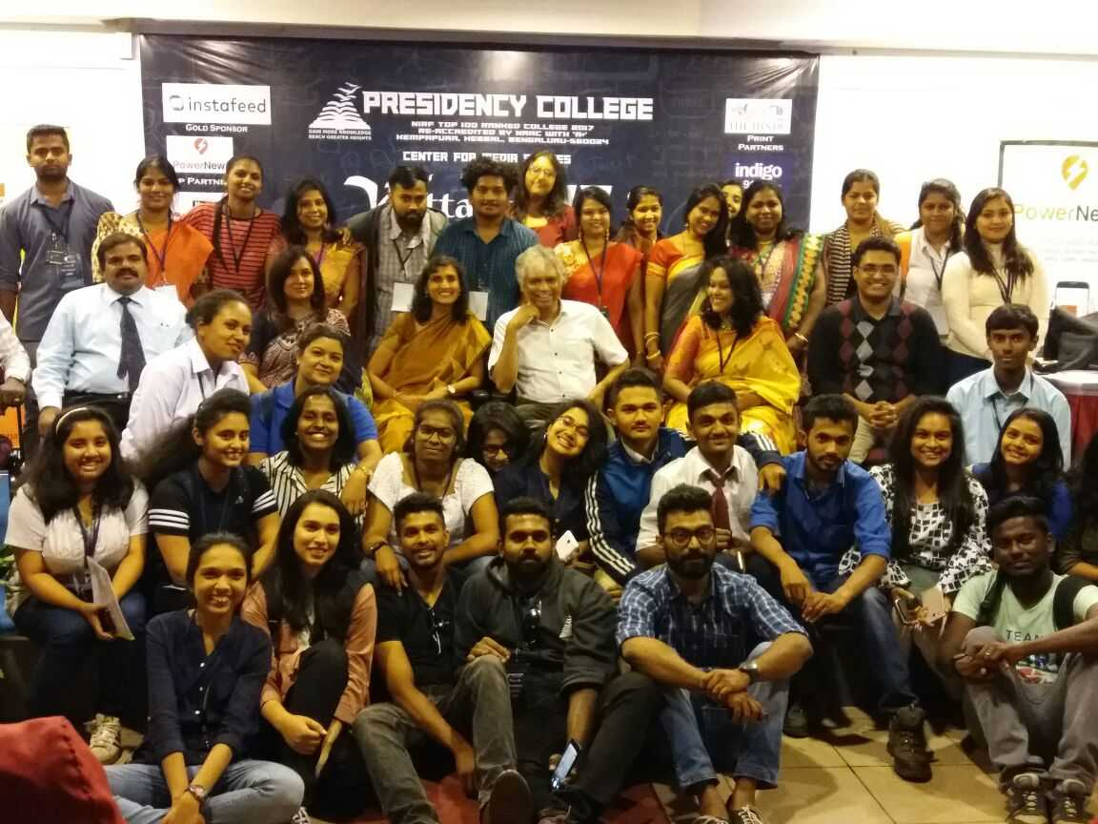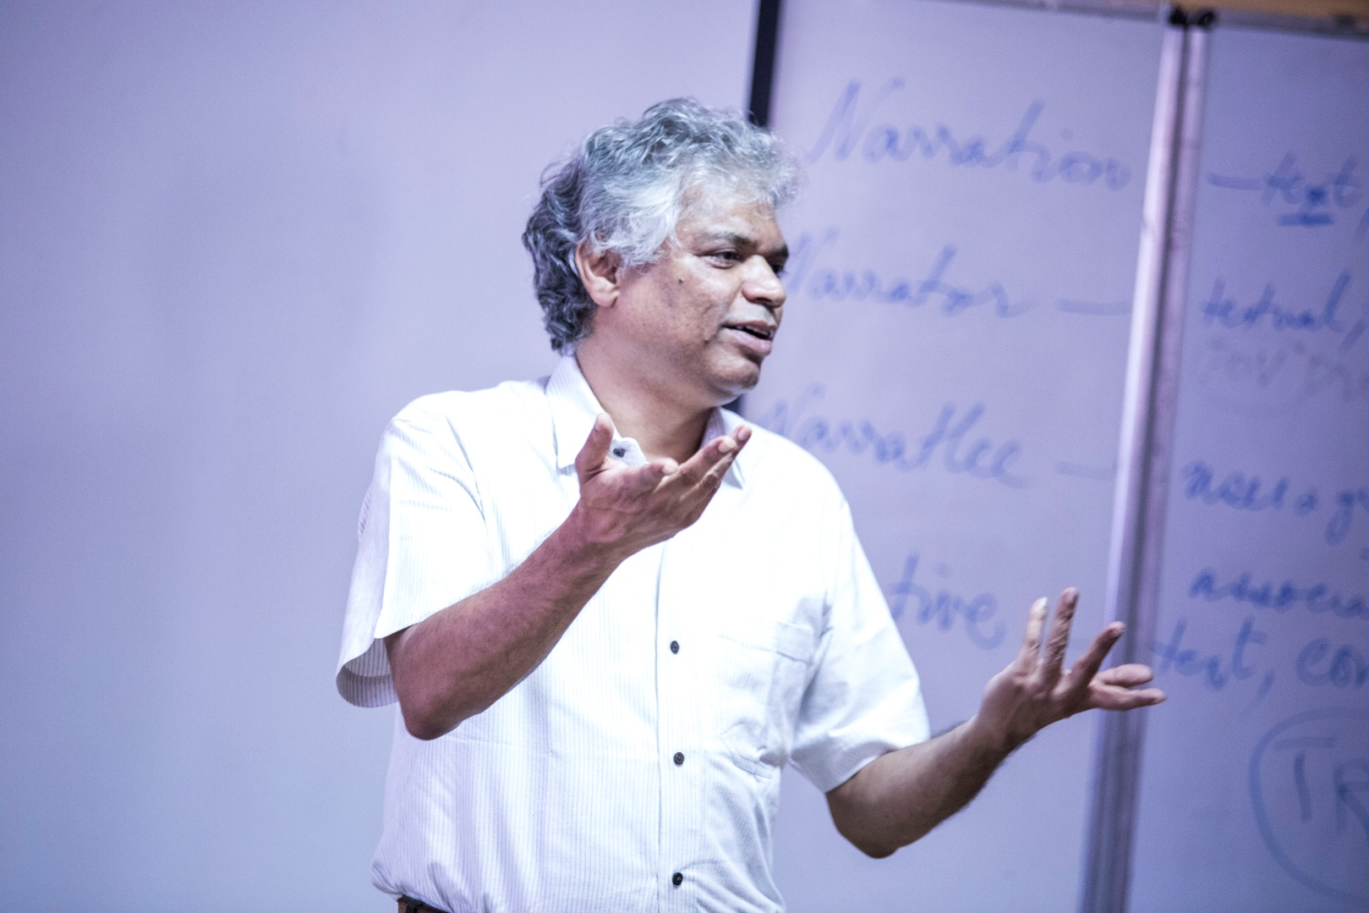

The Hindu , Page 2 – dated 27 Feb 2018.