Presidency College
Reaccredited 'A+' by NAAC

Kempapura, Hebbal, Bengaluru – 560024

www.presidencycollege.ac.in

CENTRE FOR MEDIA STUDIES
Guest Lecture/Workshop: Family Systems Constellation (Psychology)
Date: 06.06. 2020 Time: 1:20 pm
Resource Person: Mr.Aravind Shivakumar Place: Room No.220

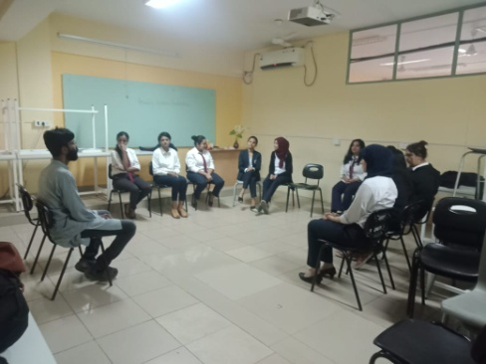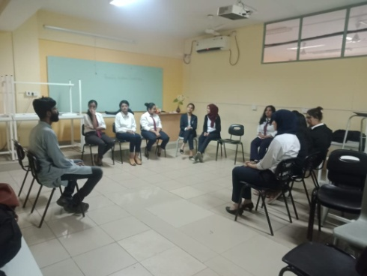
CMS department of Presidency College organized a workshop on Family Systems Constellations by Mr. Arvind on 6th February 2020. It is a method of group/family therapy in which individual persons are positioned as representatives for family members of the client and the network of relationships within a family is visualized. The workshop was attended by 3rd Year Psychology students and was facilitated by Mr.Aravind with a brief introduction by Ms. Meera Ruxana.
Starting on a very light note, the session went more in depth explanation of this field of Psychology and ended with a practical demonstration. As both the facilitators had expertise in the field and are practitioners of this form of group counselling, the session was a very interactive and informative one. Most of the students were introduced to the concept of Family Systems Constellation for the first time and thus the curiosity to understand resulted in an interesting series of questions. The basic concepts such as Order of Love, types of conscience and meaning of family system were explained in detail which brought forth a refreshing, more open point of view at life. The students also did a little exercise to understand the concept, and it helped most of them get in touch with themselves as well as bond with others. The practical session was done on a rather small group of students, and it left every single one of them with some indescribable feelings and some heartfelt emotions.

The session, initially intended for 2 hours lasted for about four hours and still there were topics left untouched indicating the vastness of this field of Psychology and the commitment it requires. It left the students with a lot to think about and a lot more to explore.
By
Aarushi, BA ( III year)

